

Name : THI HAN NAING

NCC NO : 189889

Report Date : 10.7.2024

**Point of Sale System for**

**“Tempest Books”**

**Table of Contents**

**Abstract 8**

**Acknowledgement 8**

**1. Business Proposal 9**

**1.1 Overview 9**

**1.2 Current Business History 10**

**1.3 Current Business Process 11**

**1.3.1 Registering Customers 11**

**1.3.2 Registering Staff 11**

**1.3.3 Purchasing Books 11**

**1.3.4 Customer Ordering 11**

**1.3.5 Advertising and Promoting Books 11**

**1.4 Current System Issues 12**

**1.4.1 Storing Books 12**

**1.4.2 Disadvantages of paperwork 12**

**1.4.3 Registering Customer 12**

**1.4.4 Shipment Problems 12**

**1.4.5 Uncommon Problems 12**

**1.5 Proposed System Scope 13**

**1.5.1 Filtering and editing purchase records 13**

**1.5.2 Create and record order 13**

**1.5.3 Edit and delete data 13**

**1.5.4 Create voucher 13**

**1.5.5 Filtering and searching 13**

**1.6 Aims and objectives 14**

**1.6.1 Aims 14**

**1.6.2 Objectives 14**

**1.7 Estimate Cost 16**

**1.7.1 Hardware cost 16**

**1.7.2 Software cost 16**

**1.7.3 Development Cost 17**

**1.7.4 Summary Cost 17**

**1.8 Project Plan 18**

**Chapter 1 Introduction 21**

**1.1 Background of the Current System 21**

**1.1.1 History 21**

**1.1.2 Current Business Process 22**

**1.1.3 Current System Issues 23**

**1.2 SWOT Analysis 24**

**1.2.1 Strengths 24**

**1.2.2 Weakness 24**

**1.2.3 Opportunities 24**

**1.2.4 Threats 24**

**1.3 Proposed System Scope 26**

**1.3.1 Filtering and editing purchase records 26**

**1.3.2 Create and record order 26**

**1.3.3 Edit and delete data 26**

**1.3.4 Create voucher 26**

**1.3.5 Filtering and searching 26**

**1.4 Aims and objectives 27**

**1.4.1 Aims 27**

**1.4.2 Objectives 27**

**1.5 Brief overview of the remaining chapters 28**

**Chapter 2 Similar Product Comparison 30**

**2.1 Similar product introduction 30**

**2.2 Functional Comparison 33**

**2.2.1 Customer Registration Page 33**

**2.2.2 Login page comparison 35**

**2.2.3 Order management pages 37**

**2.2.4 Checkout page 39**

**2.3 Functional Summary Evaluation 43**

**2.4 Functional Comparison Summary 43**

**2.5 Non-functional Comparison 44**

**2.5.1 Search Bar Comparison 44**

**2.5.2 Language Change 44**

**2.5.3 Shopping Cart 45**

**2.6 Non-Functional Comparison 46**

**2.7 Non-Functional Summary 46**

**Chapter 3 Feasibility Study 47**

**3.1Technical Feasibility 47**

**3.1.1 Methodologies 47**

**3.1.2 Strength and Weakness of each Methodology 48**

**3.1.3 Comparison of Methodology 51**

**3.1.4 Recommendation Methodology 51**

**3.1.5 Programming Languages 52**

**3.1.6 Strength and Weakness of each Programming Languages 53**

**3.1.7 Comparison of Programming Languages 55**

**3.1.8 Recommendation of Programming Languages 55**

**3.1.9 Databases 56**

**3.1.10 Strength and Weakness of Databases 57**

**3.1.11 Comparison of Databases 59**

**3.1.12 Recommendation of Databases 59**

**3.2 DSDM Feasibility (DSDM eight principles) 60**

**3.2.1 Focus on the Business Need 60**

**3.2.2 Deliver on Time 60**

**3.2.3 Collaborate 60**

**3.2.4 Never Compromise Quality 60**

**3.2.5 Build Incrementally from Firm Foundations 60**

**3.2.6 Develop Iteratively 60**

**3.2.7 Communicate Continuously and Clearly 60**

**3.2.8 Demonstrate Control 60**

**3.3 Possible LESPI (Legal, Ethical, Social and Professional) Issues 61**

**3.3.1 Legal Issues 61**

**3.3.2 Ethical Issues 61**

**3.3.3 Social Issues 61**

**3.3.4 Professional Issues 62**

**Chapter 4 Foundation 63**

**4.1 Target User 63**

**4.2 Functional Requirements 64**

**4.2.1 Manage Book Purchase Functional Requirement (Time box 1) 64**

**4.2.2 Manage Book Order Functional Requirement (Time box 2) 64**

**4.3 MOSCOW Prioritization 65**

**4.3.1 Must 66**

**4.3.2 Should 66**

**4.3.3 Could 66**

**4.3.4 Won’t 66**

**4.4 Non-Functional Requirements 67**

**4.4.1 Performance 67**

**4.4.2 Scalability 67**

**4.4.3 Reliability 67**

**4.4.4 Security 67**

**4.4.5 Usability 67**

**4.4.6 Maintainability 67**

**4.4.7 Compatibility 67**

**4.4.8 Legal & Regulatory 68**

**4.5 Time Box Plan 69**

**4.5.1 Timebox 1: Manage Book Purchase Process Time box 69**

**4.5.2 Timebox 2: Book Ordering Process Time box 70**

**4.6 Risk Management 72**

**4.6.1 Risk 72**

**4.6.2 Risk management 72**

**4.6.3 Risk monitoring 72**

**4.6.4 Risk avoidance 72**

**4.7 Identification of possible risks 72**

**4.7.1 Technical risks 72**

**4.7.2 Client risks 72**

**4.7.3 Security risks 72**

**4.7.4 Third party risks 72**

**4.8 Risk Matrix (High-Medium-Low) 74**

**4.9 Critical Success Factors for current project 75**

**4.9.1 Effective management 75**

**4.9.2 Proper training 75**

**4.9.3 Successful final product 75**

**Chapter 5 Engineering 80**

**5.1 Time-Box 1: Manage Book Purchase Time-Box Development 80**

**5.1.1. Functional Requirements List 80**

**5.1.2 Use Case Diagram for Time Box – 1 81**

**5.1.3 Screen Design 83**

**5.1.4 Iteration for screen design 89**

**5.1.5 Class Diagram 92**

**5.1.6 Sequence Diagram 95**

**5.1.7 Functional Testing 96**

**5.1.8 Usability Testing 101**

**5.1.9 Iteration for Usability Testing 105**

**5.1.10 Time Box Summary 106**

**5.2 Time Box 2 Ordering Time-Box Development 107**

**5.2.1 Functional Requirement List 107**

**5.2.2 Use Cases Diagram for Time-Box 2 108**

**5.2.3 Screen Design 110**

**5.2.4 Class Diagram 112**

**5.2.5 Sequence Diagram 114**

**5.2.6 Functional Testing 115**

**5.2.7 Usability Testing 122**

**5.2.8 Time Box Summary 124**

**Chapter 6 Deployment 126**

**6.1 Deployment Diagram 126**

**6.2 Data Migration 127**

**6.2.1 Data to Migrate 127**

**6.3 Training 128**

**6.3.1 Plan 128**

**6.3.2 Manual 129**

**Chapter 7 Evaluation 152**

**7.1 Evaluation Against Aims & Objectives 152**

**7.1.1 Aims 152**

**7.1.2 Objectives 152**

**7.2 Evaluation Against Similar System 154**

**7.3 Evaluation Against Justification Made 156**

**7.4 Evaluation Against Timebox Plan 158**

**7.5 Personal Evaluation 159**

**7.6 Strength and Weakness of Tempest Books 161**

**7.6.1 Strength of Tempest Books 161**

**7.6.2 Weakness of Tempest Books 161**

**7.7 Future Amendment 161**

**7.7.1 Program 161**

**7.7.2 Design 162**

**7.7.3 Report 162**

**Appendix 163**

**Section A: Use Case Descriptions 163**

**Section B: Detailed Class Definitions 165**

**Section C: Coding 169**

**Section D: Test Scripts 170**

**Section E: Interview Scripts 181**

# **Abstract**

This report is about developing a web-based system for Tempest Books shop. The system includes admin, supplier and customer side web pages. Admin can able to purchase books from registered suppliers. They can also manage books and their relative information. Customer can able to use this website and buy books from online. They can search book from the website and create account to order books. The system is developed with DSDM method and able to develop iteratively and incrementally. The document includes from acknowledgement to deployment and is clearly explained with step by step.

# **Acknowledgement**

First of all, I would like to thanks to a founder of the book store who collaborate with me to finish this project successfully till the end and giving the chance to develop this website. For some confidential and some registrations, store name and founder’s real name cannot be described. Would like to give lots of credit to the founder, co-founder and his stuffs for explaining the detail business, daily processes and challenges patiently.

In conclusion, I would like to thanks the whole ‘Tempest Books’ founder, store’s partners and store staffs for trusting and cooperating with me to develop the website. This is the key of this project’s successful outcome.

# **1. Business Proposal**

## **1.1 Overview**

This is project is about online book selling system of an online shop named ‘Tempest Books’ which currently running their daily operation both from online social media pages and from physical stores. Current selling systems are good for Myanmar market. But to expand the business and able to penetrate into high level market having a book selling website has lots of advantages for the company. First of all, get fit into the high-level market, having a website is a must standard. Second having website can give both customers, stuffs and owners many advantages. Since customers can make fast and easy orders and admins/owners can record their data and able to check at any time.

This system will be used by owners for now. It cannot be used sale stuffs or managers at this time. There will be three types of users in this system. They are customers, owners as admins, and suppliers. Although suppliers will only able to use like customers. All three roles of users will be able to create accounts and view the website. Admins will make purchase from the suppliers and add data to the website. They will able to check the orders made by customers and confirm their orders but cannot delete nor editing orders. They will also check the order history. Admins will add the available books to the website after they finished their purchasing. Customers will able to freely visit the website and make book orders using the website.

Using this website will reduce the inconveniences occurring in the manual or online systems. It will reduce workloads and can focus on customer satisfactions. Also, they will able to expand the business and website functions in future.

## **1.2 Current Business History**

‘Tempest Books’ is a local bookstore established in 2020. It started as an online store and was later able to evolve into a physical bookstore which is located in Yangon, Myanmar. They target teenagers and adolescents when selling books Online, especially on Facebook. As soon as they were able to open a physical store, the store sold various types of books including diverse categories and a variety of genres. But the company still doesn’t have a website. For their transaction processes to get faster and secure they will need an e-commerce bookstore. With the help of a customized bookstore, they will able to expand their business further and will gain more trust from suppliers. Customers will be able to freely explore the store on the website conveniently.

## **1.3 Current Business Process**

### **1.3.1 Registering Customers**

Whenever a customer comes to the store and buys a book, the cashier will write down the customer’s information (e.g. name, phone number, address) on the store’s ledger and a voucher for the customer.

### **1.3.2 Registering Staff**

Manager will take responsibility for this process. He also acts like HR of the store currently. He will collect the data of staff and report it to admins. For the improvement of staff, manager and seniors will take the responsibility.

### **1.3.3 Purchasing Books**

The store manager will report the monthly list to the admin team before the end of every month. The admin team will make contracts with suppliers and distribute books to the store monthly. This process depends on monthly sales and will require risks, time, and responsibilities. Contacting with new suppliers will also be done by the admin team. After this process is finished, books will be distributed in the next month.

### **1.3.4 Customer Ordering**

Customers will able to order books from online and manually. When they order books manually, the store staff will record the order data. If they buy from social media, admins will record customer’s information and order data.

### **1.3.5 Advertising and Promoting Books**

Admins is currently responsible for this process. They will discuss before advertising or promoting. The founder will not do whether he likes to do. All the admins will talk about business strategies and will create interesting contents. After they decide tactics, advertisements or promotions will be on both social media pages and in the physical store.

## **1.4 Current System Issues**

### **1.4.1 Storing Books**

Time arrangement always has a problem. Reports of re-stocking books, and adding new books are the most current issues that are happening. Listing and updating best sellers, and demanded genres are also minor problems.

### **1.4.2 Disadvantages of paperwork**

All these processes and procedures are written on paper. In this case, loss of physical documents, internal and external accidents, and security threats are critical factors to the company. The inability to save documents easily, challenges in the transportation of paperwork, and insider issues are also important factors that need to be considered.

### **1.4.3 Registering Customer**

Manual processes are slower than using technology. Even basic office software knowledge is required using tools like Excel. Giving vouchers and receipts to customers is also slow which can cause inconvenience to them. Not only that but also saving their information will take step by step which will need more unnecessary staff just for that.

### **1.4.4 Shipment Problems**

Whenever there is a small problem occurs in the stocking process (purchasing books), there will be a delay in shipment. Problems with customs, and delays because of transportation problems also happen sometimes.

### **1.4.5 Uncommon Problems**

Worldwide financial problems, currency rate problems, inflations, and recessions are also problems that can affect a company’s business.

## **1.5 Proposed System Scope**

### **1.5.1 Filtering and editing purchase records**

This system will able to filter purchase records by date, product ID and product status. The records will also able to detailed checked and printed.

### **1.5.2 Create and record order**

Customers can easily create orders and able to check the order details before the payment stage. Those orders will be recorded and admins will able to check the customers’ orders. They will also check order details too but will not able to edit them.

### **1.5.3 Edit and delete data**

Admin will able to edit all the data that are related with the books. For example, they will edit the category, publishers, ISBN codes, authors information. They can also delete them when needed.

### **1.5.4 Create voucher**

The system will able to create a voucher for both purchasing and ordering. So that in future, both admins and customers can confirm data.

### **1.5.5 Filtering and searching**

Customers will able to search books by name. Or they can filter with categories, publisher, ISBN codes, or authors in respective pages. With this function can reduce time than searching books manually.

## **1.6 Aims and objectives**

### **1.6.1 Aims**

This system primary aim is for giving the convenience to customer. With the help of a website, customers will able to buy books whenever they want from anywhere. Also, the website will help admins to be able to check and analyze data.

### **1.6.2 Objectives**

Current business history 1 day

Current business process 1 day

Current business issues 1 day

Proposed system scope 1 day

Aims and objectives 1 day

Estimate cost 1 day

Project plan 2 days

**Analysis**

Gather information (from interviews) 4 days

SWOT analysis 2 days

Functional comparison 2 days

Non-functional comparison 2 days

**Feasibility Study**

Defining software development methodologies 1 day

Choosing programming languages 1 day

Choosing database 1 day

Possible LESPI 1 day

**Foundation**

Define functional requirements 1 day

Define non-functional requirements 1 day

Define prioritizations (MOSCOW) 2 days

Create time box plans 3 days

**Risk analysis**

Risk management 1 day

Identify risk 1 day

Risk matrix 1 day

**Design**

Develop use case and class diagrams 4 days

Develop entity relationship diagram (ERD) 2 days

Develop prototypes 3 days

**Developing of time boxes**

Coding 6 to 8 weeks

**Testing**

Functional testing 1 week

Usability testing 1 week

**Implementation**

Deploying beta version 3 days

Launching real version 1 day

## **1.7 Estimate Cost**

### **1.7.1 Hardware cost**

Unit prices are shown in USD = United State Dollar

|  |  |  |  |  |  |
| --- | --- | --- | --- | --- | --- |
| **No** | **Item** | **Description** | **Unit Price** | **Quantity** | **Sub-total** |
| 1. | Laptop Computer | Apple MacBook Pro M3  8-Core CPU, 10-Core GPU  8GB Unified Memory  256GB SSD Storage | $1300 | 1 | $1300 |
| 2. | Display | AOC Q27P3CW 27" QHD Monitor | $300 | 1 | $300 |
| 3. | Keyboard | Apple’s magic keyboard with touch ID, | $150 | 1 | $150 |
| 4. | Mouse | Apple’s magic mouse | $100 | 1 | $100 |
| 5. | Power backup  (UPS) | CyberPower CP1500AVRLCD3,1500VA/900W | $210 | 1 | $210 |
| 6. | Routers | MERCUSYS MW302R 300Mbps Multi-Mode Wireless N Router | $30 | 1 | $30 |
| 7. | External hub | Giismo USB C | $15 | 1 | $15 |
| **Total hardware cost** | | | | | $2105 |

### **1.7.2 Software cost**

|  |  |  |  |  |  |
| --- | --- | --- | --- | --- | --- |
| No | Item | Description | Unit Price | Quantity | Sub-total |
| 1. | Operating system | Mac OS | $0 | - | $0 |
| 2. | Data Backup | Seagate Portable 5TB | $100 | 1 | $100 |
| 3. | Browser | Safari, Chrome, Mozilla | $0 | - | $0 |
| 4. | VPN | Nord (price/year) They **must need to use VPN in Myanmar to run services** | $5 | 12 months | $60 |
| **Total software cost** | | | | | $160 |

### **1.7.3 Development Cost**

|  |  |  |  |  |  |
| --- | --- | --- | --- | --- | --- |
| No | Item | Description | Unit Price | Quantity | Sub-total |
| 1. | Web Development Cost | Language-PHP, JavaScript  Database-MySQL  Training cost-FOC  Data Entry-FOC | $1000 | - | $1000 |
| 2. | Hosting Cost | Hostinger (Premium) | $3(2months free) | 48months | $144 |
| 3. | Domain Name Registration | Z.com domain name | $12(register)  $15(renewal) | 1year | $192 |
| **Total development cost** | | | | | $1336 |

### **1.7.4 Summary Cost**

|  |  |
| --- | --- |
| 1. **Category** | **Cost** |
| Hardware | $ 2105 |
| Software | $ 160 |
| Development | $ 1336 |
| **Total Cost** | $ 3061 |

## **1.8 Project Plan**

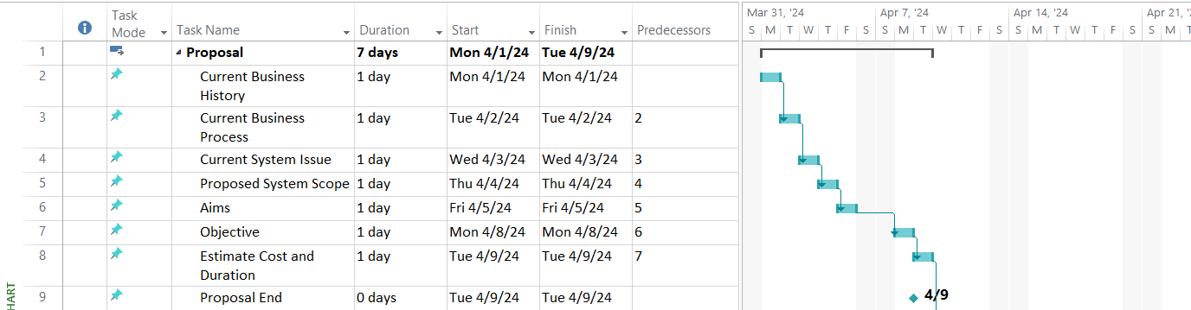

Fig (1) Project Proposal

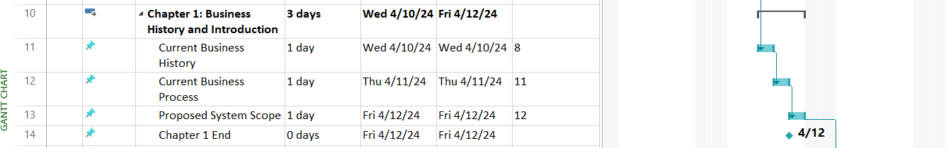

Fig (2) Introduction

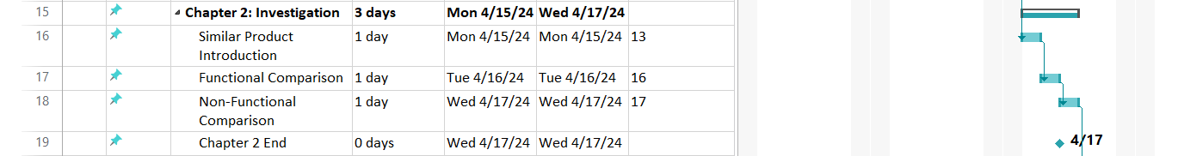

Fig (3) Investigation

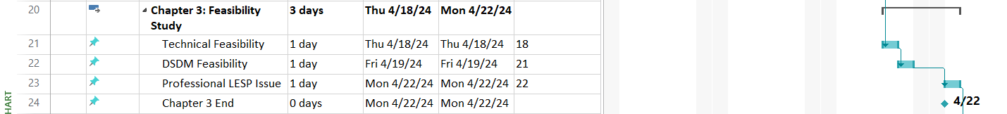

Fig (4) Feasibility Study

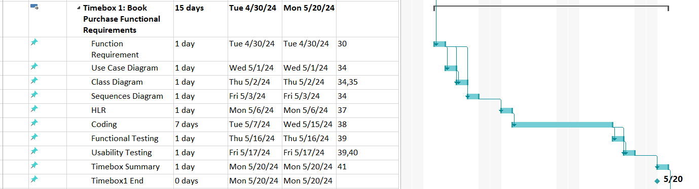

Fig (5) Functional Requirements for Time Box 1

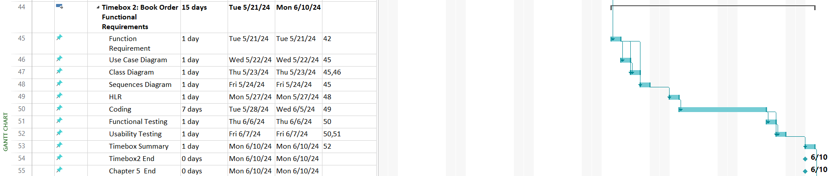

Fig (6) Functional Requirements for Time Box 2



Fig (7) Deployment

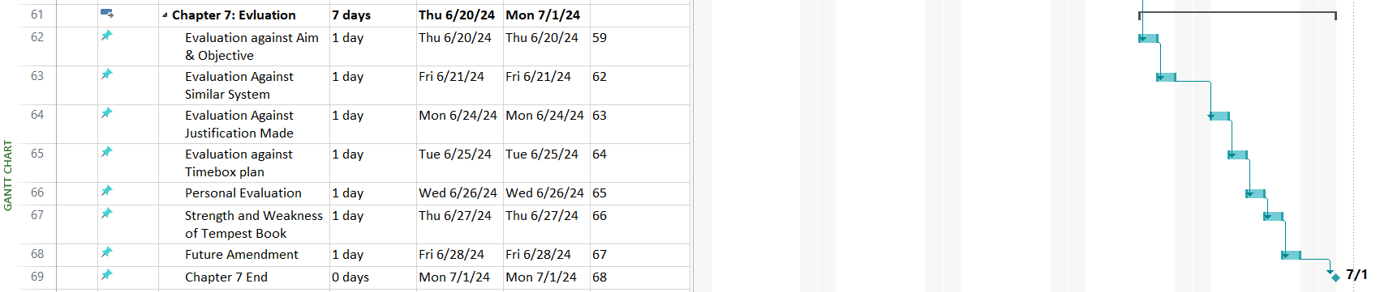

Fig (8) Evaluation

**Chapter – 1**

**Introduction**

# **Chapter 1 Introduction**

## **1.1 Background of the Current System**

### **1.1.1 History**

Tempest Bookstore is originally an online book shop which sell their products on social medias mainly on Facebook. The founder and co-founder started this business in 2020 during pandemic period. They started this business for the purpose of people to read book at home by buying books online. They originally sell comic books (mainly manga which is Japanese comic book) at the begin by targeting the younger users to read books while they bore. The founder wanted the youth to get knowledge during those pandemic periods. As soon as they got more audiences, they expand their business by bringing other book genres to their online store. They were able to aim other audience types too.

The founder has friends in US and Japan, so most of the books from US and Japan were able to sell on the store. When the store was selling booking on social medias, customers had to wait at least 2 weeks to get their orders since the founder had to purchase books from foreign. Co-founder help the founder with advertising, managing media accounts and customer support. After their physical store able to opened in 2022, the founder had purchase number of books from abroad and then re-sell those in their physical store. Then, hired stuffs to handle it. They connected with more suppliers and were able to expand their brand to various type of people.

Customers can buy most of Burmese books in physical store. The store still run on social medias and still purchase books for customers. They have lot of payment systems and fast delivery systems too. They provide most of payment that are using in Myanmar e.g. KBZpay, Wave pay, mobile wallet and other mobile banking. Cash on delivery system is also available but only for Yangon, Mandalay and Naypyidaw cities. Shipping services like Royal express, Mini express are also available for faster delivery. They deliver customer orders throughout most of the whole country but for some places which are not able to deliver with delivery services, they use government post offices.

### **1.1.2 Current Business Process**

**Registering Customer**

Whenever a customer comes to the store and buys a book, the cashier will write down the customer’s information (e.g. name, phone number, address) on the store’s ledger and a voucher for the customer.

**Registering Staff**

Manager will take responsibility for this process. He also acts like HR of the store currently. He will collect the data of staff and report it to admins. For the improvement of staff, manager and seniors will take the responsibility.

**Purchasing Books**

The store manager will report the monthly list to the admin team before the end of every month. The admin team will make contracts with suppliers and distribute books to the store monthly. This process depends on monthly sales and will require risks, time, and responsibilities. Contacting with new suppliers will also be done by the admin team. After this process is finished, books will be distributed in the next month.

**Customer Ordering**

Customers will able to order books from online and manually. When they order books manually, the store staff will record the order data. If they buy from social media, admins will record customer’s information and order data.

**Advertising and Promoting Books**

Admins is currently responsible for this process. They will discuss before advertising or promoting. The founder will not do whether he likes to do. All the admins will talk about business strategies and will create interesting contents. After they decide tactics, advertisements or promotions will be on both social media pages and in the physical store.

### **1.1.3 Current System Issues**

**Storing Books**

Time arrangement always has a problem. Reports of re-stocking books, and adding new books are the most current issues that are happening. Listing and updating best sellers, and demanded genres are also minor problems.

**Disadvantages of Paperwork**

All these processes and procedures are written on paper. In this case, loss of physical documents, internal and external accidents, and security threats are critical factors to the company. The inability to save documents easily, challenges in the transportation of paperwork, and insider issues are also important factors that need to be considered.

**Registering Customer**

Manual processes are slower than using technology. Even basic office software knowledge is required using tools like Excel. Giving vouchers and receipts to customers is also slow which can cause inconvenience to them. Not only that but also saving their information will take step by step which will need more unnecessary staff just for that.

**Shipment Problems**

Whenever there is a small problem occurs in the stocking process (purchasing books), there will be a delay in shipment. Problems with customs, and delays because of transportation problems also happen sometimes.

**Uncommon Problems**

Worldwide financial problems, currency rate problems, inflations, and recessions are also problems that can affect a company’s business.

## **1.2 SWOT Analysis**

### **1.2.1 Strengths**

**Provide various books –** having lot of books will increase the good customer feedback and ability to find the wanted book at any time is what a book reader wants most. Even if customers cannot find their wanted book, they can contact to the store since the phone numbers are provided in the system.

**Supply Chain Optimization –** since the system can purchase books from suppliers at any time, books in stock management is assured.

**Customer Engagement Tools –** system provide good UI/UX features, good visualization for customers and even provide features for disable persons.

**Clear requirements –** having clear requirements can help reduce most of the time and most of their problems.

### **1.2.2 Weakness**

**Lack of technological knowledge –** although founders may know the system that will be using, most of employees are new to this OS system and web-based system.

**Internet Dependency –** the system depends on internet connectivity, users with poor connectivity may suffer those problems. Also, when the admins had a poor internet issues may have an impact on business.

### **1.2.3 Opportunities**

**Improve efficiency –** using computerized system will fasten all the transaction processes and be more accurate. And also keep information more secretly and systematically.

**Ability to expand business easily –** they can expand business using computerized system and those systems will also be able to developed into better versions.

**Increase Popularity –** since website can be browsed all over the world, they can achieve more customers and suppliers from world-wide.

### **1.2.4 Threats**

**Rapid technological innovations –** technologies are advancing rapidly in these days and without having ability to withstand with the trends can lead to downfall of the website easily.

**Employee resist to change –** even if they can catch up with the technology innovations, most of employees even admins cannot catch up with high level technologies.

**Network threats –** since this is computerized system, if they lack of network knowledges, the website can be attacked easily in many ways.

**Maintenance cost –** hosting costs and upgrading website or maintaining website will cost a lot.

**References for SWOT analysis**

(KENTON, 2024) (Schooley, 2024) (Peterdy, n.d.)

## **1.3 Proposed System Scope**

### **1.3.1 Filtering and editing purchase records**

This system will able to filter purchase records by date, product ID and product status. The records will also able to detailed checked and printed.

### **1.3.2 Create and record order**

Customers can easily create orders and able to check the order details before the payment stage. Those orders will be recorded and admins will able to check the customers’ orders and order details for confirmations but admins will not be able to edit those orders and order details.

### **1.3.3 Edit and delete data**

Admin will able to edit all the data that are related with the books. For example, they will edit the category, publishers, ISBN codes, authors information. They can also delete them when needed. Therefore, there will be all CRUD functions for all data for admin except manipulating customers’ data. Customers will also be able to do all CRUD functions while ordering books.

### **1.3.4 Create voucher**

The system will able to create a voucher for both purchasing and ordering. There will be a print button feature for this in the system. Using this feature in future, both admins and customers can confirm data about their purchasing and orders.

### **1.3.5 Filtering and searching**

Customers will able to search books by name. Or they can filter with categories, publisher since those both have group nature. Books can also be able to find with ISBN numbers and author names. With this function, customers can search books faster and reduce unnecessary time than searching books manually.

## **1.4 Aims and objectives**

### **1.4.1 Aims**

This system primary aim is for giving the convenience to customer. With the help of a website, customers will able to buy books whenever they want from anywhere. Also, the website will help admins to be able to check and analyze data.

### **1.4.2 Objectives**

#### **Analysis**

* Gather information (both internal and external interviews)
* SWOT analysis
* Similar product comparison
  + Functional comparison
  + Non-functional comparison

#### **Feasibility Study**

* Methodologies
* Programming Languages
* Choosing database

#### **Foundation**

* Functional requirements
* Non-functional requirements
* Prioritizations
* Time box planning

#### **Risk Analysis**

* Risk management
* Identification of possible risks
* Risk matrix

#### **Design**

* Develop use case and class diagram
* Develop ERD (entity relationship diagram)
* Develop Prototype (UI)

#### **Developing timeboxes**

* Coding

#### **Testing**

* Functional testing and iteration
* Usability testing and iteration

#### **Implementation**

* Deploying beta version
* Launching real version

## **1.5 Brief overview of the remaining chapters**

There will be more 6 chapters left in this documentation. The upcoming chapter is bout similar product comparison which will include functional comparisons and non-functional comparisons of 3 similar websites. Feasibility studies will be in chapter 3 which will include technical feasibility, DSDM feasibility, LESPI. Chapter 4 is about making foundation for the project. There will be functional requirements, non-functional requirements, MOSCOW prioritizations, risk managements, risk identifications, risk matrix and, critical success factors for the project.

**Chapter 2**

**Similar Product Comparison**

# **Chapter 2 Similar Product Comparison**

## **2.1 Similar product introduction**

In this chapter, three websites will be compared which are related with online selling system (e-commerce). They are shop.com.mm, ict.com.mm, and citymall.com.mm. Their designs and features will be compared each other and later be referenced in this project.

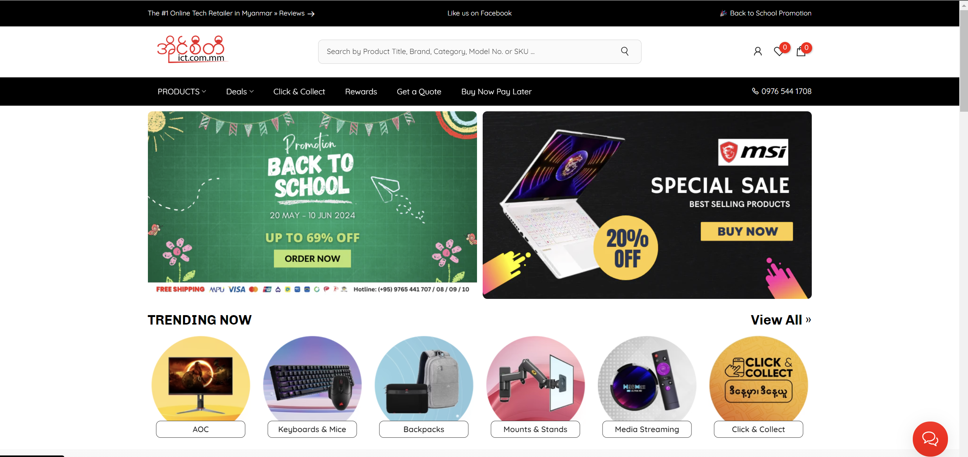

This is the home page of ict.com.mm.

This is well known e-commerce website in Myanmar. It provides all types of technology related things. The website is easy to use and has e-commerce related features. Customers can buy products and save it to cart and later before the payment step, they can edit their orders, choose payment methods, payment names, delivery types.

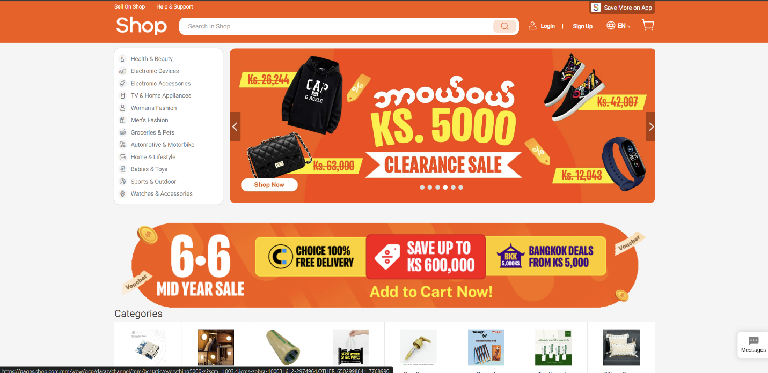

This is the home page of shop.com.mm.

It is most famous e-commerce website in Myanmar. Their functions, products, and services are well known. They provide functions which an e-commerce website should have. For example, real-time update, delivery systems, ordering system, rating items, provide various types of payment systems, well categorized items.

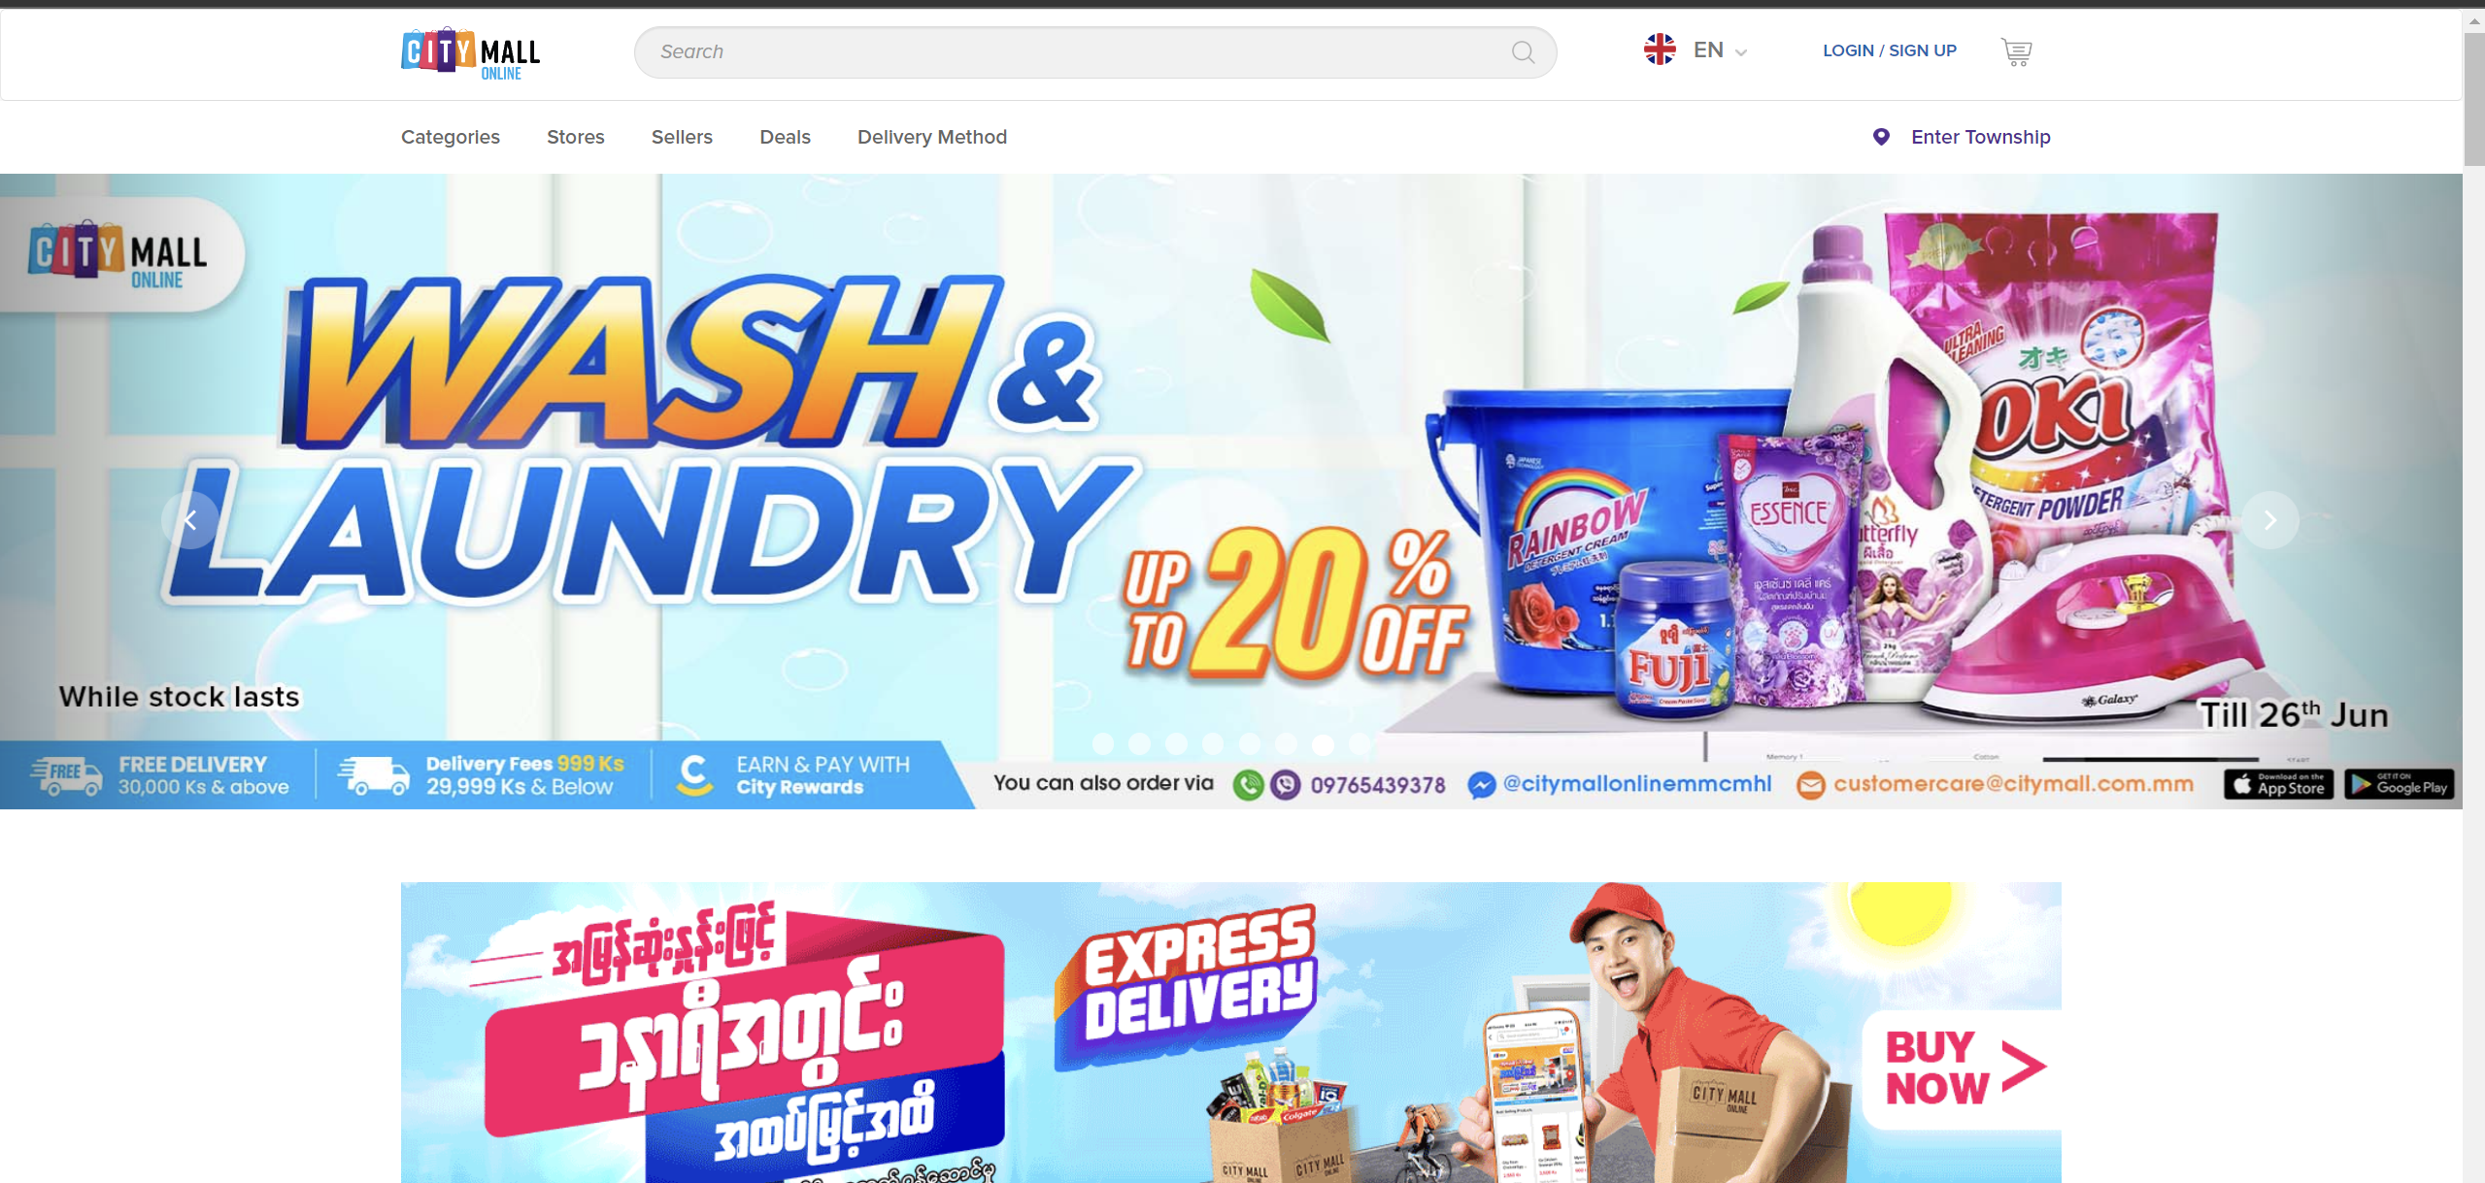

This home page of citymall.com.mm.

Citymall is a famous shopping center in Myanmar. Their website is also well known among the shopping centers. It provides enormous products including foods, home products, fashion related items, tech items, and so on. They also have main key factors of e-commerce system-based websites.

## **2.2 Functional Comparison**

### **2.2.1 Customer Registration Page**

Ict.com.mm

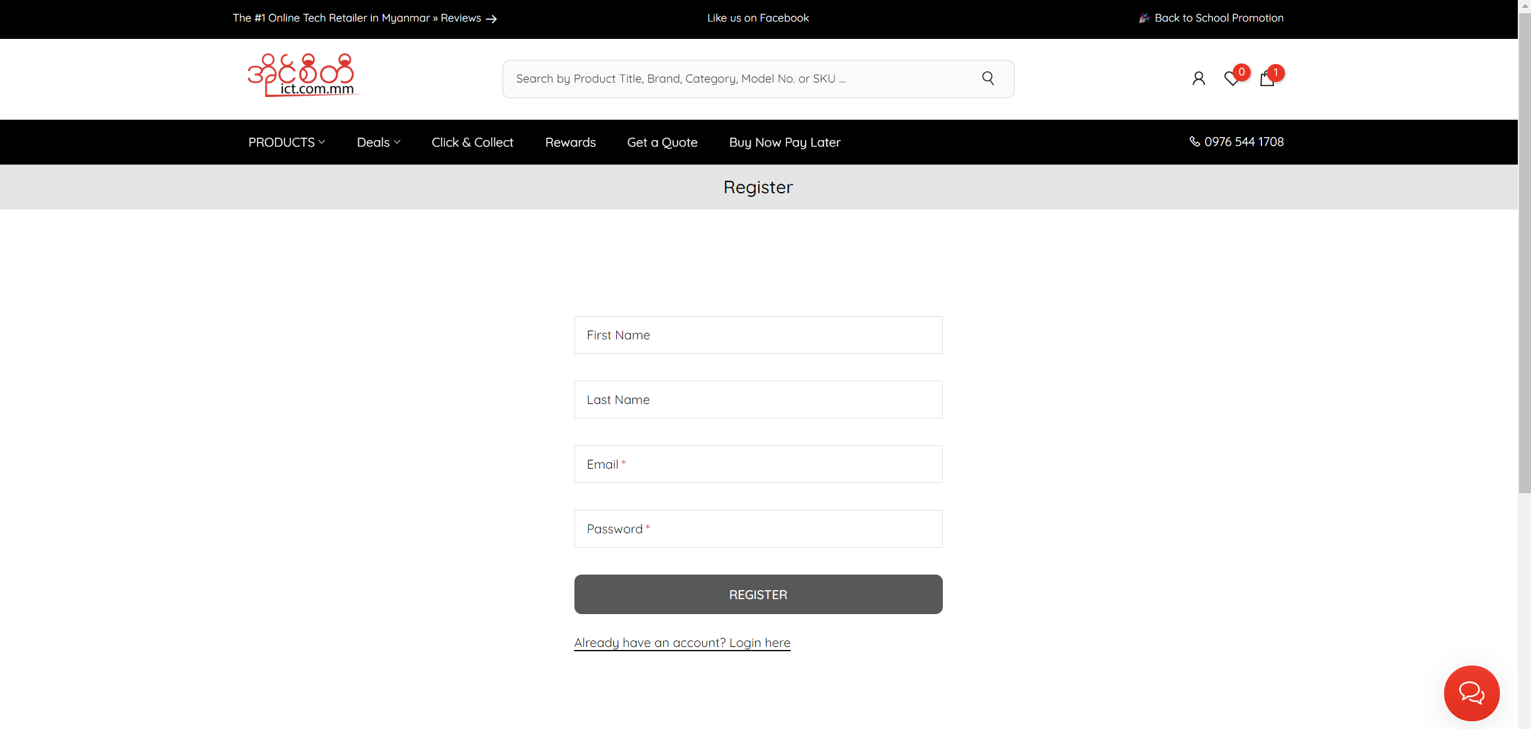

This is the customer registration page. User will need to submit the information to register an account. If the user already has an account, login page can be go through from the described link.

Shop.com.mm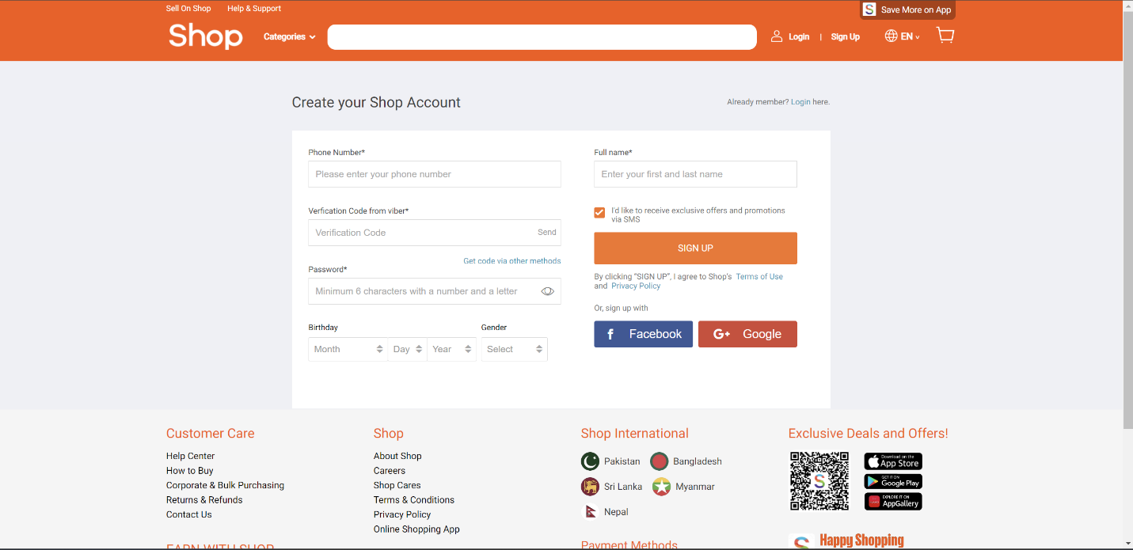

This is the registration page of shop.com.mm. user will need to submit the described information to make registration. The good feature of this website is that if user does not want to submit the information, user can use Google or Facebook account as a registration.

Citymall.com.mm

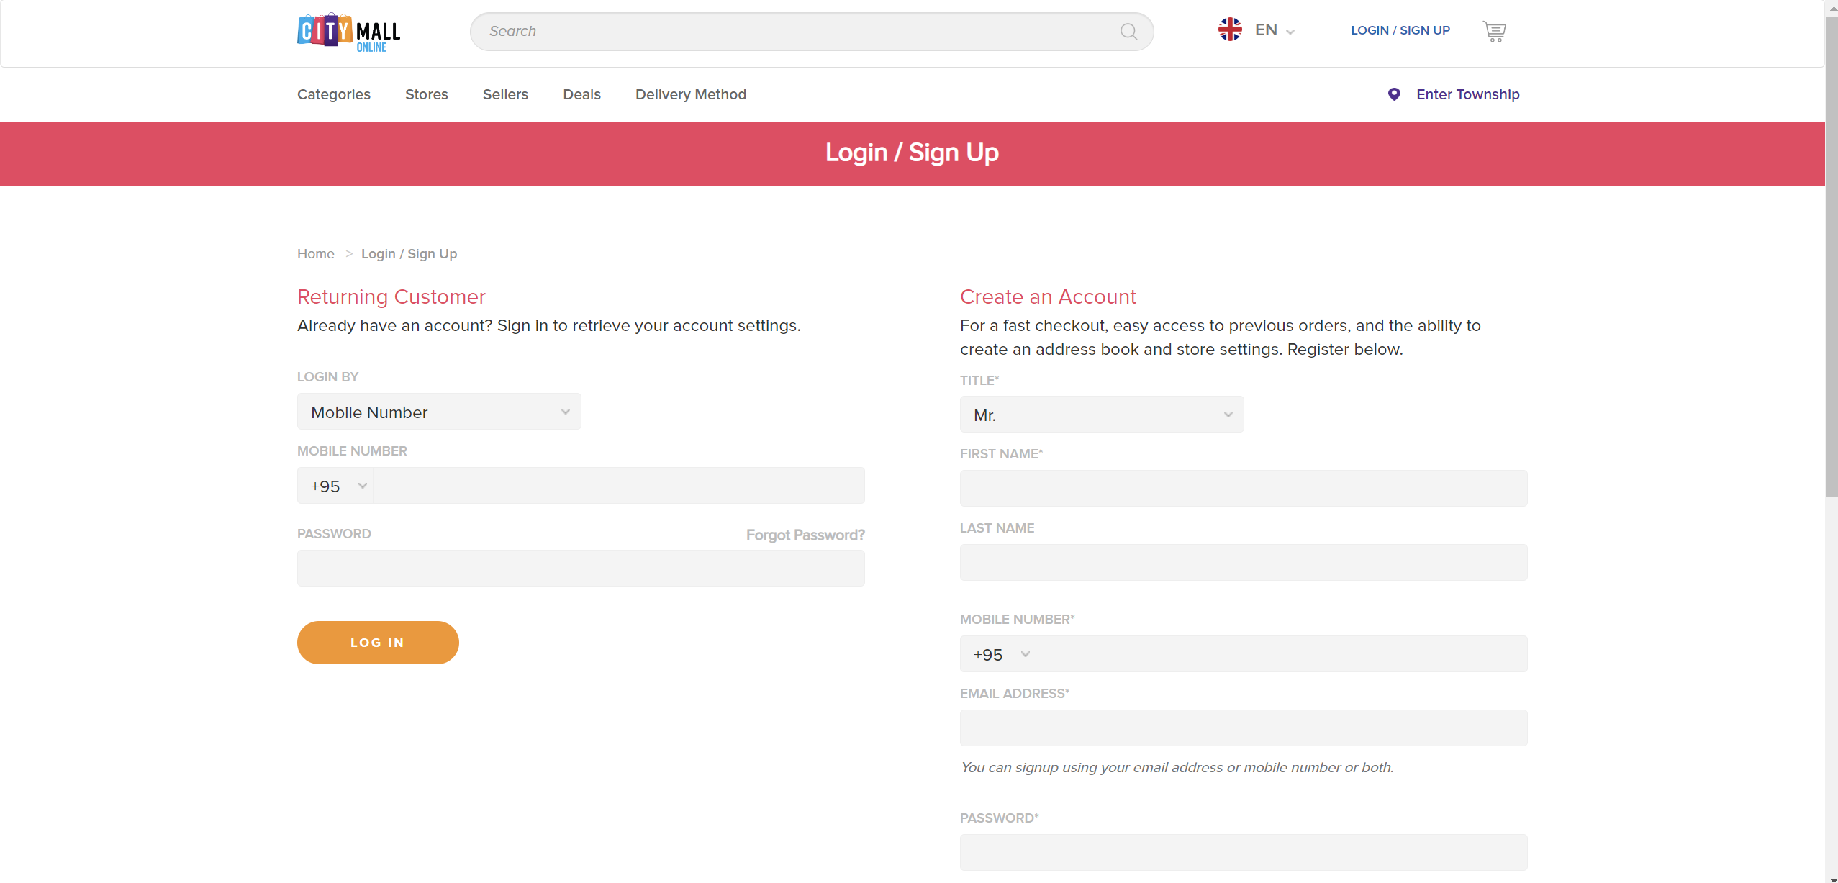

This is the registration page of citymall.com.mm. User need to submit the described information. After submitting, OTP (one-time password) key will be messaged in submitted phone number for the confirmation. After correctly submit OTP, account registration process of Citymall website is complete.

### **2.2.2 Login page comparison**

Ict.com.mm

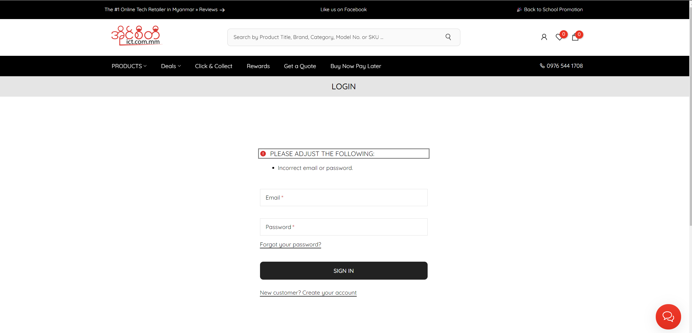

This is login page of ict.com.mm. User has to provide email and password. If they are correct user will able to make order process.

Shop.com.mm

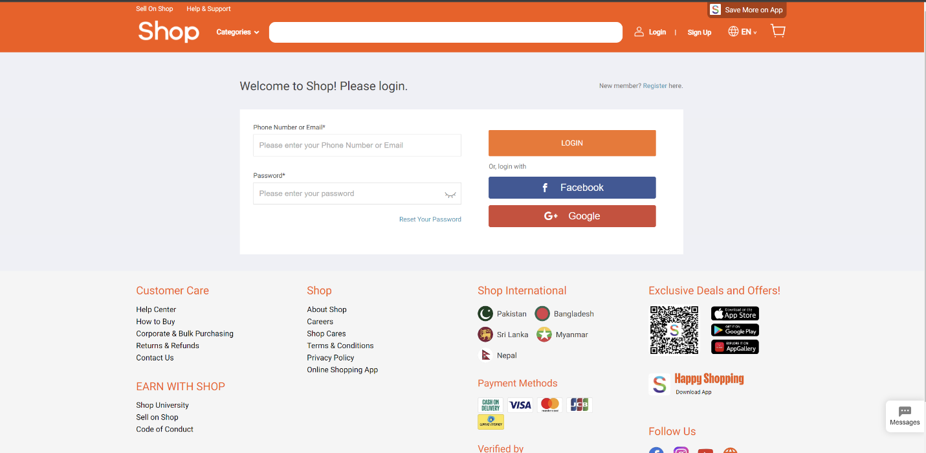

This is login page of shop.com.mm. User can enter email and password if account is made. Or user can use Facebook or Google accounts to login the website.

Citymall.com.mm

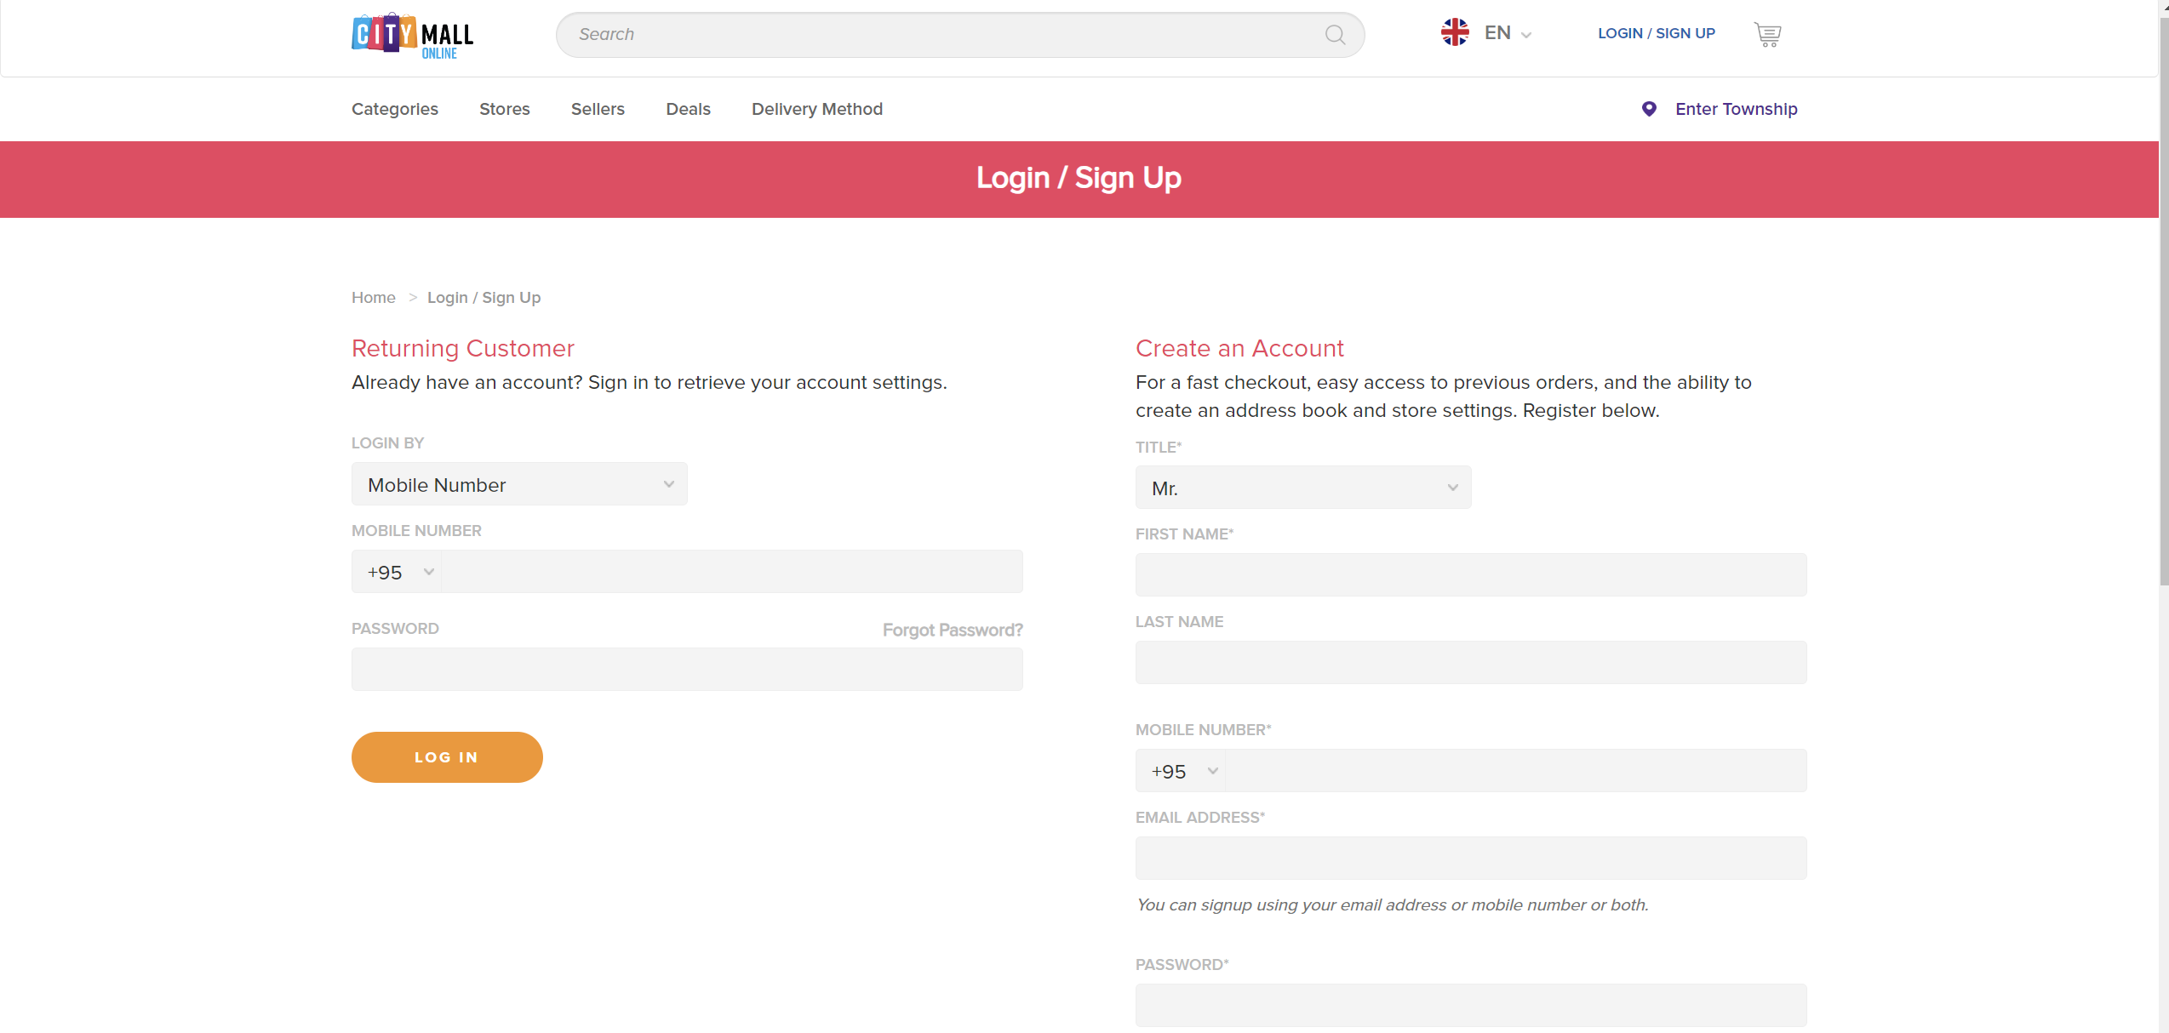

City mall website has the same page for login and account registration. User will have to enter mobile phone number and password. If they are correct, user will able to continue the order processes.

### **2.2.3 Order management pages**

This page normally called as a cart in e-commerce websites.

Ict.com.mm

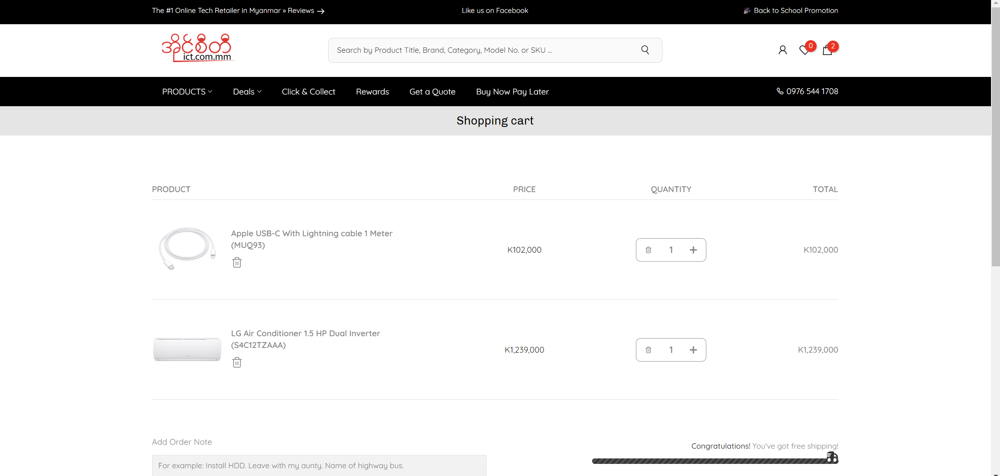

User can check the items bought in this place. User can also check the price and can add more quantity in this page.

Shop.com.mm

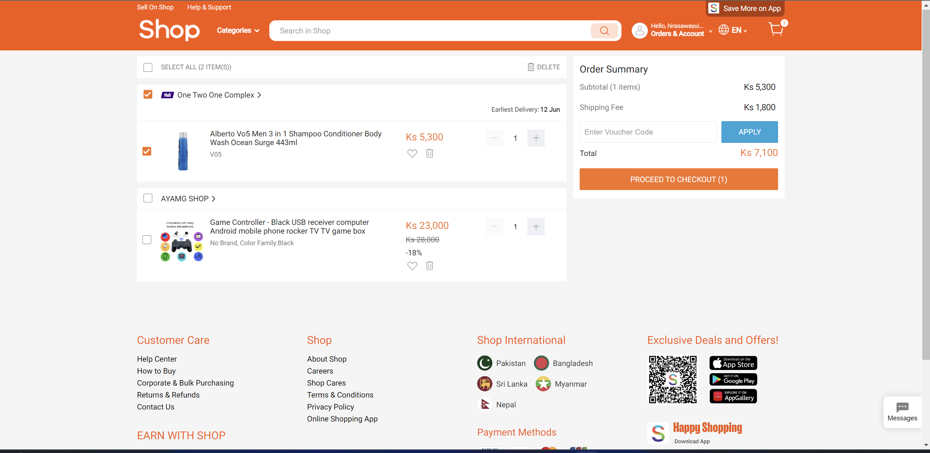

In this website, use can check the ordered items and can increase the quantity. Shipping fee is also included in this cart page.

Citymall.com.mm

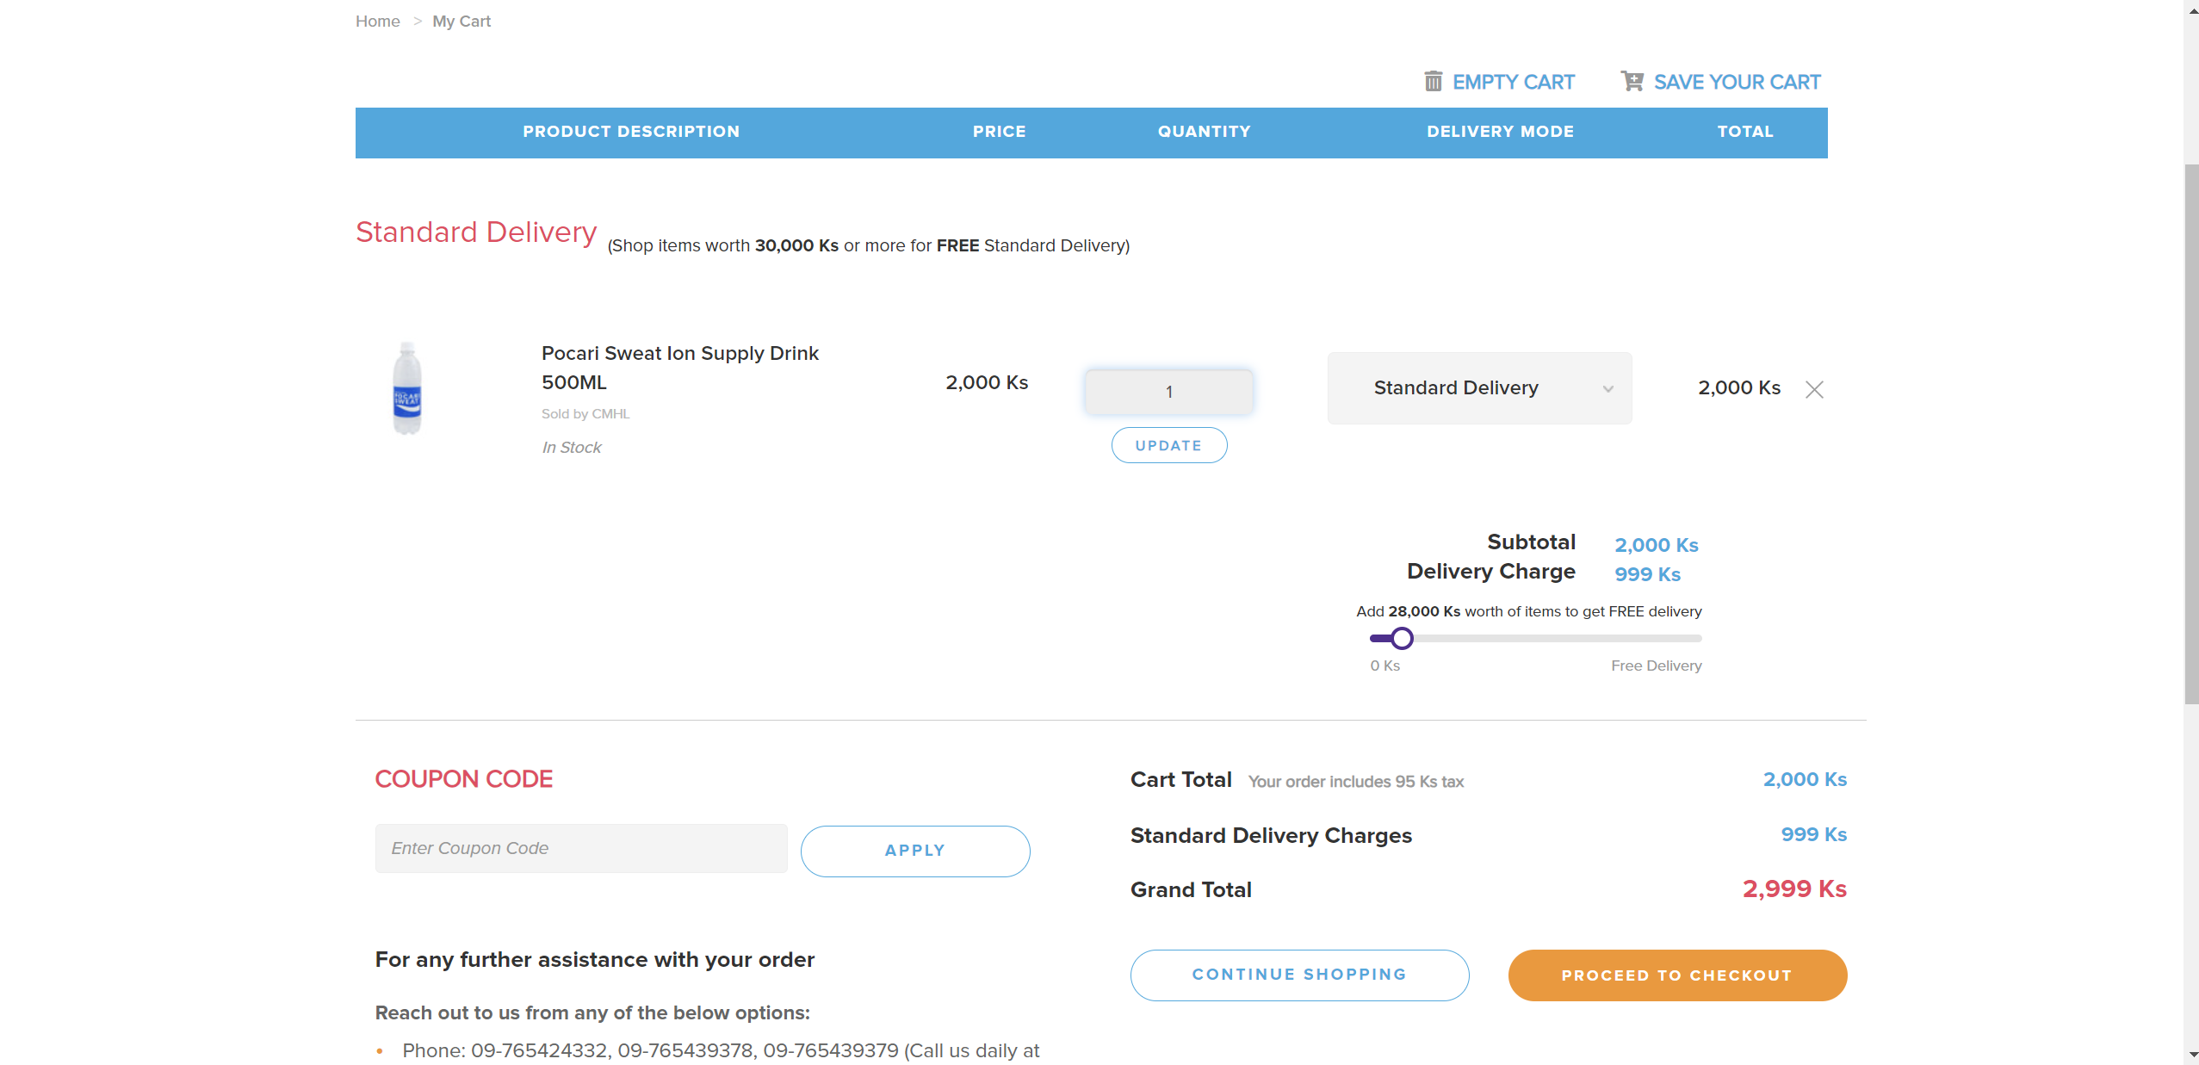

In this website when user wants to update the quantity, user have to enter the amount. There is also coupon code if user have their coupon while buying items in their shopping mall center. There is also standard delivery charge and grand total cost of orders.

### **2.2.4 Checkout page**

Ict.com.mm

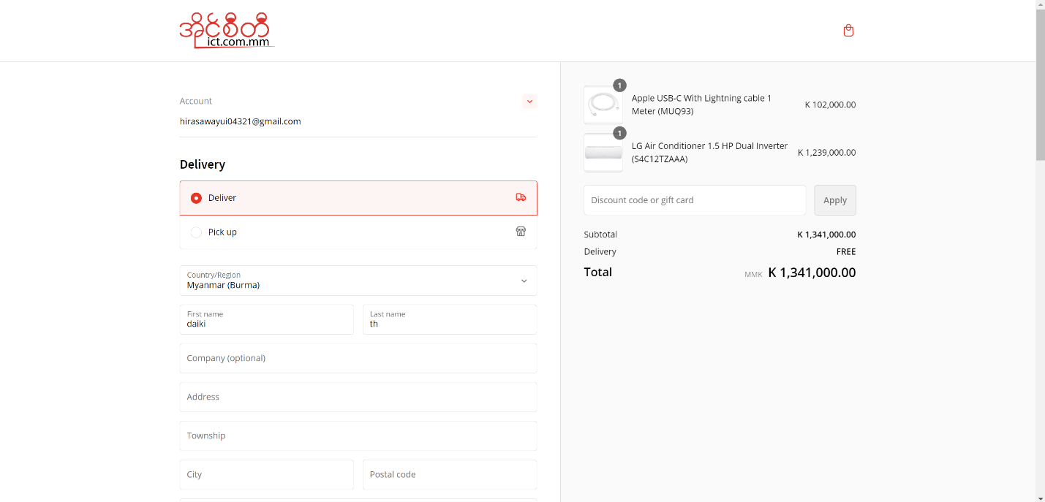

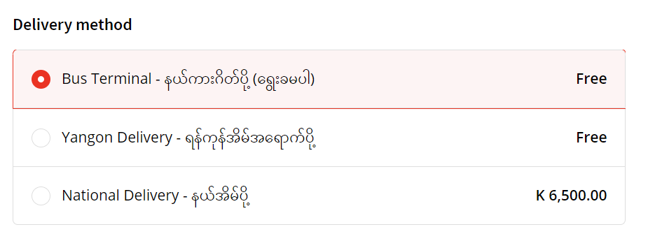

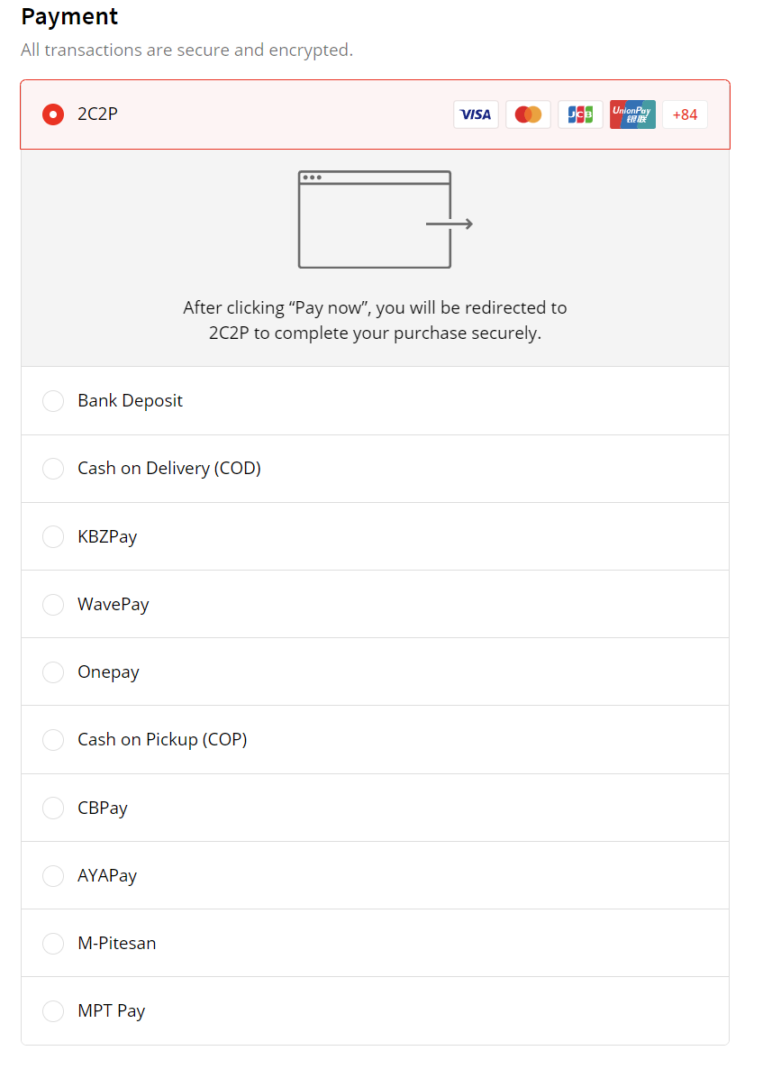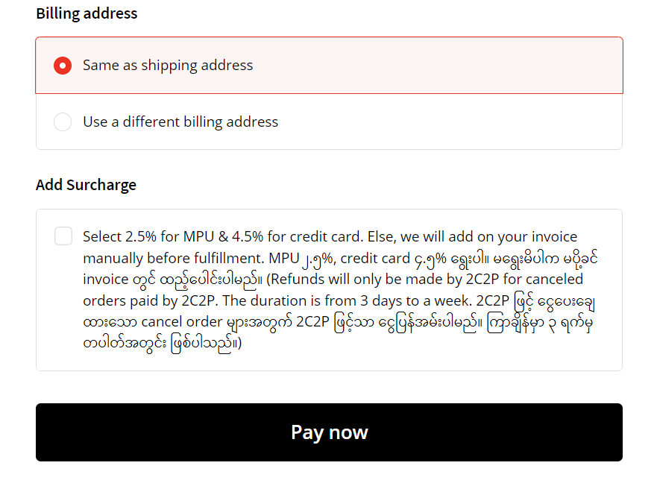

In this page, user can check the order list before doing the payment. In this website, user can choose whether he/she likes to choose delivery or pick up. There is location for user to add if deliver is chosen. There are also delivery methods, payment types,

Shop.com.mm

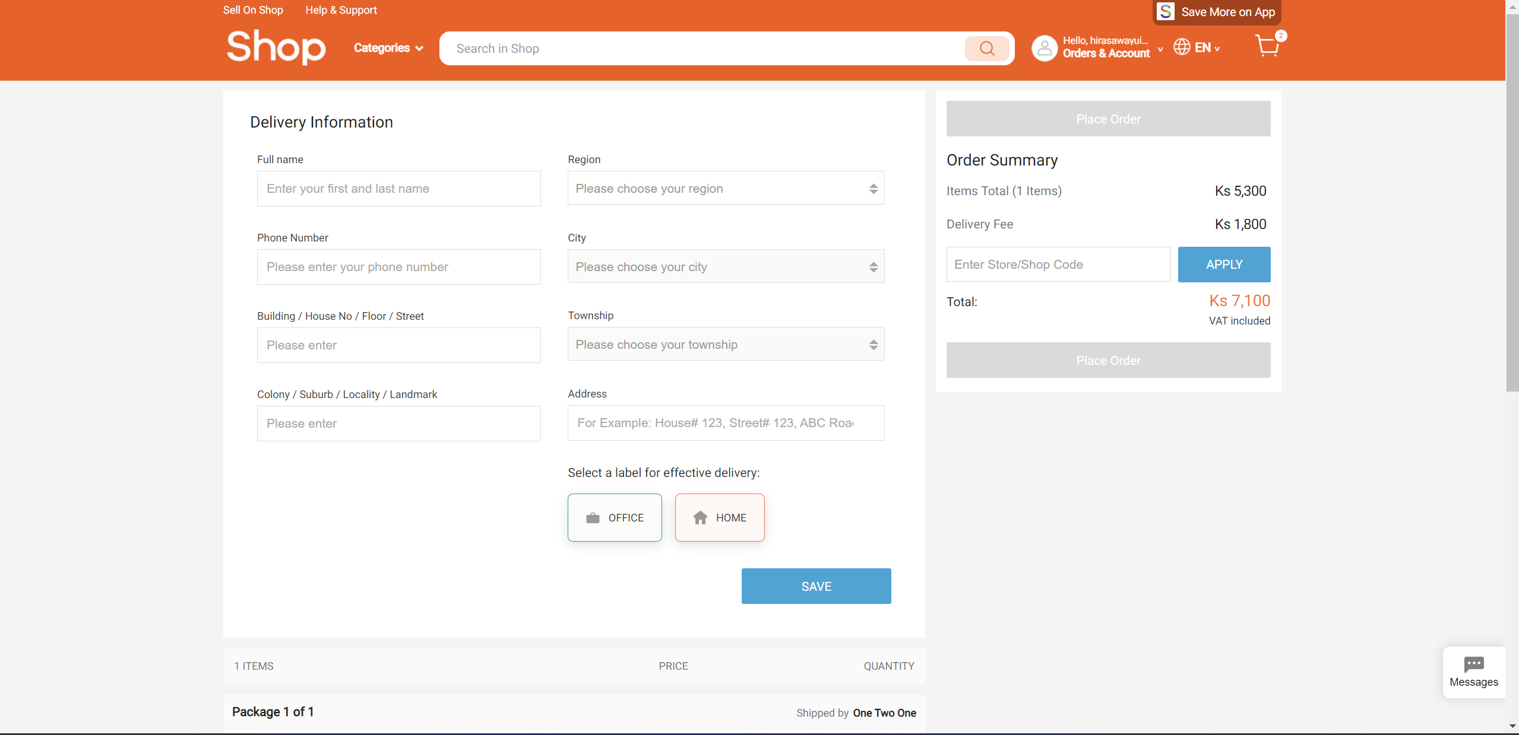

In this website, customer can final check the order and choose save to make order. All the total charges including delivery fees are described.

Citymall.com.mm

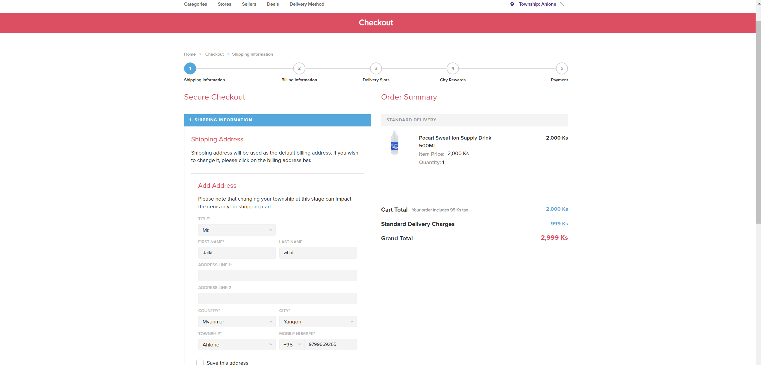

Customer will need to add name that wants to be delivered as. Customer will also add necessary information before making order payment and can able to check all the order status including delivery charges and prices before the payment.

## **2.3 Functional Summary Evaluation**

Each functional requirements’ best score – 5.

Worst score – 1.

|  |  |  |  |  |
| --- | --- | --- | --- | --- |
| **No** | **Function** | **Ict.com.mm** | **Shop.com.mm** | **Citymall.com.mm** |
| 1. | Customer Registration | 1 2 3 4 5 | 1 2 3 4 5 | 1 2 3 4 5 |
| 2. | Customer Login | 1 2 3 4 5 | 1 2 3 4 5 | 1 2 3 4 5 |
| 3. | Order Management | 1 2 3 4 5 | 1 2 3 4 5 | 1 2 3 4 5 |
| 4. | Check out page | 1 2 3 4 5 | 1 2 3 4 5 | 1 2 3 4 5 |
| 5. | Overall | 17 | 19 | 16 |

## **2.4 Functional Comparison Summary**

This is the functional comparison summary for 3 similar websites which are ICT, Shop, and Citymall. For Customer Registration although ICT’s UI is good but its UX is not that convenient to use that much and customers cannot use their Gmail accounts or other media accounts to register. While the other websites have that features and easy to use. Customer Login page is almost the same for all three websites. While order managing, Citymall website need to give more detail information for customer. The other two websites are good for that. ICT has the best check out page among them. It provides details information that customer will need to enter and also various type of payment information to choose. For the overall, they all have great features and necessary functions as an E-commerce website.

## **2.5 Non-functional Comparison**

### **2.5.1 Search Bar Comparison**

Ict.com.mm



Shop.com.mm



Citymall.com.mm



All three websites’ search bar are similar and their functions work similar too.

### **2.5.2 Language Change**

Ict.com.mm

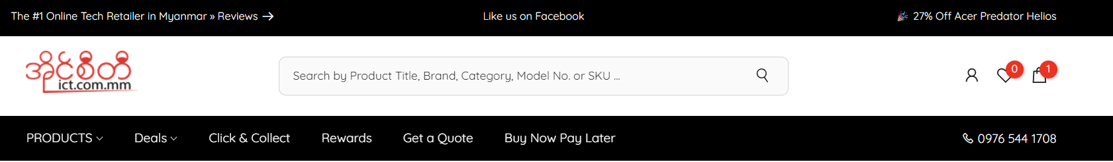

Shop.com.mm



Citymall.com.mm



Shop.com.mm and Citymall.com.mm provide language exchangeable system while Ict.com.mm do not provide it.

### **2.5.3 Shopping Cart**

Ict.com.mm



Shop.com.mm

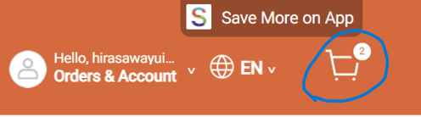

Citymall.com.mm

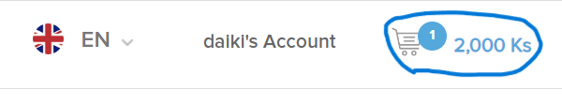

Ict.com.mm has simplest shopping cart design. And Citymall.com.mm even provide the amount in their shopping cart icon.

## **2.6 Non-Functional Comparison**

Each non-functional requirements’ best score – 5

Worst score – 1

|  |  |  |  |  |
| --- | --- | --- | --- | --- |
| **No** | **Non-Function** | **Ict.com.mm** | **Shop.com.mm** | **Citymall.com.mm** |
| 1. | Search Bar Comparison | 1 2 3 4 5 | 1 2 3 4 5 | 1 2 3 4 5 |
| 2. | Language Change | 1 2 3 4 5 | 1 2 3 4 5 | 1 2 3 4 5 |
| 3. | Shopping Cart Comparison | 1 2 3 4 5 | 1 2 3 4 5 | 1 2 3 4 5 |
| 4. | Overall | 8 | 13 | 14 |

## **2.7 Non-Functional Summary**

These three websites have unique designs and provide good non-functional features. ICT website has modern UI design. Shop website provide easy to use features for users. Citymall provides tons of product visualization on their website. Their search bars are easy to be found. But the language providing feature is not available in ICT. This feature is really important for people in Myanmar. For the shopping cart, Citymall is the best since it refreshes really quick and also provide the ordered amount which is convenient feature for the users.

# **Chapter 3 Feasibility Study**

## **3.1Technical Feasibility**

### **3.1.1 Methodologies**

**DSDM (Agile)**

DSDM is a dynamic system development method and has an iteration nature. It is a framework of an Agile methodology. It includes timebox plans, prioritizations of task (MOSCOW), collaboration, and iterations development. It can be used for long term and can be set budget and durations. There will also be user involvement in this method since it focuses on client’s requirements. Since DSDM is an agile framework, it is also flexible and has ability to accept changes easily. This method can also guarantee the final product quality and can be delivered right on time.

**Waterfall**

Waterfall is a traditional development methodology and has sequential nature. It was created and established in 1970 by Winston w. Royce. Waterfall has rigid structure and approach phase by phase. It has 6 phases and called as streams or phases and can move to another phase only after previous phase is completely finished. It is suitable for project with clear requirement and less changes. Waterfall emphasizes linear development which will need specific requirements and difficult to go back to previous phase. Unlike DSDM, it is not flexible and cannot handle many changes.

### **3.1.2 Strength and Weakness of each Methodology**

**Strength of DSDM**

**User involvement**

DSDM prioritize user involvement which can enhance the project faster by knowing the exact requirements. Not only this fasten the project, it also improves the final quality of the product and improve the relationship between the team and the stakeholders.

**Iterative and incremental development**

Having iterative and incremental natures is one of the reasons people use DSDM in modern days. Iterative nature helps the project by not wasting time whenever the error occurs. And Incremental nature increases the project by developing in parallel since it breaks downs into various structures.

**Flexible and quality assurance**

DSDM is highly flexible, adaptable and focus on final product quality. It accepts changes while maintaining the quality of the product.

**Streamlined error handling**

It can handle errors without delaying the other developments. In DSDM, testing is done in each stage and can solve the early errors even if they were found in final stage of the product.

**Extensible for future developments**

In DSDM, future developments, maintenance and product extensions are also considered and well-planned since the beginning of the project, it is created for future iterations whenever users want extend their product in the future.

**Weakness of DSDM**

**Documentation issues**

Since it has iterative nature, documentation updating problems are always occur in DSDM. Sometime there can be late documentations and report. And in sometimes, documentation is too much when the project dealt with lots of iterations.

**Dependency on user requirement**

DSDM depend and focus on user requirement a lot. Sometime this can occur lots of iterations. Also lacking user involvement can be risky for the final product.

**Costly implementation**

It starts with low cost and the longer the project takes, cost will be increase also. Iterations can also increase the cost and cannot able to predict the exact cost of the project.

**Unpredictable product result and scope**

Since the product will face the changes and iterations, the final product result cannot be predictable since the beginning. So, do the scope of the project can only be averagely predicted due to DSDM’s flexible and adaptive natures.

**References for strength and weakness of DSDM**

(airfocus, n.d.) (Shahrukh, 2022) (Product Plan, n.d.)

**Strength of Waterfall**

**Clear structure**

Since the beginning, every stages of the project are well planned and detailed. Project members can do their respective jobs within the planned time. It also can predict the final stages and product at the beginning.

**Predictable cost**

Plans and costs can be predictable in the early stage in Waterfall method. This could help the stakeholders to adjust the budget and can also help the members by knowing their exact salary.

**Emphasis on documentation**

This method focuses on documentation and deliver the final product to stakeholders with well-written documentation. Since there are less changes in the development, there will be consistent and clear documentation.

**Clear scope and goals**

In waterfall, aims and objectives are clearly defined in the beginning stage of the project. This could help the stakeholders know the final product. Knowing the exact goals can help the stakeholders to make clearer choices.

**Weakness of Waterfall**

**Inflexibility**

Unlike Agile base methodologies, waterfall is inflexible and unable to accept the changes easily. And once the scope is defined, it is mostly impossible to change and not suitable for projects that require changes and future developments.

**Lack of customer involvement**

Clients only involve in the early stage of the project since the client involvement is limited. This could cause the final product results may not meet with the client’s expectations.

**Lack of prototyping**

There is no prototyping until the late stages of the project since its development progresses in a linear fashion. This could be troublesome when there is misleading between clients and developers.

**Late defect discovery**

Testing in waterfall usually occurs only after development stages. So whenever a defect or an error occurs, there will be huge problem since it is hard to change and whenever a change is occurred, the whole development will restart again.

**References for strength and weakness of Waterfall**

(solo innovator, n.d.) (Aiden Gallagher, 2019) (tryqa, n.d.) (lucidchart, n.d.)

### **3.1.3 Comparison of Methodology**

|  |  |  |
| --- | --- | --- |
| **Criteria** | **DSDM (Agile)** | **Waterfall** |
| Size | Suitable for any project of any business. | Suitable for projects with clearly defined detail requirement and fewer changes. |
| Timeline | Provides developments and supports until the project is decomposed. | The exact timeline of the project is defined and documented. |
| Flexibility | Is flexible and adaptable. Can accept changes and able to adjust with client’s needs. | Since aims and objectives are predefined, changes may not be done easily. |
| User Involvement | User involvement is important and user may be able to involve in every stage for better product quality and make sure it meets the requirements | User involvement is only in the early stage of the project. Unless there is an emergency conditions, user or owner may not involve in the project |
| Budget | The cost is vary depending on the changes and timeline of the project which may include future business extensions and maintenance. | Since a clear budget is defined at the beginning of the project, it is suitable for fixed budget projects. |

### **3.1.4 Recommendation Methodology**

**DSDM**

For a website like ‘Tempest Books’ would be preferred with DSDM. There will lot of changes in the future for example, design changes, adding new features and functions for customers. Also, as the business becomes larger, there will be further improvements in the product. DSDM can able to provide the changes while maintaining the old system which would be suitable for E-commerce websites. Also, there is testing in every stage and involves risk managements, CIA of customer information and business information is secured which would be good for reputation of business. Therefore, DSDM is suitable for the current project and can guarantee that its final result will also meet owners’ satisfactions.

### **3.1.5 Programming Languages**

**PHP**

PHP is widely used in web development and an open source scripting language. It is easy to write the server-side scripts for dynamic web pages and compactable with various databases like MySQL, PostgreSQL and others. It also easy to understand and most of the website are built with PHP and many developers can understand and able to use PHP language. It also has powerful framework like Laravel. It also provides good security features like data encryption, secure authentication methods, and protect vulnerabilities against SQL injections and XSS attacks. In summary, PHP is ease to use, cost effective, has powerful features and robust frameworks, and extensive community support made it one of the most popular language choices for building dynamic and iterative web applications.

**Java**

Java is a compiler language and also platform independence since it can run on any device that has Java Virtual Machine. It is popular for its scalability nature and widely used in large-scale web applications and also has robust frameworks and libraries that helps in building complex projects. Java may not be as lightweight as other languages. But advancements in JVM, compiler technologies and having frameworks like Spring, Hibernate make Java popular in enterprise level applications and still using. Java also has great security features like build-in security manager, cryptography APIs, and authentication mechanisms. In summary, Java’s scalability, versatility, reliability, performance, and strong ecosystem make it also reliable and demanded language for enterprise-level web applications.

### **3.1.6 Strength and Weakness of each Programming Languages**

**Strength of PHP**

**Database support:** PHP support for various databases such as MySQL, PostgreSQL which are commonly used in web development. It integrates seamlessly with MySQL by using PDO extensions.

**Flexibility:** PHP is highly flexible and versatile. It can be combined with other programming languages like JavaScript and HTML to create front-end dynamic pages. And it supports multiple programming paradigms so that developers can choose appropriate approach.

**Cost-effective:** PHP is open source and its frameworks and libraries are also open-source. Also, XAMPP and WAMP like database software packages and RDBMS like MySQL and PostgreSQL which are also open source.

**Vast Ecosystem:** PHP has a large ecosystem of frameworks. Most popular framework like Laravel and also has many libraries. And they are also open-source.

**Weakness of PHP**

**Poor security:** Inexperienced code writings and outdated practices can harm the system easily. Issues like SQL injections, and XSS (cross-site scripting) can occur if codes are not detailed written.

**Less support for modern development practices:** PHP not always support for latest and advanced features like other programming languages do. For example, JavaScript’s frameworks like React, Next.js and Vue.js have more features and interactive, real-time applications.

**Emphasizing only web development:** While PHP may be good choice for web development, it may not be as good as other programming languages when using for different purposes. For example, data science, data mining and machine learning. Also, there are more useful, and robust frameworks and libraries in other programming languages.

**References for strength and weakness of PHP**

(epamanywhere, 2024) (geeksforgeeks, 2022)

**Strength of Java**

Platform independence: Java can be run on any device that has a Java Virtual Machine (JVM) without depending on OS. This makes Java portable while being a popular choice for learners and developers.

**Rich APIs:** Java has extensive libraries and enormous APIs specialized for each task. For example, utilities, networking, and I/O, etc. Although Java may be hard but by using those APIs can help faster and easier to develop a program.

**Scalability and Versatility:** Java is mainly used in enterprise-level programs but also suitable for small programs. Not only Java is scalable but also versatile including web, mobile, enterprise, cloud-based, big data and etc.

**Numerous frameworks and libraries**: Java provide many frameworks specialized with each field. For example, Spring for web, Hibernate for ORM, Spring Cloud for microservices and clouds, etc. This makes Java a good choice even in modern days.

**Weakness of Java**

**Complexity:** For some learners Java is hard and complex to learn since it has harder syntax than other languages like JavaScript and Python.

**Memory Consumption:** Java require significant memory space and take more memory usage than any other languages.

**Performance:** Java has poor and slower performance than native languages like C, C++. This is due to memory consuming, garbage collection, and runtime environment.

**References for strength and weakness of Java**

(data flair, n.d.) (geeksforgeeks, n.d.) (Rafalski, 2023)

### **3.1.7 Comparison of Programming Languages**

|  |  |  |
| --- | --- | --- |
| **Criteria** | **PHP** | **Java** |
| Learning and Syntax | Has easy and simple syntax especially for web development. And also, a good choice for beginners | Complex syntax and hard to learn. Object oriented principles will require a lot. And may take more to become proficient. |
| Use Cases | Suitable for small to medium web development. | Prefer for large-scale and enterprise level development. |
| Frameworks | Has popular web frameworks such as Laravel, Symfony, and CodeIgniter. | Has robust frameworks like Spring, Hibernate, and JavaServer Faces (JSF), and widely used in enterprise environments. |
| Community and support | Has large and active community providing resources, forums and libraries | Has strong community with extensive documentation, libraries especially for large-scale enterprise level. |
| Security | Known as weak security vulnerabilities in past but modern frameworks emphasize security. | More secure due to strong type system and include exception handling and emphasize security. |

### **3.1.8 Recommendation of Programming Languages**

For small e-commerce system website like ‘Tempest Books’ PHP would be a better choice. Since they will need to add more functions and changes in future. For example, design changes, adding new functions, improving user experiences. Also, PHP is easy to understand and able to write HTML, CSS in one file. PHP is more flexible in web development due to simpler syntax, dynamic typing, and ease of integration with web servers. And PHP is easier to deal with web hosting since it has wider range web hosting options than Java. It is easier to add more functions and changing in PHP than making changes in Java. Robust framework like Laravel is also available to support PHP. Moreover, developing with PHP is more cost effective and fewer time consumption and better suitable with DSDM method than Java.

### **3.1.9 Databases**

**MySQL**

MySQL is an open-source relational database management system (RDBMS) which can be used for data organizing and management. MySQL is one of the most popular database systems and being open-source helps has large community support. It is based on structured query language (SQL) that allows user to manipulate and manage the relational database (having tables and relations). MySQL is used with programming languages like PHP, Python, Java and others to create dynamic web systems. It uses client-server architecture letting user perform database related processes from graphical user interface (GUI). MySQL is used in various environments where easy data storage and retrieval are needed and widely used in content management system (CMS), e-commerce platforms, and data warehouses.

**MongoDB**

MongoDB is a popular open-source NoSQL database that store data in JSON (non-relational) document. Unlike relational databases, it uses collections (which are analogous to tables) and documents (similar to rows, but in JSON-like format) to store data. MongoDB is widely used in modern web applications and suited for content management, real-time analytics, mobile application and more. It is also flexible and scalable and fast iteration life cycle since it uses schemaless design. MongoDB has a large and active community support and provided by rich ecosystem of tools and libraries.

### **3.1.10 Strength and Weakness of Databases**

**Strength of MySQL**

**Ease of use:** MySQL is well-known for its ease of installation and configuration. It is a popular for starters to learn databases since it uses relational database management system.

**Performance:** It is optimized for speed and has ability to perform under heavy loads and high-volume transactions. It is better when the databases are properly managed and structed.

**Flexible and versatile:** it supports on various platform and different operating systems. It can also be used in many different environments for various purposes. It is also compactable with many programming languages.

**Scalability:** when is well-structed and designed, it can handle increasing amount of large data as the system grows.

**Weakness of MySQL**

**Limited features:** MySQL historically had a large gap in functionality compared to other database systems although recent versions, add more functions and features to close up with the gap.

**Security:** its security features has been improved but still well-known for being vulnerable. Security threats may occur if it is not well-structured, configured and maintained. Regular update must be needed for security.

**Concurrency:** MySQL needs to be well-configured to handle large and complex data. If not performance problems like bottlenecks may occur and unable to run under heavy load.

**References for strength and weakness of MySQL**

(blue claw database developer resource, n.d.) (patches, 25)

**Strength of MongoDB**

Scheme-less design: MongoDB use flexible schema storing with JSON document. This make easier in dynamic evolutions and migrations.

Rich query language: It supports powerful query language allowing to use complex queries, aggregation pipelines (sequence of data), and indexing.

Scalability: It can handle large amounts of traffic and data. And allows for data distribution of data across clusters. MongoDB is suitable for a wide range of use cases and have high performance.

**Weakness of MongoDB**

**Memory usage:** MongoDB consume more memory compared to relational databases. This may due to indexing which are stored in memory, caching mechanisms and in-memory storage engine which will utilize RAM to improve performance.

**Limited SQL support:** it uses its query language which is Mongo Database Language (MQL). This requires to learn new syntax and techniques if transitioning from a relational database like a startup.

**Complexity:** Using MongoDB can be complex in operations such as monitoring, maintenance, and robust backup. This may due to sharding and replication of data clusters which means its distributed architecture.

**References for strength and weakness of MongoDB**

(knowledgenile, n.d.) (Colos, 2023) (Narayanan, 2015)

### **3.1.11 Comparison of Databases**

|  |  |  |
| --- | --- | --- |
| **Criteria** | **MySQL** | **MongoDB** |
| Flexibility | Need predefined schema with tables and columns. Schema changes may be complex. | Scheme-less and can have collection of different structures, flexible for evolving data models. |
| Use Cases | Used in e-commerce platform, financial applications, CMS which require complex queries and transactions. | Used for rapidly changing data models or unstructured data such as real-time analytics, mobile applications, IoT. |
| Performance | Optimized for structured data and ACID compliance, ensuring consistency and transactional workloads. | Faster read write operations when dealing with unstructured or semi-structured data. |
| Community support | Has mature and extensive community. | Has growing community and rich ecosystem. |
| Size | Suitable for small and medium sized enterprises. | Can be used in large and enterprise applications. |

### **3.1.12 Recommendation of Databases**

For a medium-sized e-commerce website like 'Tempest Books', MySQL is a more suitable choice over MongoDB. Business requirements do not need complex queries and will need data consistency and integrity. Also, further developments will not need that much update in database. Maintaining data and their security is crucial for establishing customers' trust in the business. MySQL is easy to use and already familiar with the developer team. All these factors make MySQL suits for this project.

## **3.2 DSDM Feasibility (DSDM eight principles)**

### **3.2.1 Focus on the Business Need**

Project member leaders will focus on user requirements and prioritize the tasks. they need to analyze what they need most, and what the business needed. they will need to identify and set their aims and objectives in meetings.

### **3.2.2 Deliver on Time**

They will need to finish their daily, weekly tasks based on Gantt chart. Gantt chart is used to clarify the durations and deadlines of each tasks of the whole project.

### **3.2.3 Collaborate**

Joint meetings weekly meetings, daily checkup meeting will be applied for user involvement, collaboration and to increase members effective activities.

### **3.2.4 Never Compromise Quality**

Testing ensures a function meets its functional requirements. Testing should be done after designing, system changes and after task combinations. Those testing are essential for the final product's quality.

### **3.2.5 Build Incrementally from Firm Foundations**

Requirements will be broken down into timeboxes and will be prioritized into levels. During those steps considering incremental requirements will also help the project works incrementally. For example, design changes or adding new functions.

### **3.2.6 Develop Iteratively**

After one timebox is finished, testing, evolution and review will be done for future developments or refinements, ensuring ongoing project success.

### **3.2.7 Communicate Continuously and Clearly**

Meeting with stakeholders will need frequently. project members will also communicate continuously (for e.g. early meetings) get clearer objectives and work progresses with the help of visualized diagrams and clear documentations.

### **3.2.8 Demonstrate Control**

There will be a demonstration to get reviews and feedback from stakeholders after each timebox is finished.

(Petit, 2024) (Buehring, 2023) (agilebusinessconsortium, n.d.)

## **3.3 Possible LESPI (Legal, Ethical, Social and Professional) Issues**

### **3.3.1 Legal Issues**

**Data Protection**: Data transactions, product detailed information, purchase and order information will need to be secured. Leaking information can ruin the reputation of the company’s image. Also, leaking information like these will be illegal and against the laws.

**Taxes**: The company must pay the necessary taxes. Avoiding taxes can be suited and ruin the company business. Not only physical store’s taxes but also technical taxes must be paid. Also, customers must pay taxes for buying products.

**Using for Illegal Purposes**: Some staffs may be using website for illegal purposes such as taking customer information, selling illegal things, prohibited products, sharing false information can be problem. The admins must sure their employees don’t use the website for illegal purposes.

### **3.3.2 Ethical Issues**

**Intellectual Property**: System’s source code must be protected. While using system avoiding copyright, trademark, and patent data is also crucial. If they must be used giving proper credit to the owners will be needed.

**Privacy**: Some employees will be able to use the system like admins. But they must not search the customer account information and admin account information. These accounts contain important and valuable data, checking their information can break the privacy.

**Weak Security**: Having weak security can lead information to be leaked easily. This is big problem and have highest risk. This can loss customers and ruin the business completely.

### **3.3.3 Social Issues**

**Digital Divide**: Some stuffs including admins may not be able to use the system diplomatically. They will need digital literacy and make sure they know how to use the system safety and diplomatically.

**Online Behavior**: Since the system is based online, there will be bad reviews, misinformation about the business and the system, and cyberbullying can happen as the system become popular.

### **3.3.4 Professional Issues**

**Collaboration**: Suppliers’ collaboration will need for further growth but in some case, they can act unprofessional acts which is not informing the company about stopping the collaboration. So, do the vice versa for the admins to suppliers. This kind of acts should not be happened.

**Leaking Information**: Company must need to make agreements with suppliers and stuffs to maintain the information of the business even they are not related to company anymore.

# **Chapter 4 Foundation**

### **4.1 Target User**

|  |  |  |  |
| --- | --- | --- | --- |
| **Type of User** | **Age** | **Computer skill/ Technology Literacy** | **Language skill**  **(having English skills would be better)** |
| Admin | 25-40 | Must have basic knowledge of technology and business-related technologies | Must understand technological terms and business terms |
| Suppliers | 30-50 | They need to understand email usage and basic website usage | Must understand business English |
| Customers | 15-70 | They will need to understand technological terms to use website | They can use language translation feature but understand English and tech terms would be better |

## **4.2 Functional Requirements**

### **4.2.1 Manage Book Purchase Functional Requirement (Time box 1)**

1. Manage Admin (HL)

* Register account (ML)
  + Account already exists - Email checking (LL)
  + Password length check (LL)
  + Check input fields null (LL)
* Login (ML)
  + account authentication checking (HL)
* Logout

1. Purchase Order Management (HL)

* Create Purchase Order (ML)
* Update Purchase Order (ML)
* Read Purchase Order (ML)
* Delete Purchase Order (ML)

1. Manage Supplier (HL)
   * Register (ML)
     + Account already exists - Email checking (LL)
     + Password length check (LL)
     + Check input fields null (LL)
2. Manage Book (HL)

* Purchase Book (ML)
* Book Quantity (ML)
* Wholesale Price (ML)
* Cancel Purchased Books (ML)

### **4.2.2 Manage Book Order Functional Requirement (Time box 2)**

1. Manage Customer (HL)

* Register account (ML)
  + Account already exists - Email checking (LL)
  + Password length check (LL)
  + Check input fields null (LL)
* Login (ML)
  + account authentication checking (LL)
* Logout (ML)

1. Manage Book (HL)

* Order Books (ML)
* Cancel Ordered Books (ML)
* Number of Books (ML)
* Retail Price (ML)

## **4.3 MOSCOW Prioritization**

|  |  |  |  |  |
| --- | --- | --- | --- | --- |
| **Functional** | **Must** | **Should** | **Could** | **Would** |
| Manage Purchase |  | - | - | - |
| Manage Order |  | - | - | - |
| Manage Books |  | - | - | - |
| User Authentication |  | - | - | - |
| Searching and Filtering | - |  | - | - |
| Manage Supplier | - |  | - | - |
| Manage Category | - |  | - | - |
| User Reviews and Rating | - |  | - | - |
| Loyalty Program | - | - |  | - |
| Customer Account Leveling | - | - |  | - |
| Ads | - | - | - |  |
| Cryptocurrency Payment | - | - | - |  |

### **4.3.1 Must**

|  |  |
| --- | --- |
| **Must** | **Justification** |
| Manage Purchase | It is a must for managing the purchasing books from suppliers. |
| Manage Order | It is necessary for both customers and admins to manage order information. |
| Manage Books | It is crucial to manage books data. For example, price, categories. |
| User Authentication | It is important and essential function for login into website. |

### **4.3.2 Should**

|  |  |
| --- | --- |
| **Should** | **Justification** |
| Searching and Filtering | This should be included in website for faster searching of books. |
| Manage Supplier | The admin should be able to manage and contact with supplier for performing and confirming of purchases. |
| Manage Category | It should be included for better searching and managing of books. |
| User Reviews and Ratings | This should be in the system for popularity and reputation. |

### **4.3.3 Could**

|  |  |
| --- | --- |
| **Could** | **Justification** |
| Loyalty Program | This could help the business income more and company popular. |
| Customer Account Leveling | This could increase the external income for the company and also can give satisfaction to customers. |

### **4.3.4 Won’t**

|  |  |
| --- | --- |
| **Won’t** | **Justification** |
| Ads | This won’t be in the system for avoiding bad reviews and better user experience. |
| Cryptocurrency Payment | This feature won’t be in the system for now since cryptocurrencies are not popular and widely using in Myanmar. |

**References for MOSOCW prioritization:** (productplan, n.d.) (agilebusiness, n.d.) (atlassian, 2023)

## **4.4 Non-Functional Requirements**

### **4.4.1 Performance**

The system has calculated data sizes, managed files, and coding to run faster. Data types’ size will be calculated and defined in MySQL to reduce unnecessary spaces. Files, folders and used images are well managed to run faster. Unnecessary codes and unused code lines are deleted and consistency coding are used better performances.

### **4.4.2 Scalability**

Good programming algorithms and database logics are analyzed and implemented. Fault tolerance and resilience are also considered for better scalability. As mentioned, codes are also optimized and tested if the system can handle much workload.

### **4.4.3 Reliability**

There will be backup server in case the main server crashes. Data backups, testing and recovery plans will be involved for website consistency and reliability.

### **4.4.4 Security**

The system will force users to add strong passwords for better security. Data management will be different with account roles for data integrity. Security protocols like HTTPS will be used to ensure data are encrypted. There will be more updates and patches to improve security.

### **4.4.5 Usability**

UI/UX are studied properly for better usage experiences for users. Colors used are also represent and associated with book and knowledge. Simple design is used for various types of users especially for customers. Recognizable icons, some interactive designs, useful features and functions will be used.

### **4.4.6 Maintainability**

Since the system used DSDM, it will also be maintainable and can add more features in future. There will also be code comments for readability and documentations to understand the system easily.

### **4.4.7 Compatibility**

This system will be able to perform on any type of browsers. It will also be able to used on any devices including desktop, laptop, tablet and mobile. User has to have network, computer or phone and a browser to use the website.

### **4.4.8 Legal & Regulatory**

This system follows laws and legislation to assure that company is reliable and not using unethical technology. Legal and regulatory and company policies are also described in customer-sided website.

## **4.5 Time Box Plan**

### **4.5.1 Timebox 1: Manage Book Purchase Process Time box**

|  |  |  |  |
| --- | --- | --- | --- |
| **Timebox Name** | **Manage Book Purchasing Process Time-box** | | |
| Start Date | April 30, 2024 | | |
| End Date | May 20, 2024 | | |
| Task | Duration | Start Date | End Date |
| Function Requirement | 1 | April 30, 2024 | April 30, 2024 |
| Use Case | 1 | May 1, 2024 | May 1, 2024 |
| Class Diagram | 1 | May 2, 2024 | May 2, 2024 |
| Sequence Diagram | 1 | May 3, 2024 | May 3, 2024 |
| High-level & Low-level Prototype | 1 | May 6, 2024 | May 6, 2024 |
| Coding | 7 days | May 7, 2024 | May 15, 2024 |
| Functional Testing | 1 | May 16, 2024 | May 16, 2024 |
| Usability Testing | 1 | May 17, 2024 | May 17, 2024 |
| Time Box Summary | 1 | May 20, 2024 | May 20, 2024 |
| Key Deliverables (Output)  **Design**   * Use Case Diagram for Book Purchasing Process * Entity Relationship Diagram (ERD) for Book Purchasing Process * Class Diagram for Book Purchasing Process * Sequence Diagram for Book Purchasing Process * Low Level and High-level Prototype     **Coding**  Admin Authentication  Supplier Authentication  Manage Book (CRUD)  Manage Purchase (CRUD)  Manage Categories (CRUD)  Show Listing    **Testing**  Functional Testing  Unit Test Document  Usability Test Document  Test Case and Test Script for Time-box 1 | | | |

### **4.5.2 Timebox 2: Book Ordering Process Time box**

|  |  |  |  |
| --- | --- | --- | --- |
| **Timebox Name** | **Manage Book Ordering Process Time-box** | | |
| Start Date | May 21, 2024 | | |
| End Date | June 10, 2024 | | |
| Task | Duration | Start Date | End Date |
| Function Requirement | 1 | May 21, 2024 | May 21, 2024 |
| Use Case | 1 | May 22, 2024 | May 22, 2024 |
| Class Diagram | 1 | May 23, 2024 | May 23, 2024 |
| Sequence Diagram | 1 | May 24, 2024 | May 24, 2024 |
| High-level & Low-level Prototype | 1 | May 27, 2024 | May 27, 2024 |
| Coding | 7 days | May 28, 2024 | June 4, 2024 |
| Functional Testing | 1 | June 6, 2024 | June 6 2024 |
| Usability Testing | 1 | June 7, 2024 | June 7, 2024 |
| Time Box Summary | 1 | June 10, 2024 | June 10, 2024 |
| Key Deliverables (Output)  **Design**   * Use Case Diagram for Book Purchasing Process * Entity Relationship Diagram (ERD) for Book Purchasing Process * Class Diagram for Book Purchasing Process * Sequence Diagram for Book Purchasing Process * Low Level and High-level Prototype     **Coding**  Admin Authentication  Supplier Authentication  Manage Book (CRUD)  Manage Purchase (CRUD)  Manage Categories (CRUD)  Show Listing    **Testing**  Functional Testing  Unit Test Document  Usability Test Document  Test Case and Test Script for Time-box 1 | | | |

## **4.6 Risk Management**

### **4.6.1 Risk**

Risk is something that will or may occur during the operation time of a system. Even though project teams put their hard work to their product, there may be risks in future since they cannot able to predict from every perspective. There are different types of risks in various fields such as technology, business, medical and other professionals.

### **4.6.2 Risk management**

Even though risks can occur in unpredictable or predictable time, having a plan for those can reduce the impact of risks. Risk management can be vary depending on teams, projects, product, field, etc.

### **4.6.3 Risk monitoring**

After risk management plans are decided or planned, monitoring risks and implementing faster recovery plan will be able to reduce impact.

### **4.6.4 Risk avoidance**

Even though having risk managing plans and risk monitoring are applied, some risks with little impact may be able to avoid for bigger risks.

## **4.7 Identification of possible risks**

**4.7.1 Technical risks**

This may include errors and bugs, poor coding, not working functions and features, and so on. These technical risks will need better solution before deploying the system in real life.

**4.7.2 Client risks**

Clients may not have strong technology knowledge and they may face problems with website changes since the project is based on DSDM. This can lead to lower user involvements too.

**4.7.3 Security risks**

Security risks like attackers’ problem, customers’ password security and client’s awareness can occur too. Although those risks can be forecasted and prepared, not only these security risks but also unpredictable security problems can occur.

**4.7.4 Third party risks**

Suppliers’ problems, software problems, delivery problems and some other systems, properties or companies can be considered as third parties. Risks can occur from them too.

**References for risks**

[IBM, 日付不明] (team, n.d.) (marquette uni, n.d.)

## **4.8 Risk Matrix (High-Medium-Low)**

|  |  |  |  |  |  |
| --- | --- | --- | --- | --- | --- |
| **Risk** | **Probability** | **Impact** | **Proactive Action** | **Reactive Action** | **Risk Owner** |
| Scalability Issues | Medium | Medium | Scalability plan should be done before development stages | Use another server, hosting or optimize system architecture | Project manager or Tempest Books owner |
| Poor Documentation | High | Low | Encouraging team to write daily or task by task documentations | Monitor and update regularly | Project manager and developer team |
| Changes in requirement | Low | High | Make agreements and define detailed scope before project | Calculate and renegotiate with client and adjust like budget and timeline | Project Manager or owner |
| Weak technology knowledge | Medium | High | Include workshops and knowledge sessions | Create training camp or workshops | Project Manager and owner |
| Cyber security | High | High | Use anti-virus software and add security features or educate users | Backup data and store separately | Users (admins) |
| Unforeseen Risks | Low | Medium | Brainstorm and analyze possible problems and have plans for it | Have incident recovery plan and backup plan | Tempest Books owner |
| Natural disaster | Low | Medium | Analyze and plan for like backup for devices (eg. Pc) | Migrate another server, use backup devices | Owner |

## **4.9 Critical Success Factors for current project**

### **4.9.1 Effective management**

Management is the most important in every field. Admins or top management will need to make best managing plans such as resource allocation, staffs managements (human resource), successful decision making and so on. They will need to monitor the implemented projects and products too. For this project, project manager will need to decide how the staffs will be leveled and give them tasks by tasks. Manager will need to negotiate about salaries, meeting times, meeting places, project making places too. Without proper and effective management plan, the project’s result will not be successful or not even finished properly.

### **4.9.2 Proper training**

Before the product is operated, there will be training for staffs to understand the product. They will be taught about how to use this website safe and secure. Also, they will be taught about how not to break the privacy and policies. They will be trained even if they know about technologies since systems are not always the same and understanding the product would be a necessary for a staff. During training, only staffs with the position to use this system will be involved. Not only staffs but also the admins will be trained before deploying. These training will be effective and a good preparation when the system is used in real life since there are unseen problems and risks may occur.

### **4.9.3 Successful final product**

Not only human requirements are necessary for successfulness of the project but also full functioning system is necessary. The final product must be full filed the requirements, tested, and also involved some factors like security which the end user might know must be implemented to become a successful project. Final product must also be designed attractively to lure the customers too. All these functional, and non-functional factors are crucial to achieve a successful final project

**The Whole System Use Case**

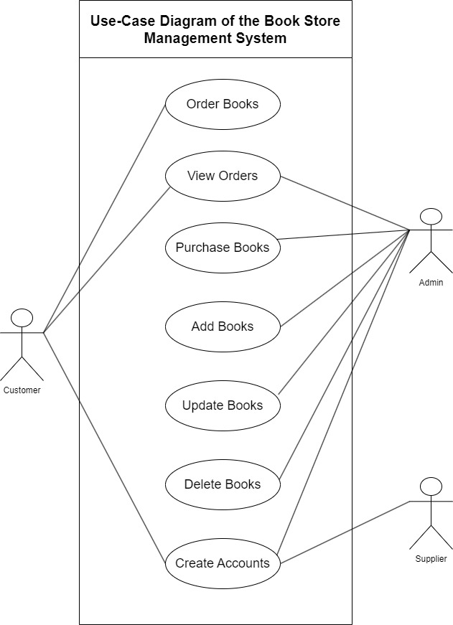

**The whole system initial class diagram (entity relationship diagram)**

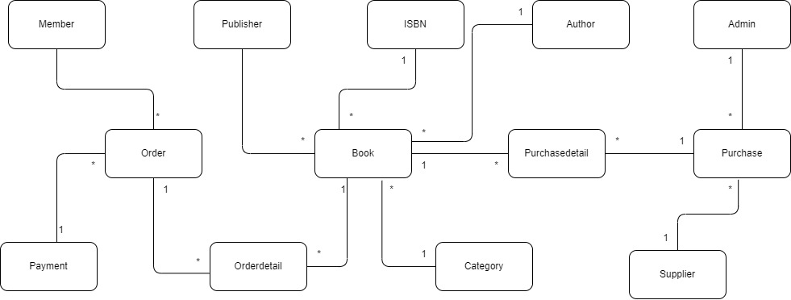

**The Whole Class Diagram**

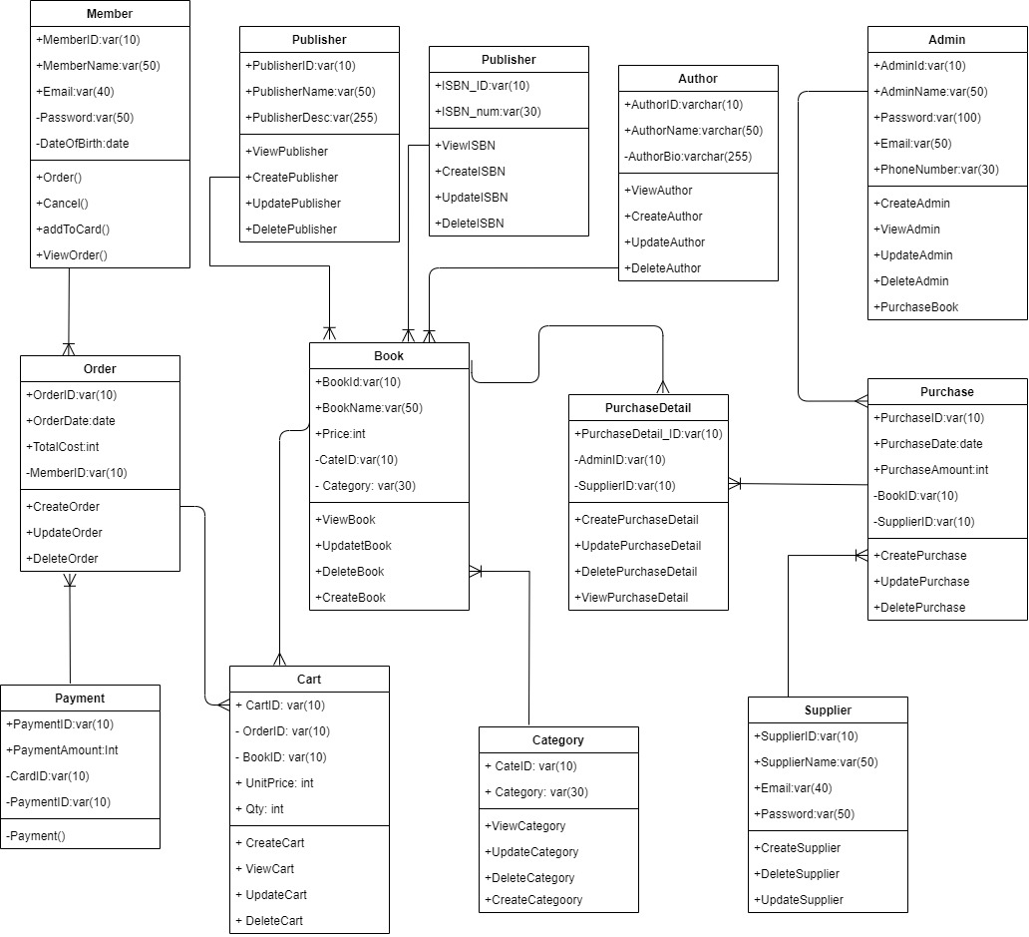

**Chapter – 5**

**Exploring and Engineering**

# **Chapter 5 Engineering**

## **5.1 Time-Box 1: Manage Book Purchase Time-Box Development**

**Project Plan for Time-Box 1**



Project Plan Gantt Chart for Time Box 1

### **5.1.1. Functional Requirements List**

1. Manage Admin (HL)

* Register account (ML)
  + Account already exists - Email checking (LL)
  + Password length check (LL)
  + Check input field null (LL)
* Login (ML)
  + account authentication checking (HL)
* Logout (ML)

1. Purchase Management (HL)

* Create Purchase Order (ML)
* Update Purchase Order (ML)
* Read Purchase Order (ML)
* Delete Purchase Order (HL)

1. Manage Supplier (HL)
   * Register (ML)
     + Account already exists - Email checking (LL)
     + Password length check (LL)
     + Check input field null (LL)

* Login (ML)
  + Account authentication checking (HL)
* Logout (ML)

1. Manage Book (HL)

* Purchase Book (ML)
* Book Quantity (ML)
* Wholesale Price (ML)
* Cancel Purchased Books (ML)

### **5.1.2 Use Case Diagram for Time Box – 1**

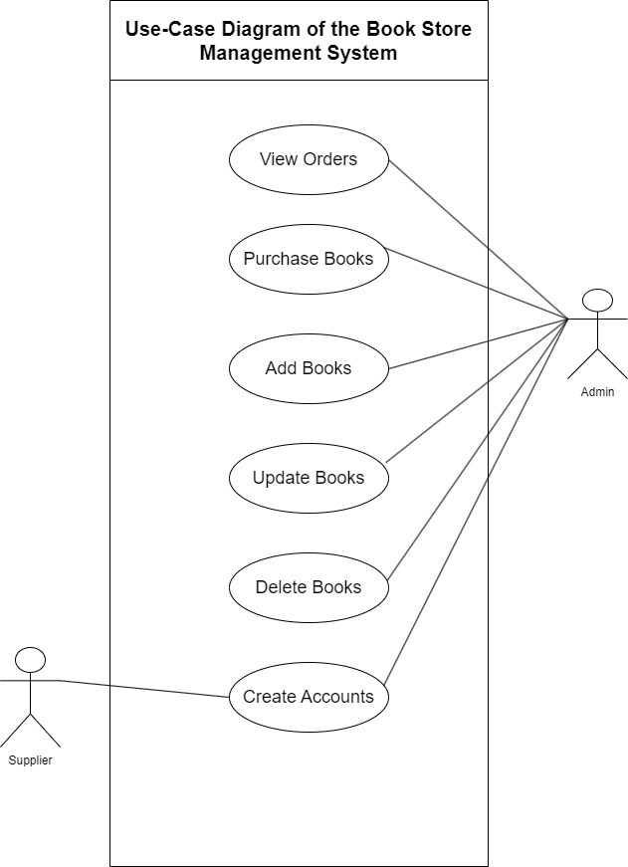

**Use Case Description**

|  |  |
| --- | --- |
| **Use Case Name** | Create Accounts |
| **Actor** | Admin |
| **Flow of Event** | Fill the necessary information from registration form and then click register button. |

**The remaining use case descriptions are in Appendix.**

### **5.1.3 Screen Design**

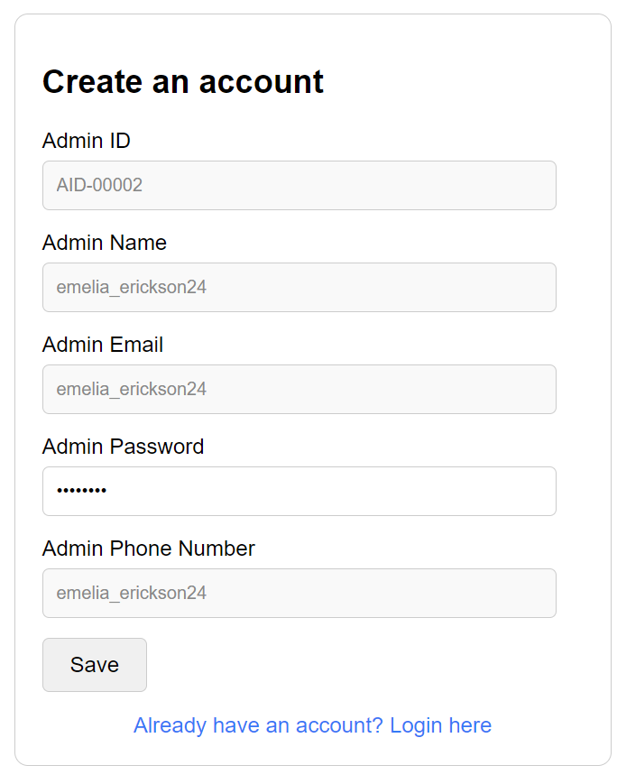

Low level prototype for admin registration

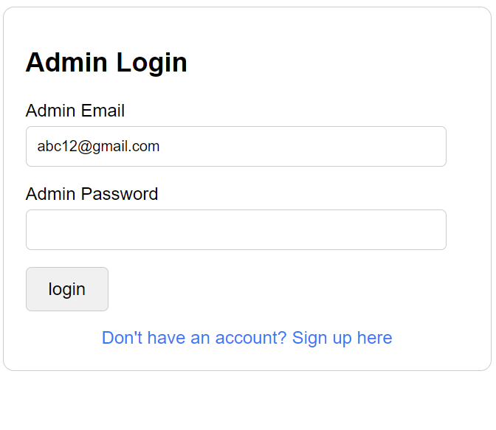

Low level prototype for admin login

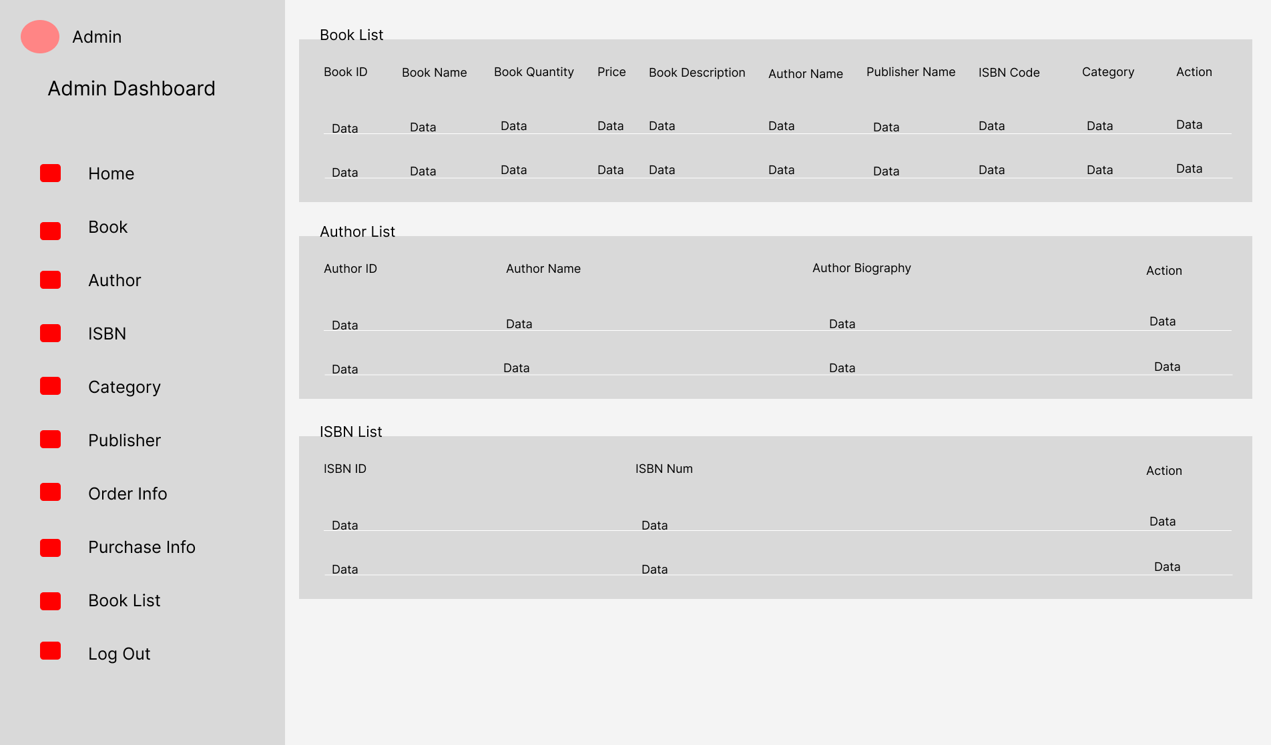

Low level prototype for admin dashboard

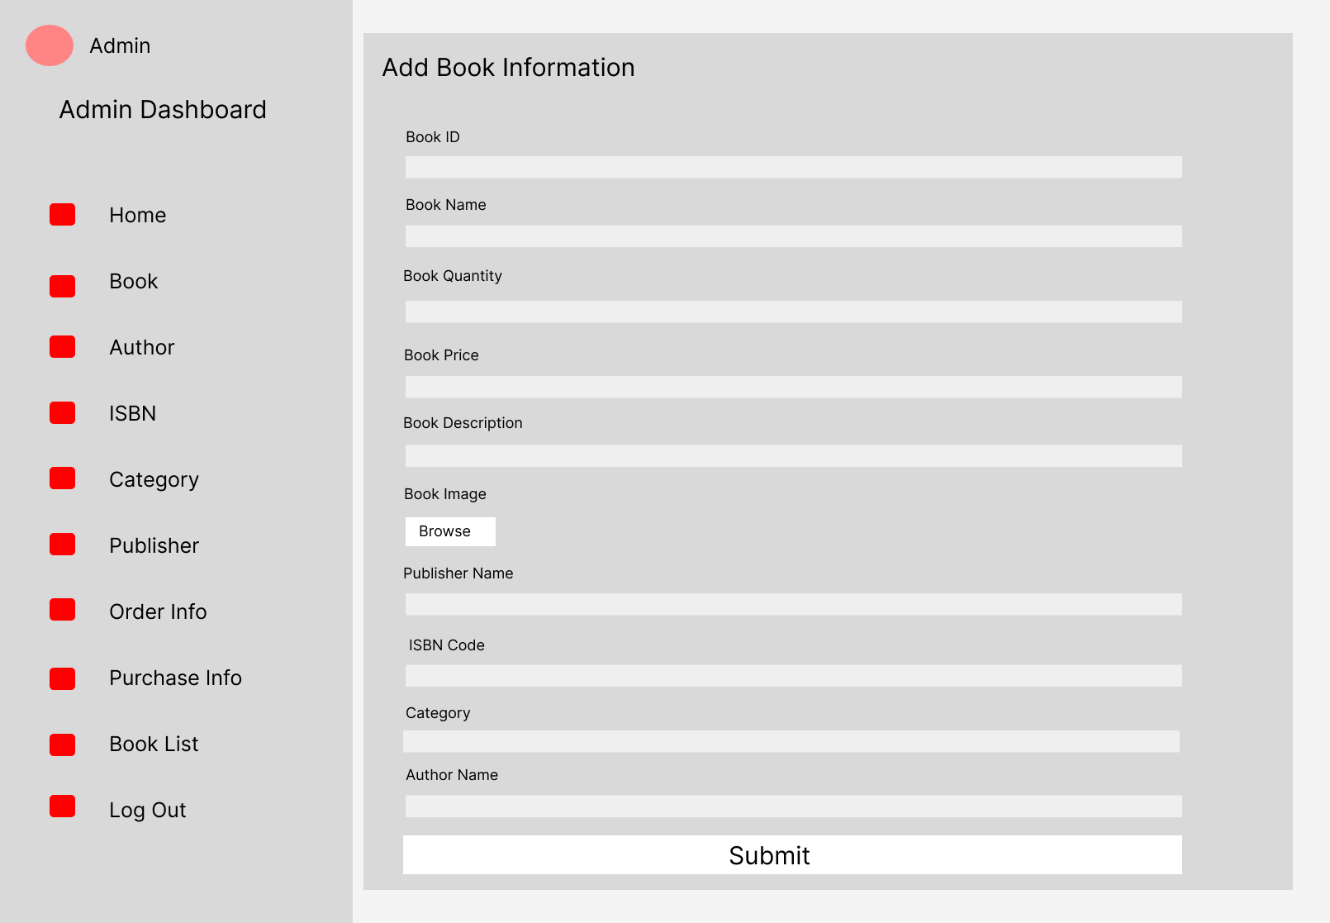

Low level prototype for adding book information

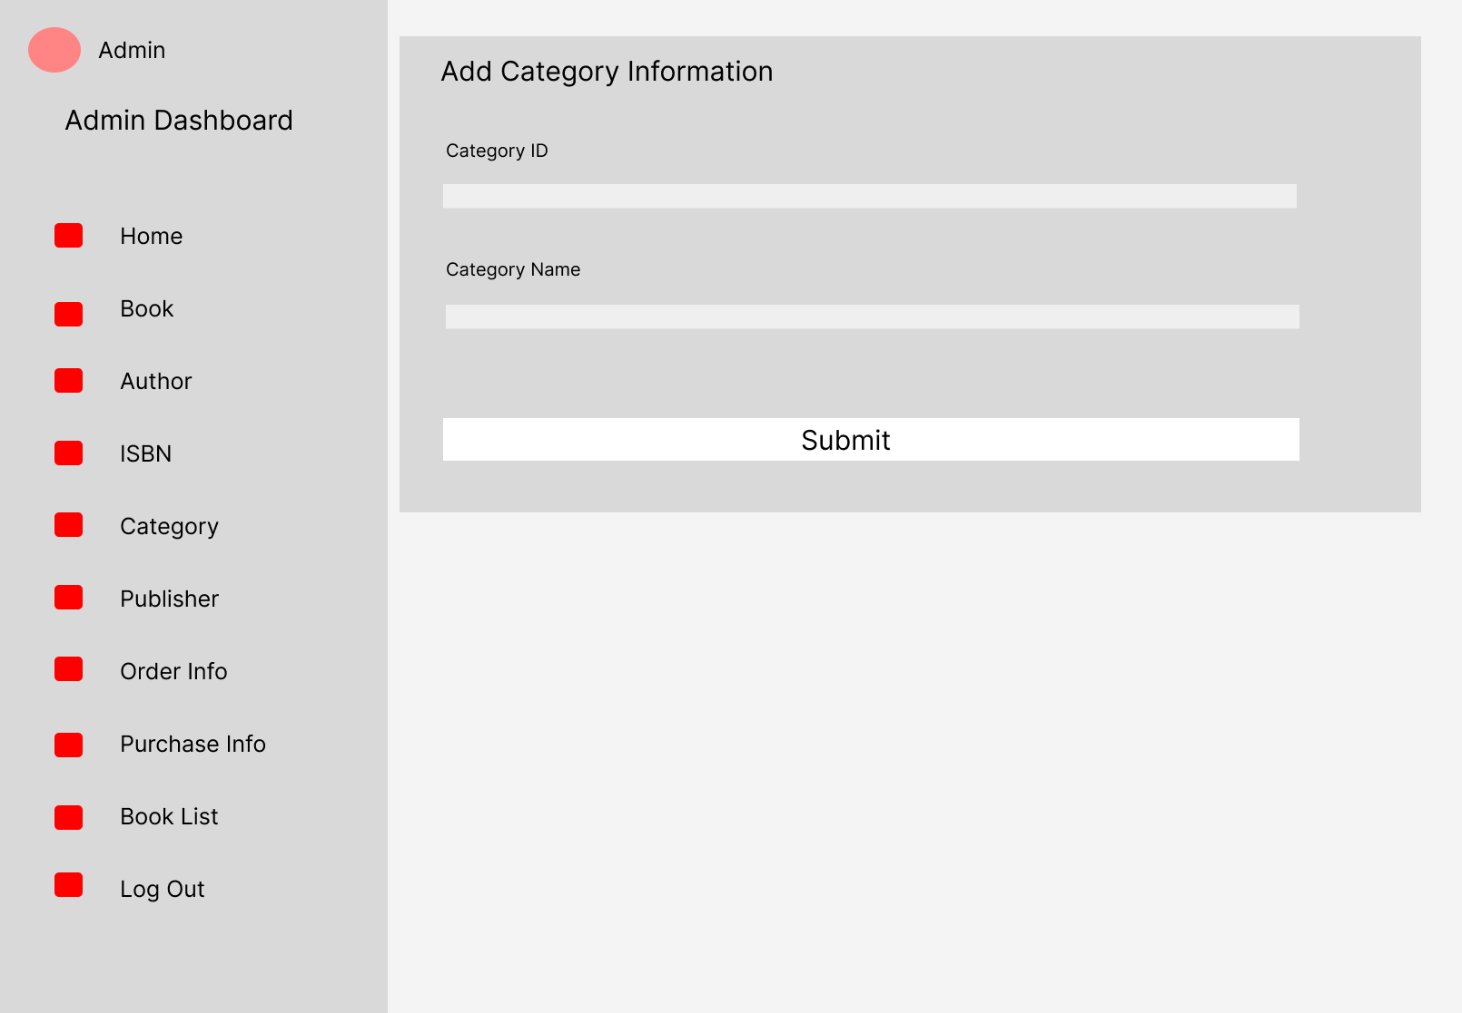

Low level prototype for adding category information

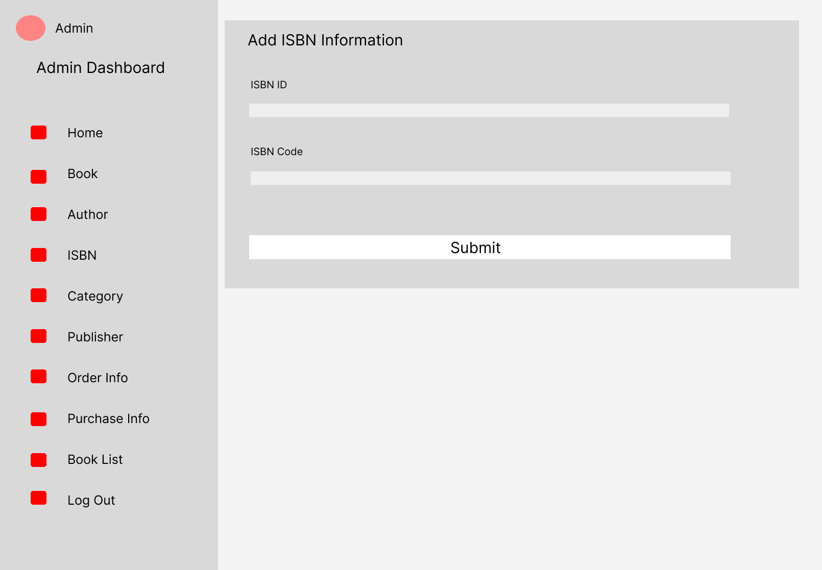

Low level prototype for adding ISBN information

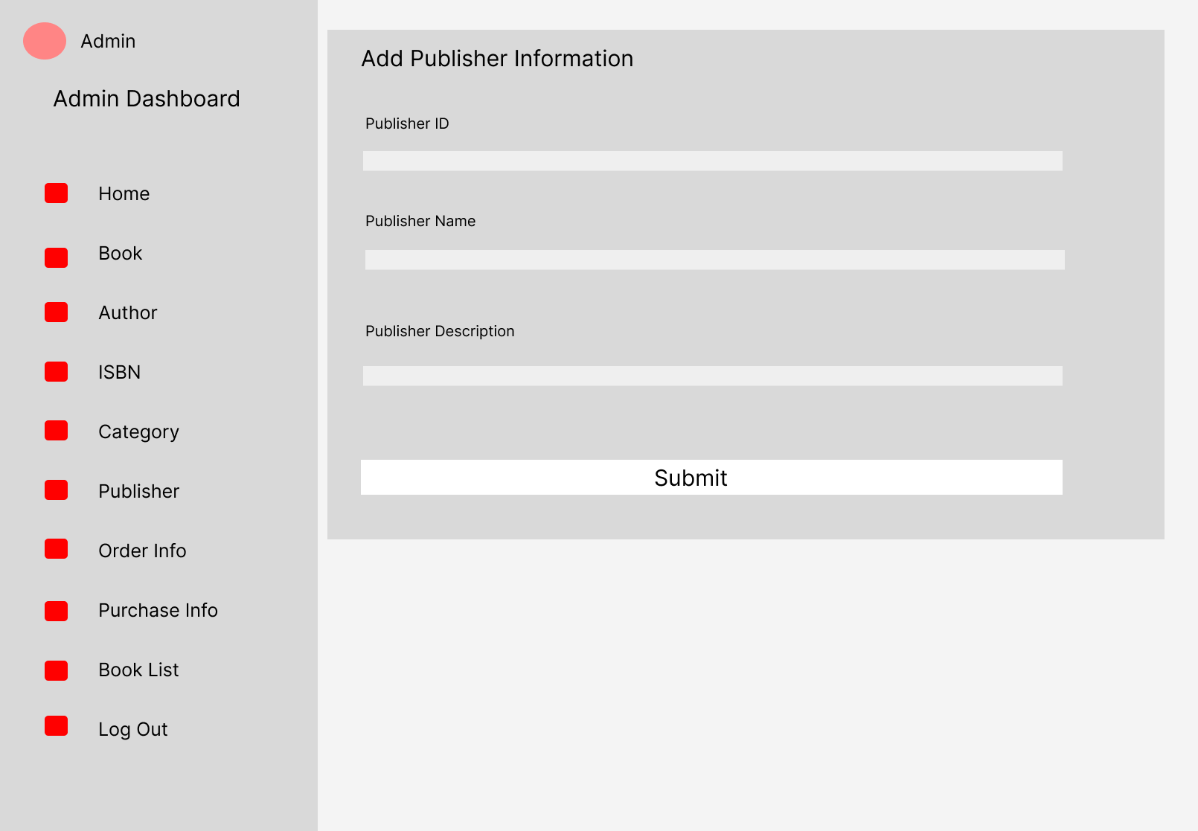

Low level prototype for adding Publisher information

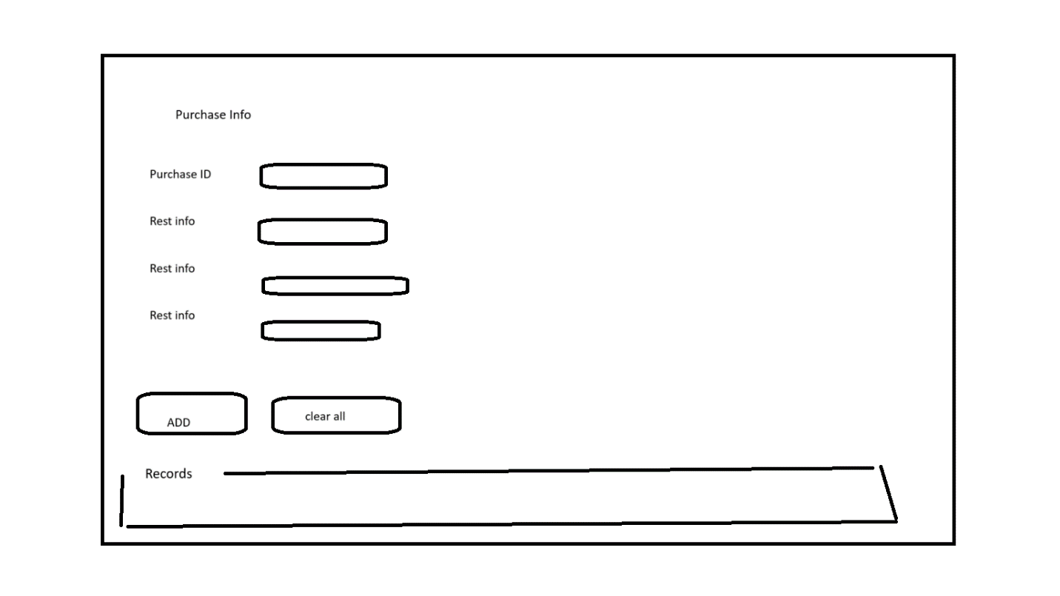

Low level prototype of book purchasing page

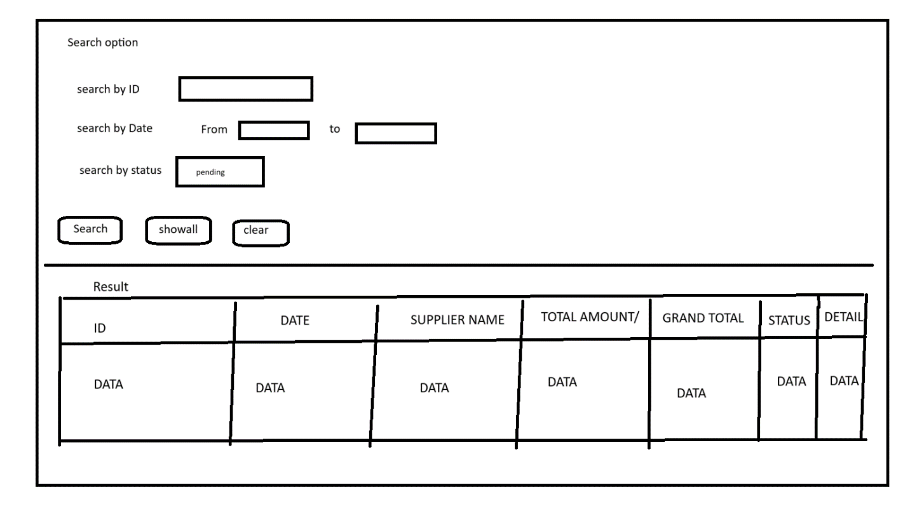

Low level prototype of searching purchase data

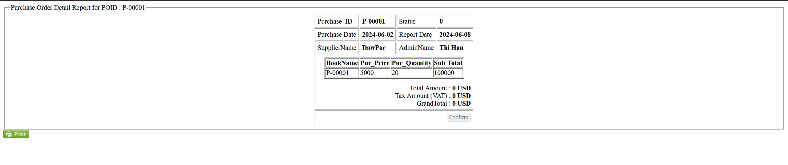

Low level prototype of Print result

### **5.1.4 Iteration for screen design**

**Iteration 1**

User registration design and sign up button’s text was not favored by the admins so the screen design is changed.

**(Iteration 1) Screen Design for Register Form**

Before

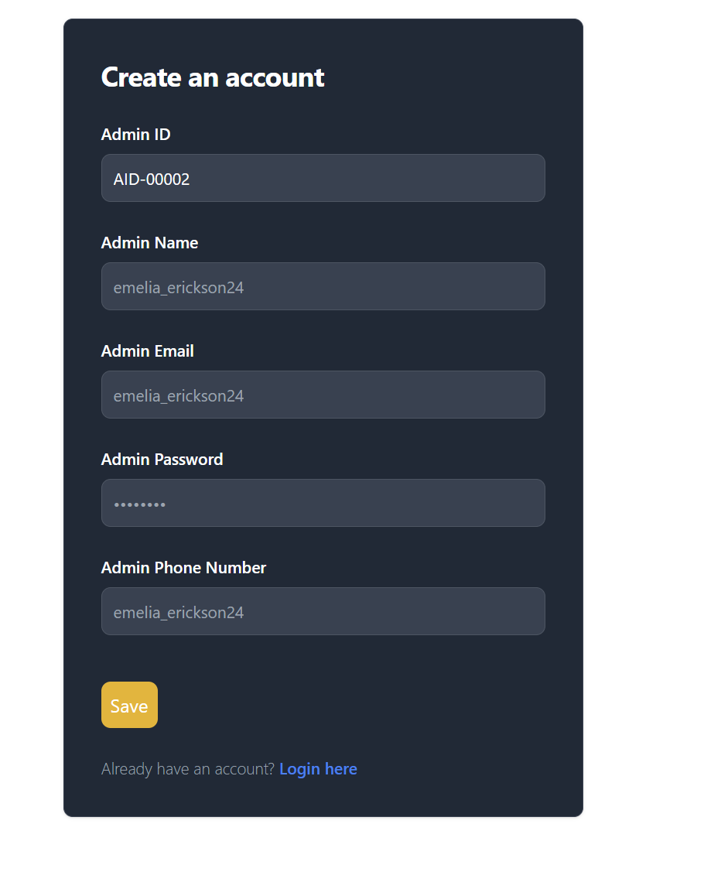

After

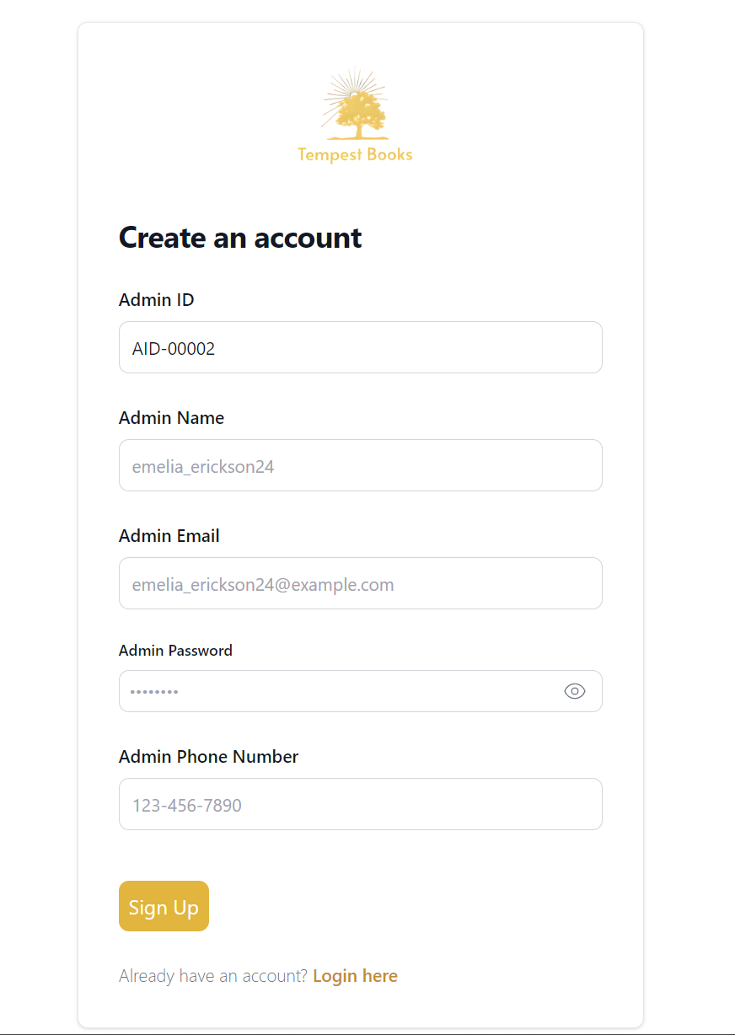

Color is fixed and button text is changed.

**Iteration 2**

User request toggle button for password in register form so that they can check it before submitting

**(Iteration 2) for password toggle button**

Before

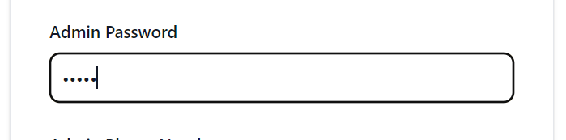

After

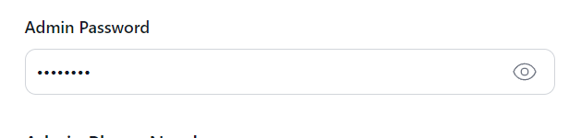

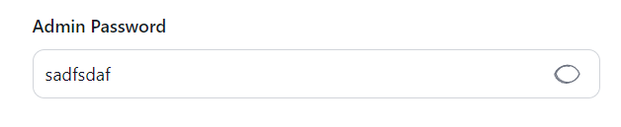

### **5.1.5 Class Diagram**

**Initial Class for Time-Box 1**

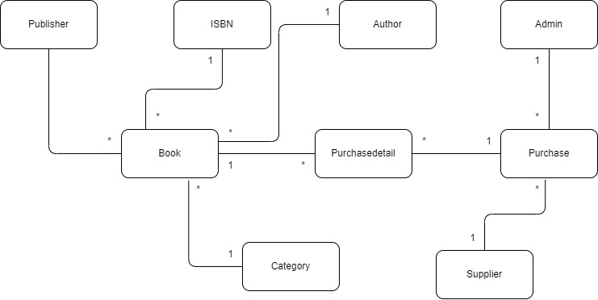

**Detailed Class for Time-Box 1**

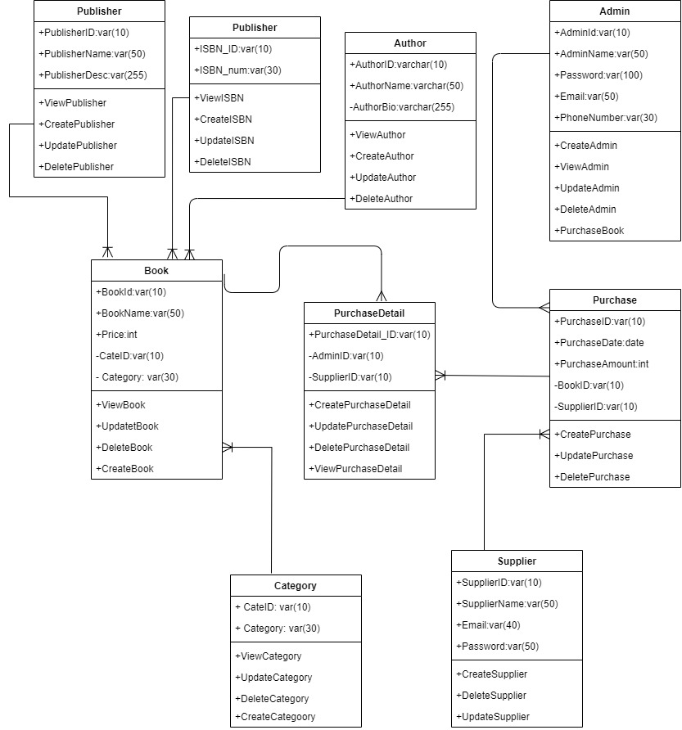

Detail Class Definitions

|  |  |
| --- | --- |
| **Class Name** | Admin |
| **Attributes** | AdminID, AdminName, AdminPassword, AdminEmail, AdminPhnum |
| **Operation** | Register (), Create(), Delete(), Update (), Search () |
| **Description** | << The Role class is used to do register for admin to control the system.>> |

**Remaining class definitions are in Appendix section**

### **5.1.6 Sequence Diagram**

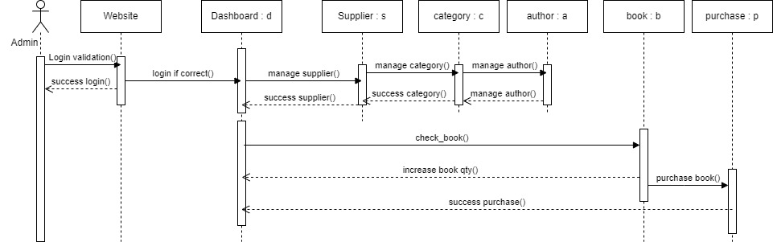

Sequence diagram for admin purchasing process

**Sequence Diagram Description**

Admin has to login to the website in order to make purchase process. According to the sequence diagram, after login into the website, admin will reach to the dashboard if the validation is correct. Admin can manage supplier for book purchasing. Admin can also manage category, author (including ISBN and author too which are not described in diagram). After managing those, admin can able to check the book then purchase book. After purchasing the success message will show up and the quantity of books will increase.

### **5.1.7 Functional Testing**

**Test plan**

**Module 1: Admin registration form**

|  |  |  |  |
| --- | --- | --- | --- |
| **Test Script** | **Description** | **Date** | **Tester** |
| 1.1 | Testing input box can be null or not | 24th June 2024 | Thi Han Naing |
| 1.2 | Testing password’s view can be seen and unseen or not work | 24th June 2024 | Thi Han Naing |
| 1.3 | Testing strong password is required or not | 24th June 2024 | Thi Han Naing |
| 1.4 | Testing login link work or not | 24th June 2024 | Thi Han Naing |

|  |  |  |  |  |
| --- | --- | --- | --- | --- |
| **Unit Test 1** | | **Test Case: admin registratiton form** | **Designed by: Thi Han Naing** | |
| **Data Source: Admin Table** | | **Objective**: To test the data entry in  Admins registration form | **Tester**: **Thi Han Naing** | |
| **Test Case** | **Description** | **Test Procedure** | **Expected Result** | **Actual Results** |
| 1.1 | Testing input box can be null or not | 'Sign Up' button is clicked, all information must be saved | Show ‘Please fill out this field’ message. | See Fig.1.1 & 1.2 |

Before

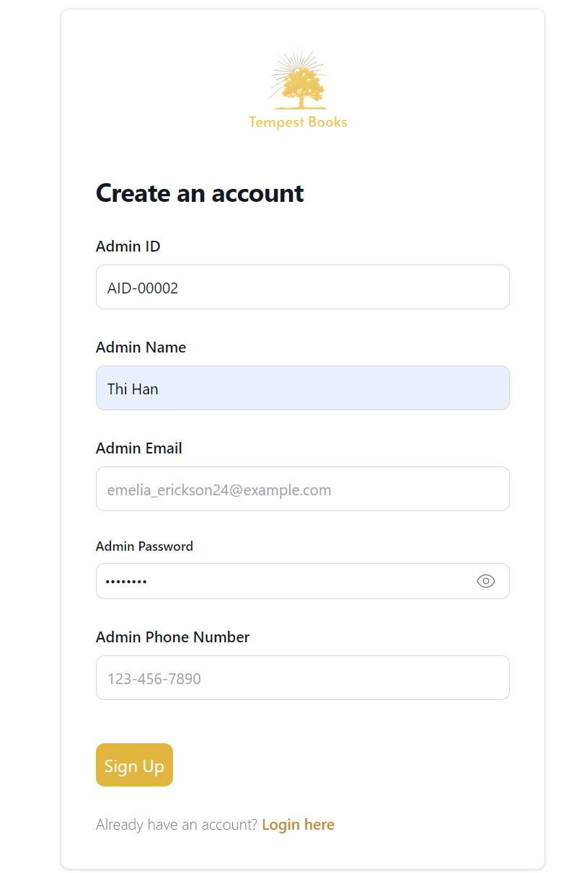

Fig 1.1

After

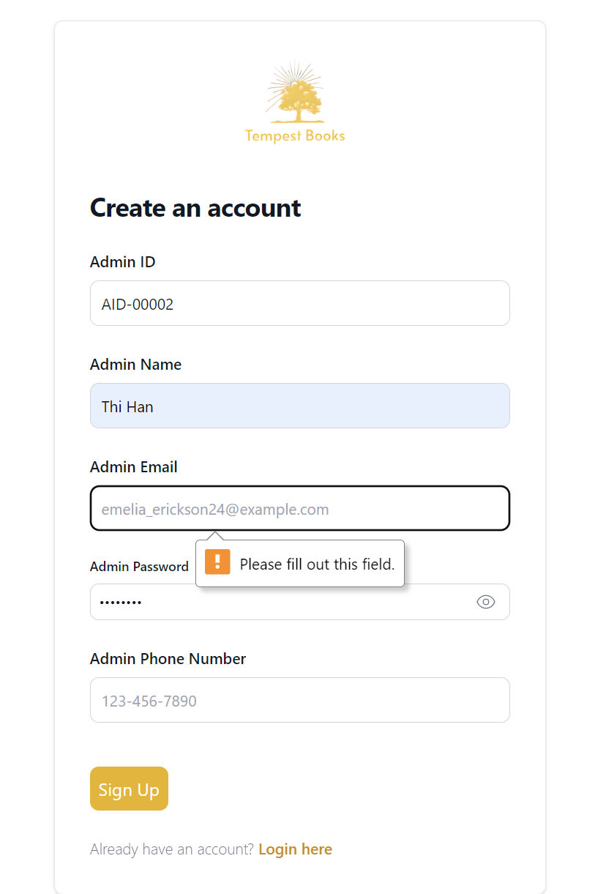

Fig 1.2

**The remain test script can be seen in Appendix**

**Module 2: Adding information form**

Book information adding page will be tested as an example since the other pages are the same.

|  |  |  |  |
| --- | --- | --- | --- |
| **Test Script** | **Description** | **Date** | **Tester** |
| 1.1 | Testing input box can be null or not | 24th June 2024 | Thi Han Naing |
| 1.2 | Testing drop downs can work or not | 24th June 2024 | Thi Han Naing |
| 1.3 | Testing image can be chosen or not | 24th June 2024 | Thi Han Naing |

|  |  |  |  |  |
| --- | --- | --- | --- | --- |
| **Unit Test 2** | | **Test Case: Add book information form** | **Designed by: Thi Han Naing** | |
| **Data Source: Book Table** | | **Objective**: To test the data entry in  Add Book information form | **Tester**: **Thi Han Naing** | |
| **Test Case** | **Description** | **Test Procedure** | **Expected Result** | **Actual Results** |
| 1.1 | Testing input box can be null or not | ‘Submit’ button is clicked, all information must be saved | Show ‘Please fill out this field’ message. | See Fig.2.1 & 2.2 |

Before

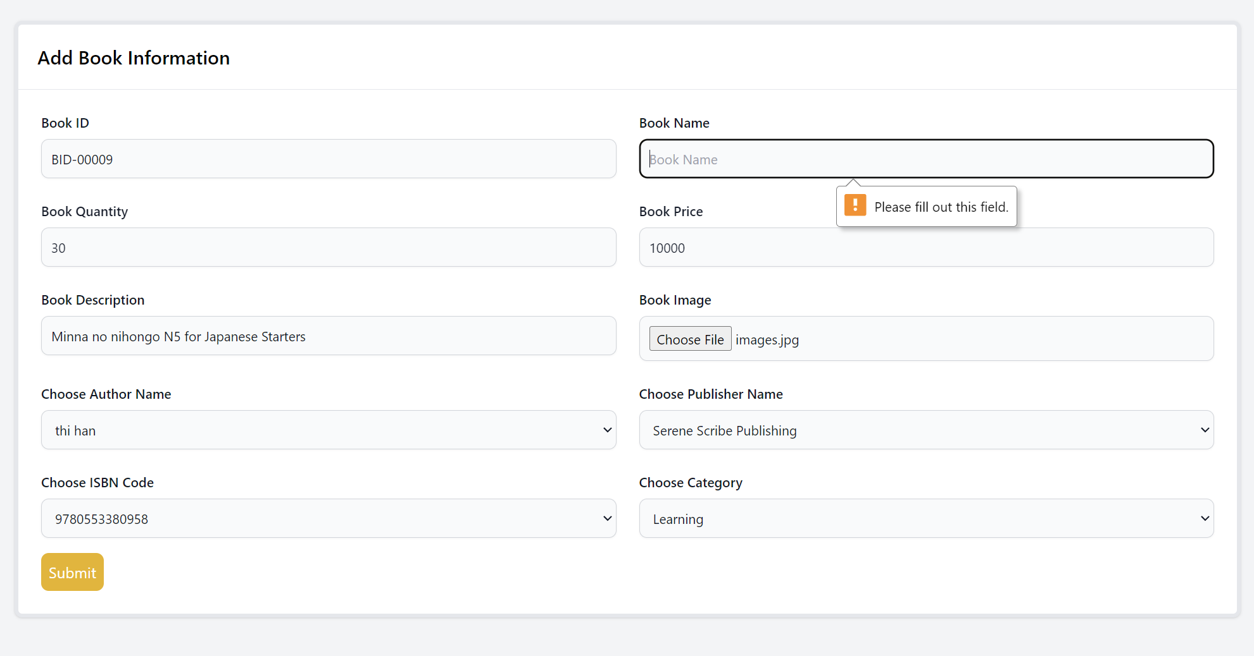

Fig 2.1

After

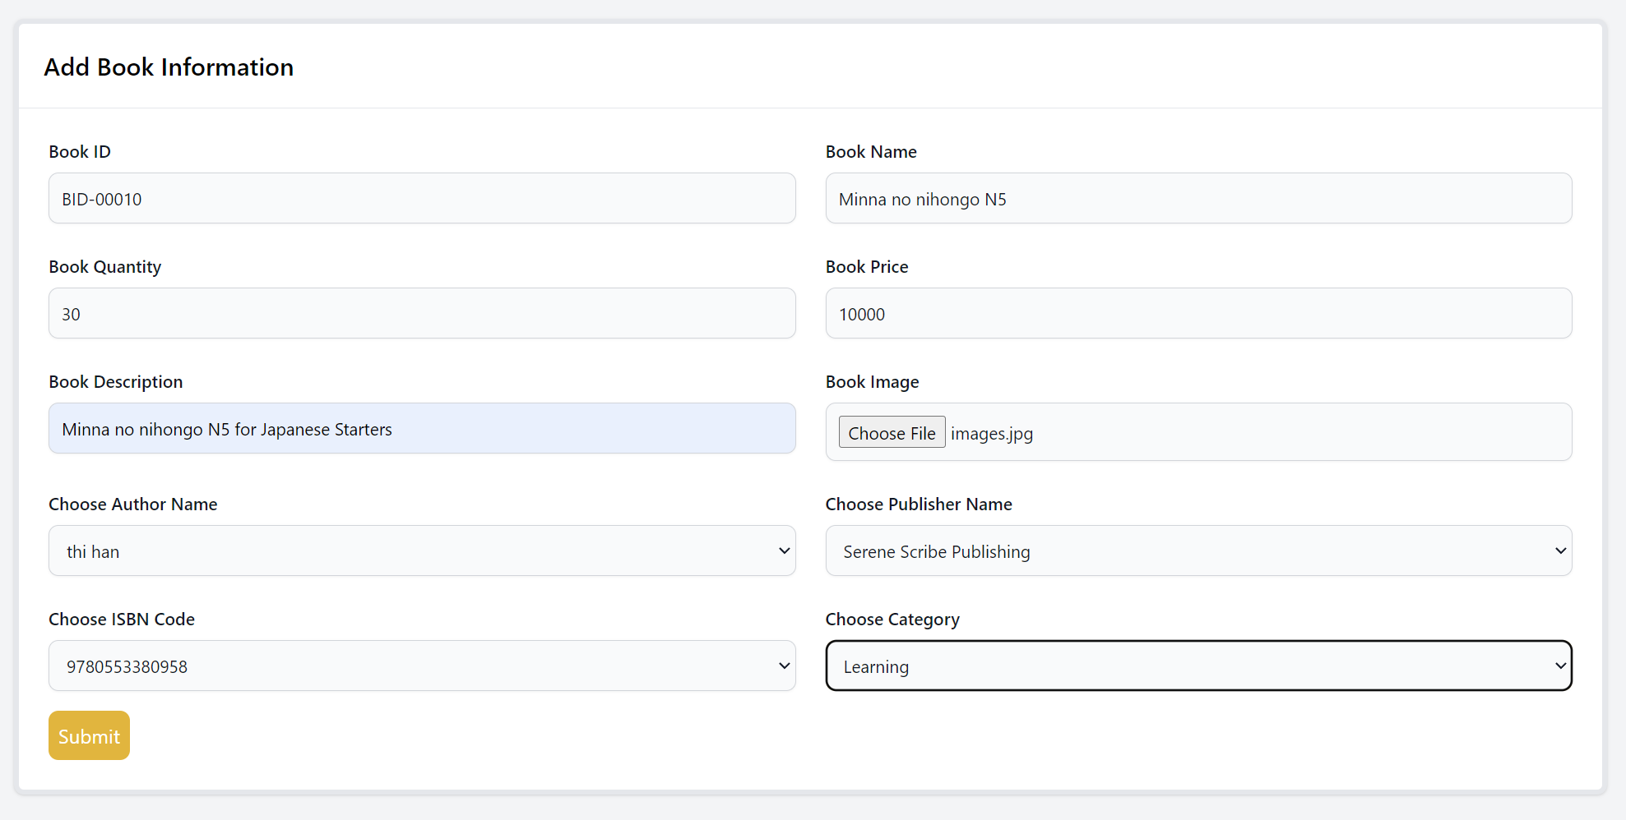

Fig 2.2

**The remain test script can be seen in Appendix**

### **5.1.8 Usability Testing**

**Visibility of system status**

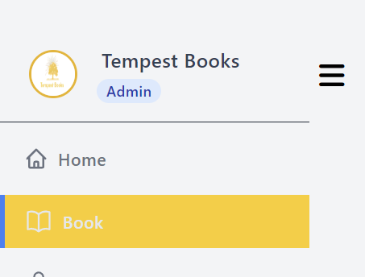

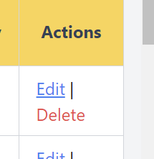

For the users to know that they will be link to other pages, there are hover functions to improve the visibility of the system. With these features they can confirm the system will show another page.

**Match between system and real world**

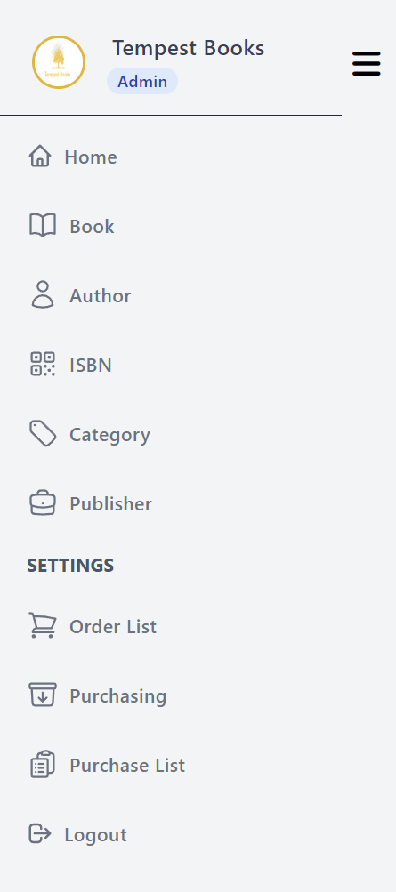

For better understanding and how the system work, the suitable icons are used. Users will easy understand with those icons.

**User confirmation**

To prevent accident clicking there will be alert box to ask confirmation from the user.

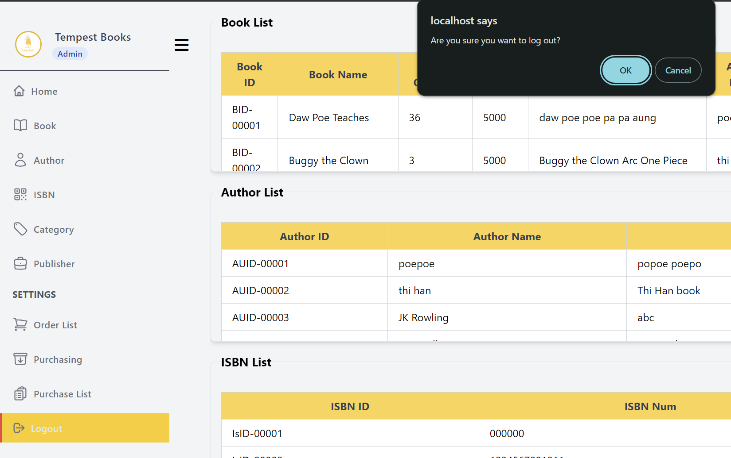

**Consistency and standard**

All the edit and delete are design same for consistency. And list tables’ designs are also the same for standardization.

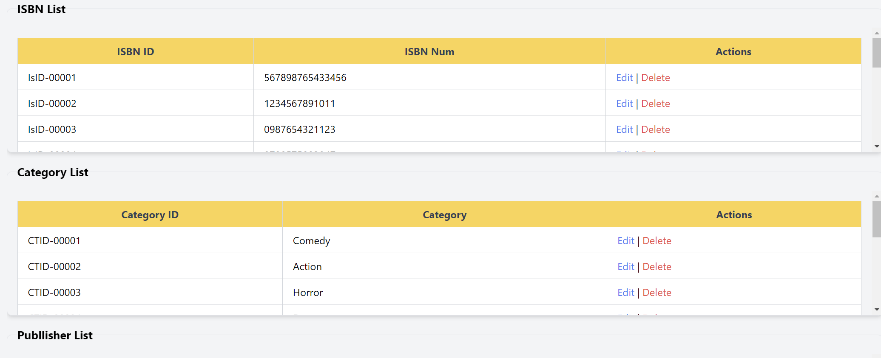

**Error Prevention**

For the user to not accidently delete data, there will be alert box for it.

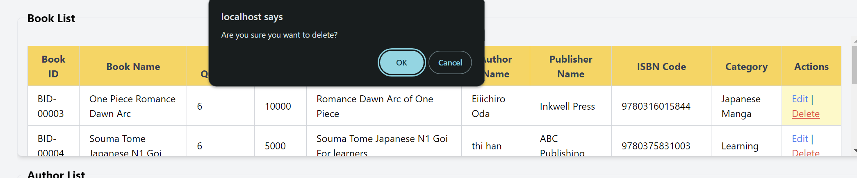

### **5.1.9 Iteration for Usability Testing**

**Iteration 3**

Client request to add all placeholder values in boxes so they can see clearly what they will need to do. This will also prevent wrong input values and improve user quality.

**Iteration 3 (Error Prevention)**

**Before**

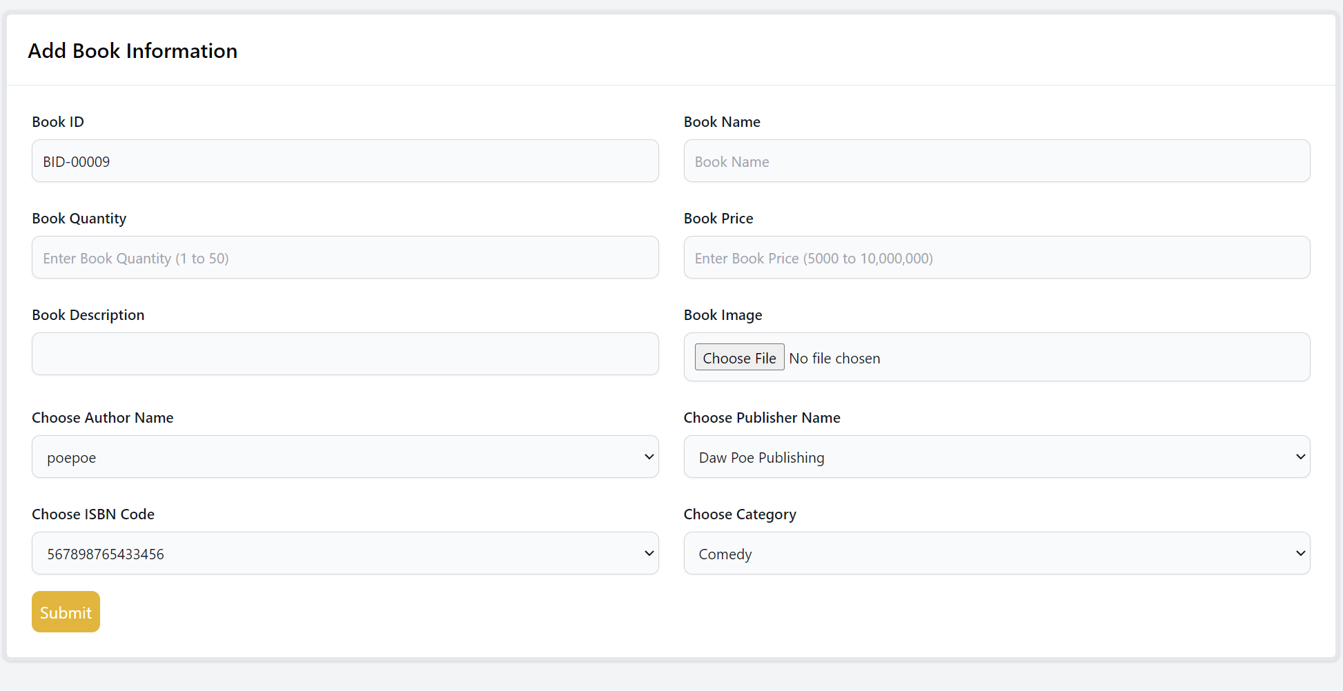

**After**

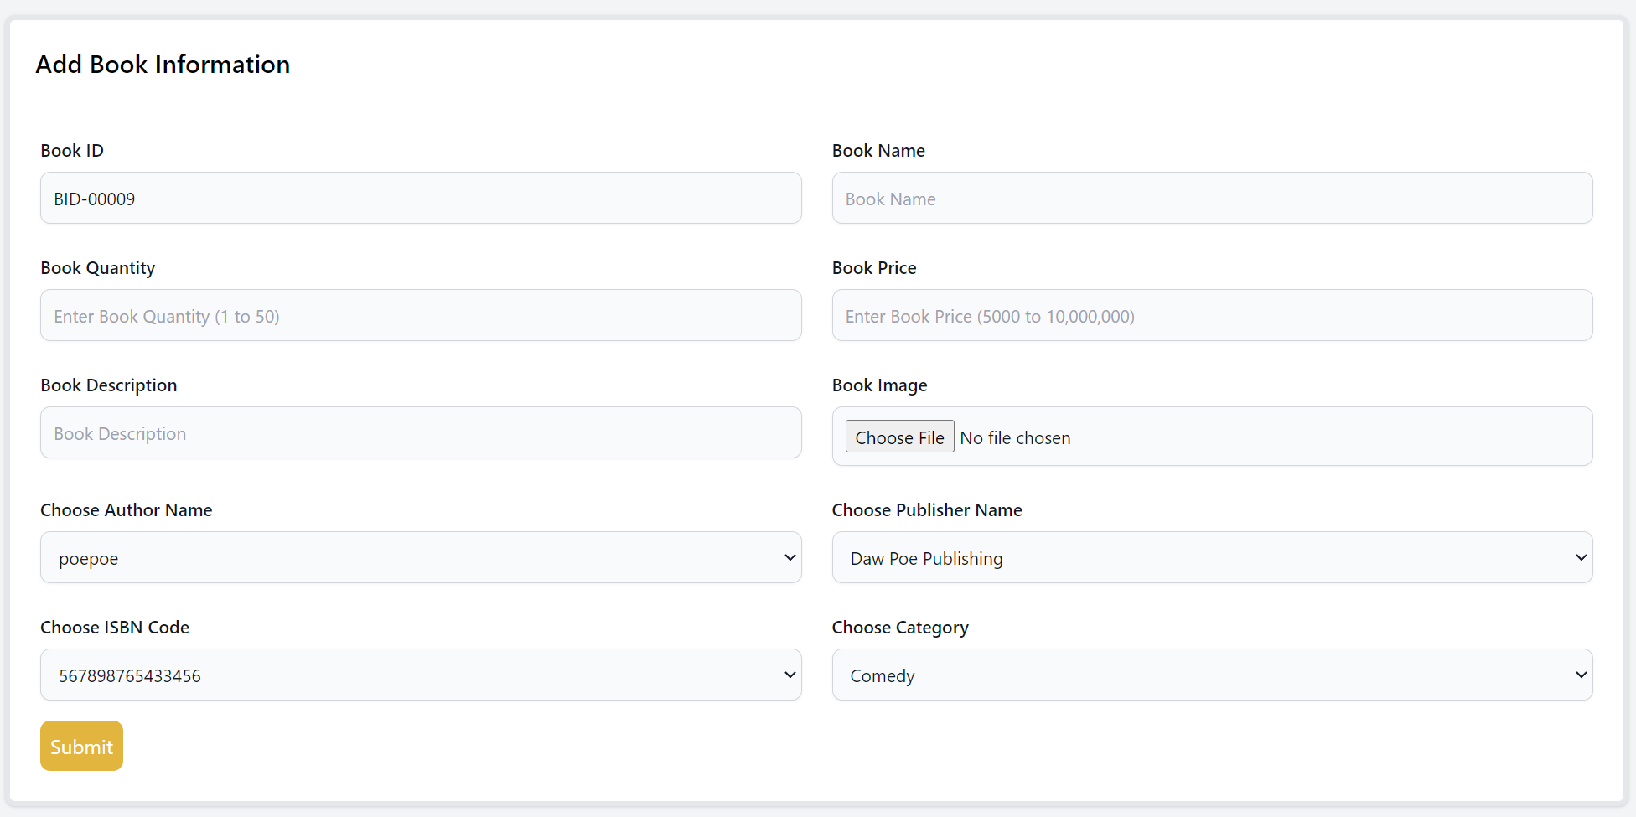

### **5.1.10 Time Box Summary**

Work done

Purchasing process for admin is finished in this time box. Creating information for book like categories, authors, ISBNs, publishers are developed in this time box. After these, adding information for books is developed. After creating necessary information, purchasing processes are developed. First searching and listings are developed. Then supplier registration is created Before confirmation for orders and purchase is developed, purchase process which includes purchase and purchase details is developed.

Issues

While developing this time box, specific functions for listing, purchasing process and confirmation process got errors a lot.

Solution

Checking detail codes, reading documentations, searching other people codes solved these problems.

## **5.2 Time Box 2 Ordering Time-Box Development**

Project Plan for Time Box 2



Project plan Gantt Chart for Time Box 2

### **5.2.1 Functional Requirement List**

1. Manage Customer (HL)

* Register account (ML)
  + Account already exists - Email check (LL)
  + Password length check (LL)
* Login (ML)
  + account authentication checking (LL)
* Logout (ML)

1. Manage Order (HL)

* Order Books (ML)
* Cancel Ordered Books (ML)
* Number of Books (ML)
* Retail Price (ML)

### **5.2.2 Use Cases Diagram for Time-Box 2**

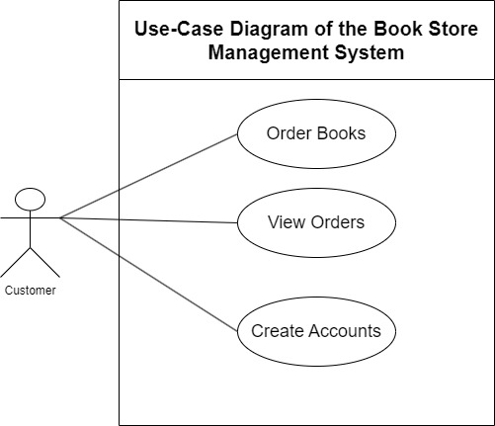

**Use Case Description**

|  |  |
| --- | --- |
| **Use Case Name** | Order Books |
| **Actor** | Customer |
| **Flow of Event** | Customers will need to select see more and go to book detail page then set the quantity and then go to checkout before making payment. |

**Use Case Description**

|  |  |
| --- | --- |
| **Use Case Name** | View Orders |
| **Actor** | Customer |
| **Flow of Event** | Customers will be able to check the information in the cart before making the payment. They can then decide delete, continue shopping or make payment. |

**Use Case Description**

|  |  |
| --- | --- |
| **Use Case Name** | Create Accounts |
| **Actor** | Customer |
| **Flow of Event** | Fill the described information from registration form and then click register button. |

### **5.2.3 Screen Design**

Customer side screen design does not have prototype, it will be change iteratively always depending on customers taste. These designs are current satisfied design chosen by admins. These designs are changed depending on them and changing repeatedly and only have small changes in each change. Also, there are no enough time for making prototype and since it will not be used high level designs are created.

**Customer Registration Form**

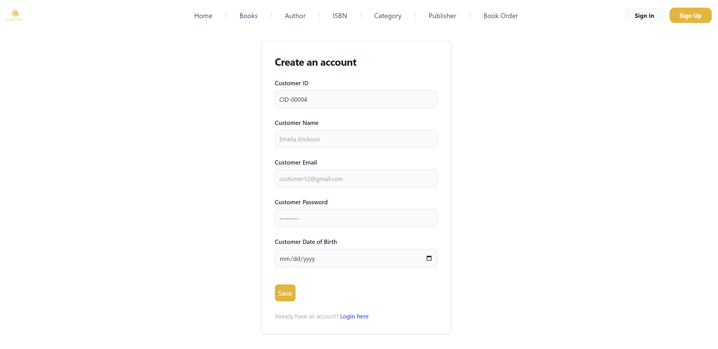

Screen design for customer registration process

**Order Books**



Click this see more button



Here customers will need to add quantity and then click add to cart

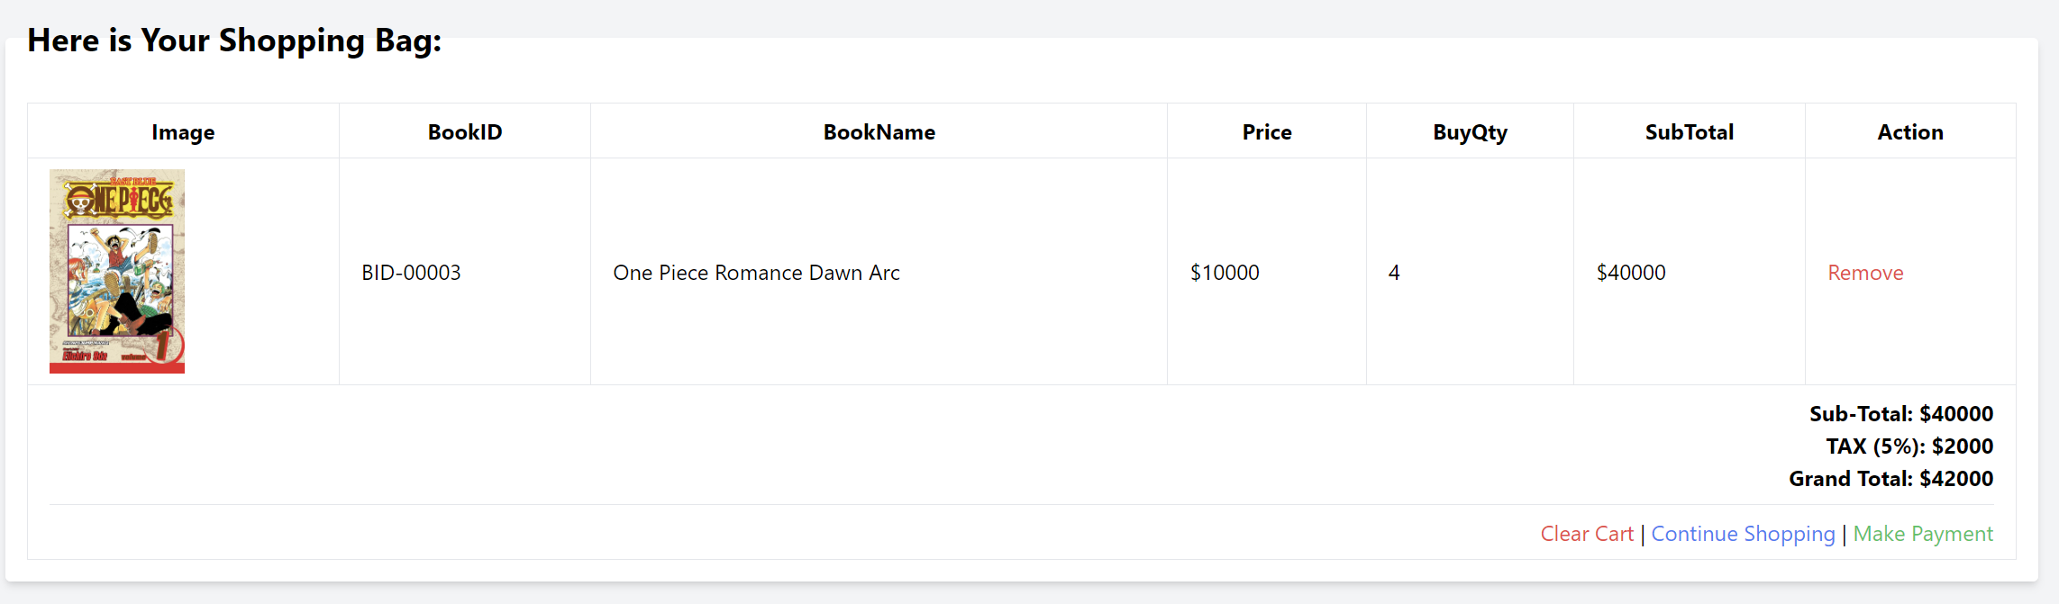

And then they can proceed to make payment by clicking it

### 5.2.4 Class Diagram

**Initial Class Diagram**

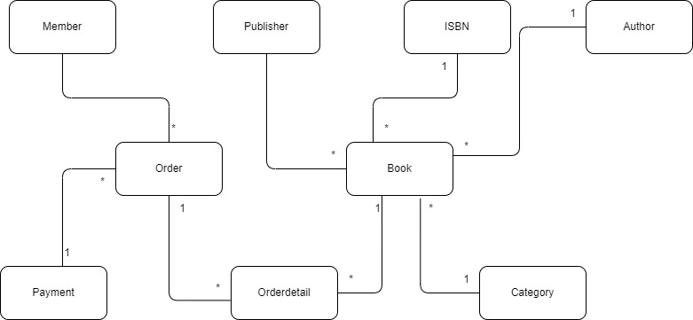

Initial class diagram for customer ordering process

**Detailed Class Diagram**

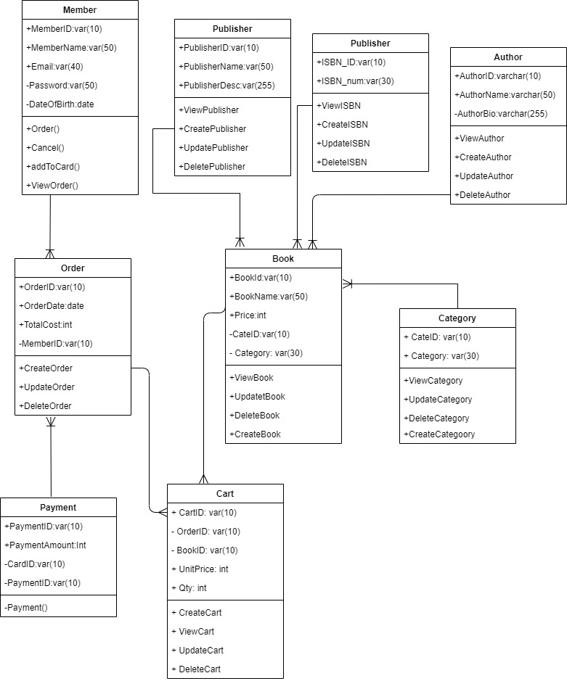

Detailed class diagram for customer ordering process. Note – orderdetail is described as cart in detailed diagram.

### **5.2.5 Sequence Diagram**

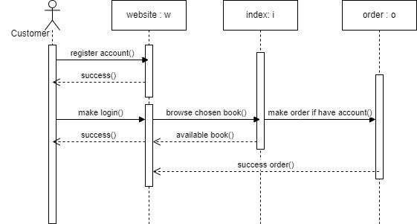

Sequence diagram for customer book ordering process

**Sequence Diagram Description**

According to the above sequence diagram flow, the customer must have account and login to make orders. The above diagram shows sequence of these activities. Firstly, customer have to register an account, then login to website. Customer can able to browse the book that are available on the website. If the chosen book is available, then customer can able to make order. The success order message will return to the website.

### **5.2.6 Functional Testing**

**Module 1: Customers registration form**

|  |  |  |  |
| --- | --- | --- | --- |
| **Test Script** | **Description** | **Date** | **Tester** |
| 1.1 | Test customer name can be null or not. | 16th Dec 2023 | Thi Han Naing |
| 1.2 | Test customer email can be null or not. | 16th Dec 2023 | Thi Han Naing |
| 1.3 | Test customer password can be null or not. | 16th Dec 2023 | Thi Han Naing |

|  |  |  |  |  |
| --- | --- | --- | --- | --- |
| **Unit Test 1** | | **Test Case: Customer Registration form** | **Designed by: Thi Han Naing** | |
| **Data Source: Customer table** | | **Objective**: To test the data entry in  customer registration form | **Tester**: **Thi Han Naing** | |
| **Test Case** | **Description** | **Test Procedure** | **Expected Result** | **Actual Results** |
| 1.1 | Testing customer name can be null or not. | 'Submit' button is clicked. Customer name is blank. | Show ‘Please fill out this field’ message. | See Fig.1.1 & 1.2 |

**Before**

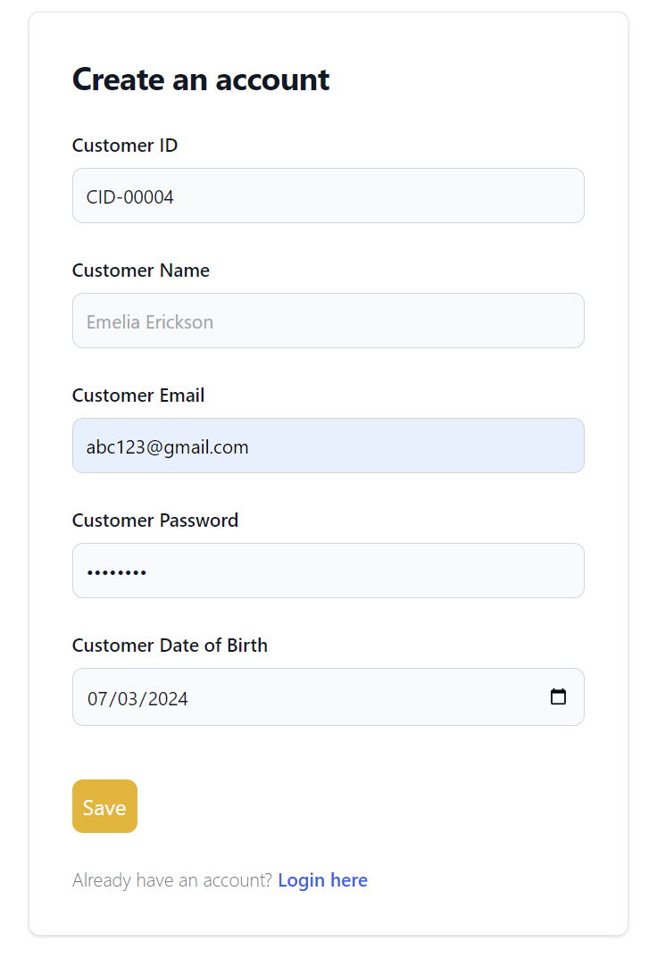

**After**

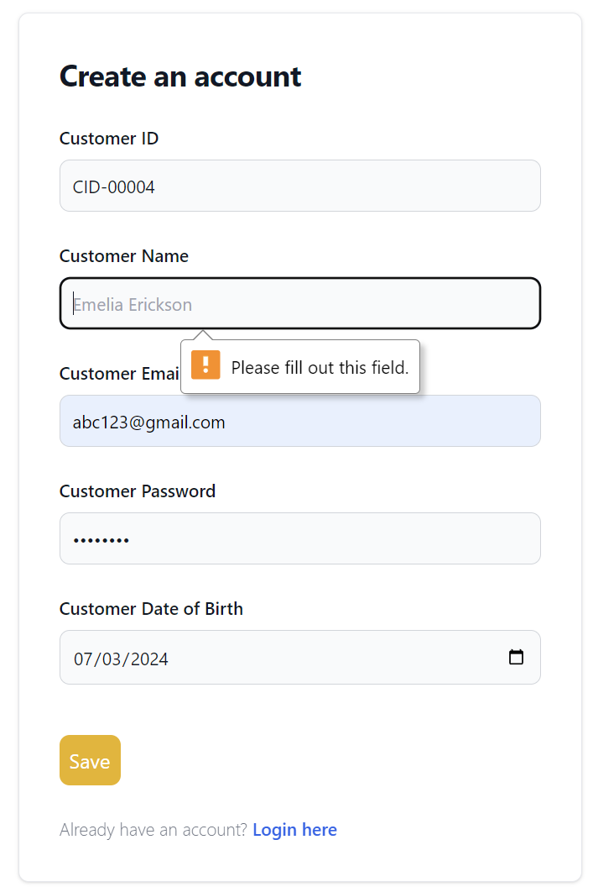

|  |  |  |  |  |
| --- | --- | --- | --- | --- |
| **Unit Test 1** | | **Test Case: Customer Registration form** | **Designed by: Thi Han Naing** | |
| **Data Source: Customer table** | | **Objective**: To test the data entry in  customer registration form | **Tester**: **Thi Han Naing** | |
| **Test Case** | **Description** | **Test Procedure** | **Expected Result** | **Actual Results** |
| 1.2 | Testing customer email can be null or not. | 'Submit' button is clicked. Customer email is blank. | Show ‘Please fill out this field’ message. | See Fig.1.3 & 1.4 |

**Before**

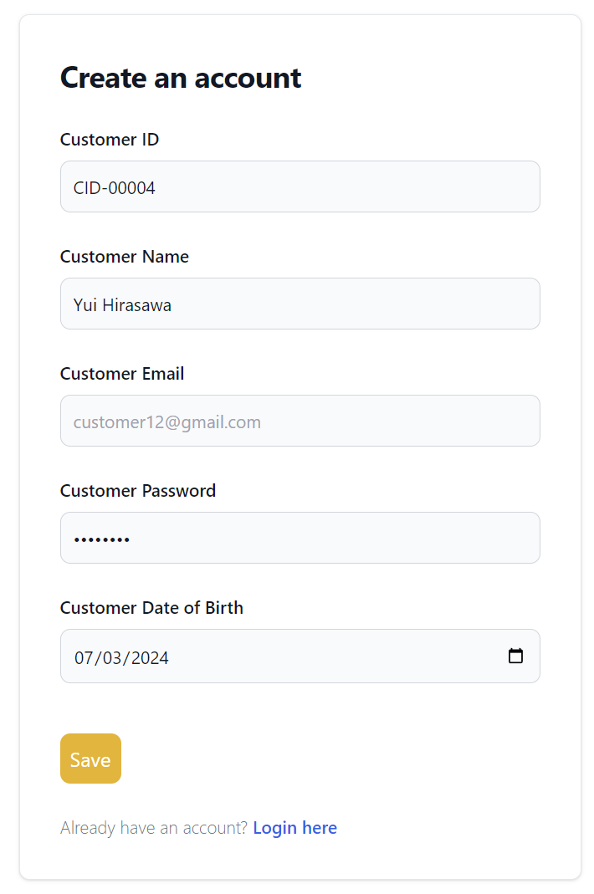

Fig 1.3

**After**

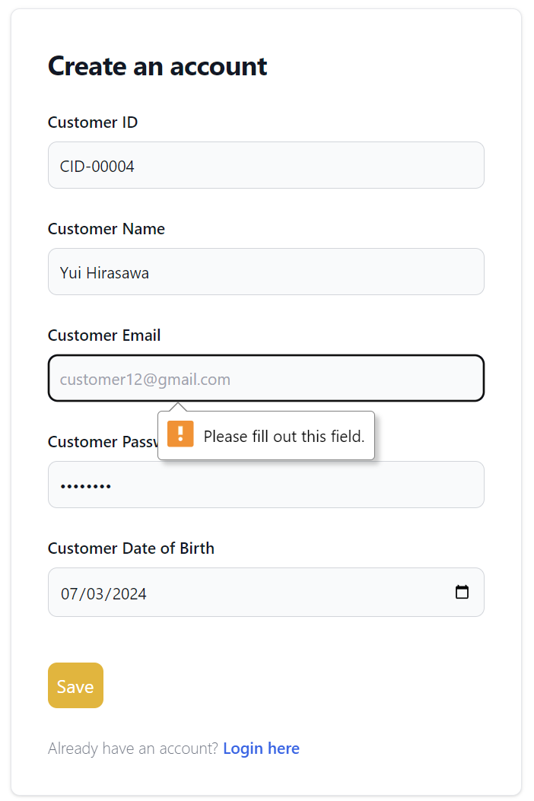

Fig 1.4

|  |  |  |  |  |
| --- | --- | --- | --- | --- |
| **Unit Test 1** | | **Test Case: Customer Registration form** | **Designed by: Thi Han Naing** | |
| **Data Source: Customer table** | | **Objective**: To test the data entry in  customer registration form | **Tester**: **Thi Han Naing** | |
| **Test Case** | **Description** | **Test Procedure** | **Expected Result** | **Actual Results** |
| 1.3 | Testing customer password can be null or not. | 'Submit' button is clicked. Customer password is blank. | Show ‘Please fill out this field’ message. | See Fig.1.5 & 1.6 |

**Before**

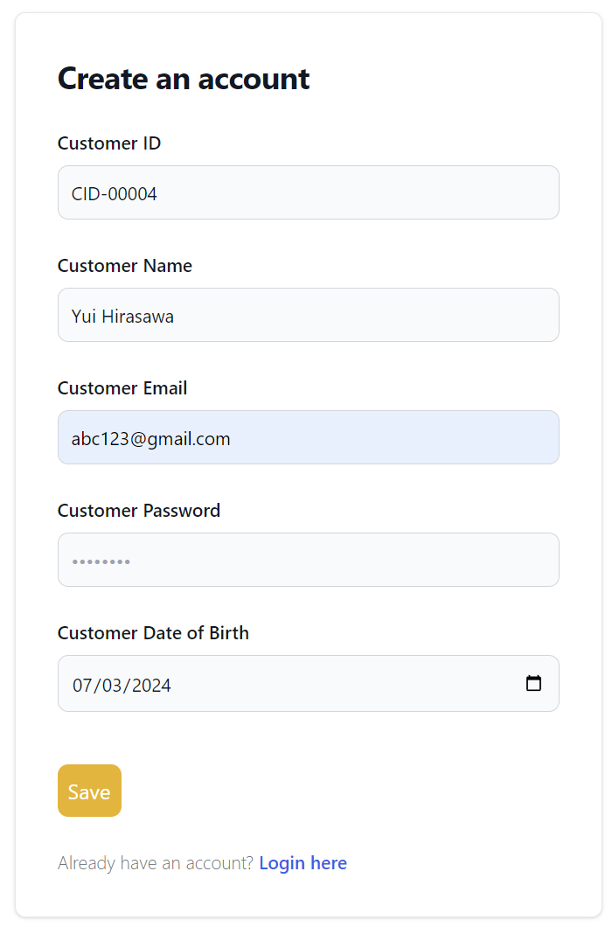

Fig 1.5

**After**

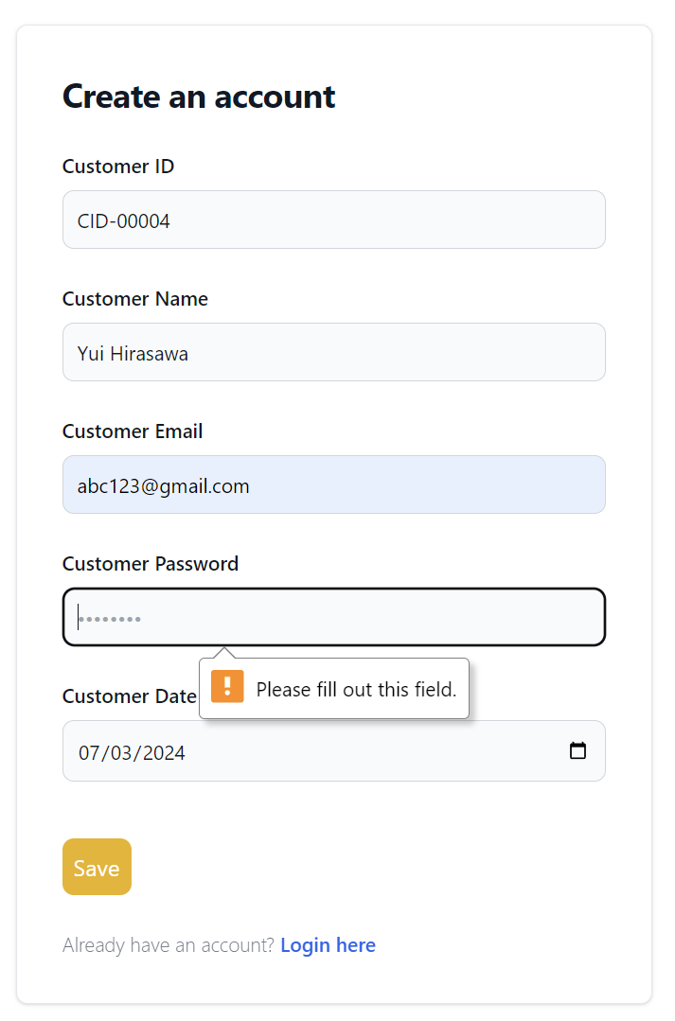

Fig 1.6

### **5.2.7 Usability Testing**

**Categorizing for faster searching**

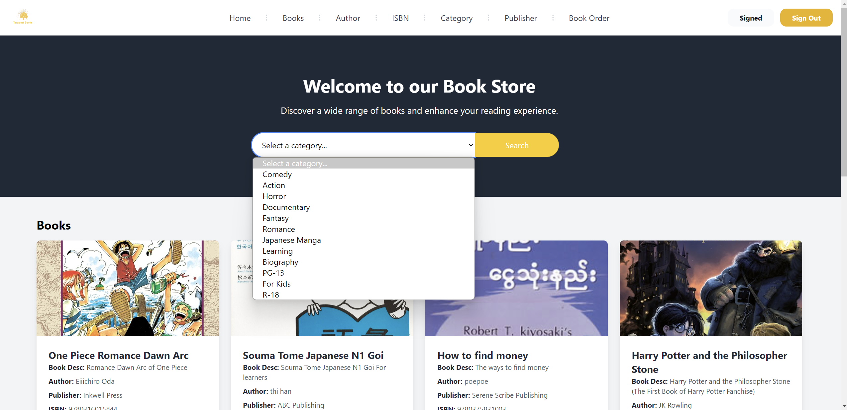

Searching books with categories will allow users to find the type of books they want faster. This function group the list of books so that customers can browse the favored genre and not necessary to know the identity of the book for example Author name.

**Searching with input**

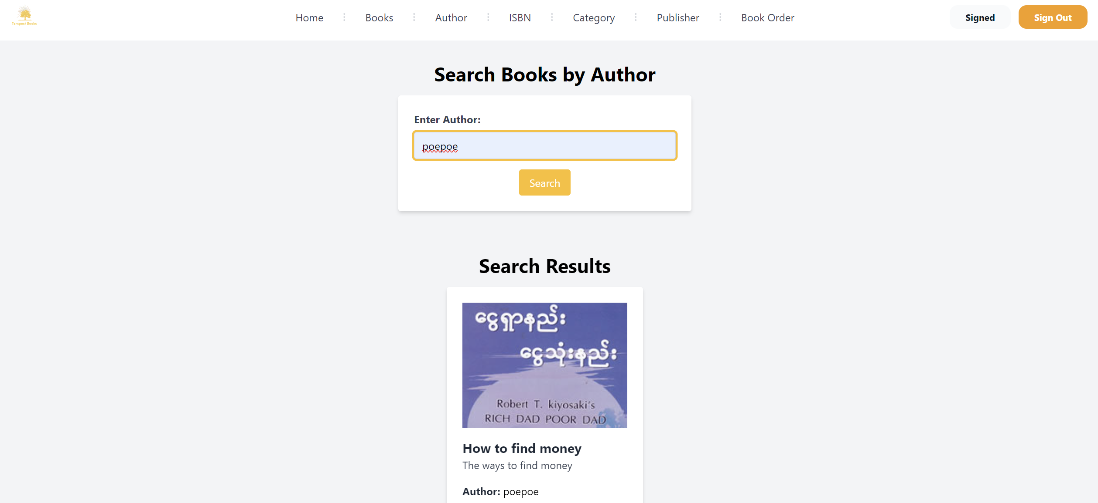

This will help user when searching books with inputs. But this must be necessary to enter specific data. That’s why this function is used only for searching with author name and ISBN only.

### **5.2.8 Time Box Summary**

Work done

Customer order, order details and related cart functions are created in this time box. Customer will able to use the website search books with author name, book name, category list, ISBN codes, publisher list. Customer will also be able to order books after creating account and also be able to manage order information in order detail system.

Issues

While developing this timebox, searching features, listing features were difficult. Making order detail functions were also difficult when it had to make calculating functions. After creating functions, applying them while making the website responsive were biggest solution. Creating diagrams were a little difficult too. For example, sequence diagram.

Solution

These issues were fixed by reading documentations, consulted with AIs, and giving plenty of time.

**No remaining timebox**

**Chapter – 6**

**Deployment**

# **Chapter 6 Deployment**

## **6.1 Deployment Diagram**

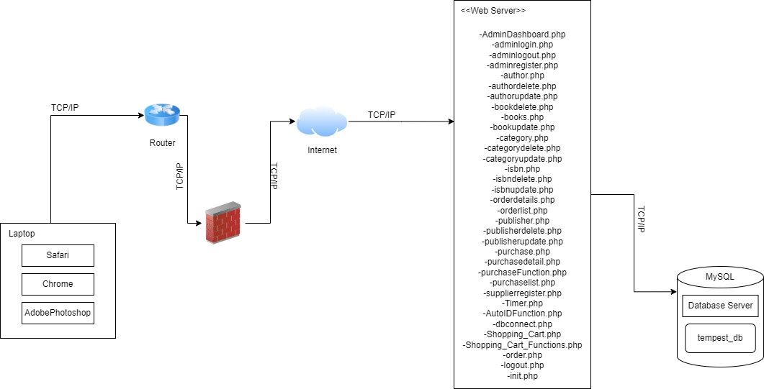

**Explanation**

This is the UML diagram for deployment. it is used as a system architecture to graphically represent how software and hardware components will be physically deployed in real life. the network has main key factors called key nodes which are routers, firewalls, servers and they are collected by TCP/IP protocol. In order to deploy this system, hosting provider has been chosen. Domain name is also registered. After testing, debugging or refining of the code, database connection has been updated for public environment. Then, related php files has been uploaded to public server vid through local computer. Since, the system has been on public network, firewall is used to protect from attackers and to improve security of the system.

## **6.2 Data Migration**

### **6.2.1 Data to Migrate**

**Explain**

Data migration is the process of moving data from one system to another. During migration, multiple data may be included depending on the system. The table below show the related data that will be migrated to host database. Database from phpMyAdmin will be exported and moved to new database from the hosting server. After configuration, the system will be test if it working well or not.

|  |  |  |
| --- | --- | --- |
| **Time Box** | **Master Data** | **Transaction Data** |
| **Time box 1:** ManagePurchase time box. | Admin, supplier, category, books, isbn, authors, publisher, purchase, purchasedetails | Purchase, purchasedetails |
| **Time box 2:** Manage Order Time-box. | Customers, books, order, orderdetails | Order, orderdetails |

**Plan**

|  |  |  |  |  |  |
| --- | --- | --- | --- | --- | --- |
| **Time Box** | **Data to Migrate** | **Duration** | **Start Date** | **End Date** | **Responsible Person** |
| **Time box 1:** ManagePurchase time box. | * Admin * Supplier * Books * Category * ISBN * Authors * Publisher * Purchase * Purchasedetails | 1 day | June 12, 2024 | June 12, 2024 | Admin & project manager |
| **Time box 2:** Manage Order Time-box. | * Customer * Books * Order * Orderdetails | 1 day | June 13, 2024 | June 13, 2024 | Admin & project manager |

## **6.3 Training**

### **6.3.1 Plan**

There will be training plan after negotiating time with people who will be using the website. For the time box 1, they will be trained strictly since this side of the system is very important. For the time box 2, they will mostly be trained about how to maintain the integrity of customer data. There will be more additional knowledge trainings for like security and technical knowledge.

|  |  |  |  |  |  |  |
| --- | --- | --- | --- | --- | --- | --- |
| No | Content | Trainee | Start Date | End Date | Venue | Time |
| 1. | **Time Box 1**   * Admin * Supplier * Books * Category * ISBN * Authors * Publisher * Purchase * Purchasedetails | Admins, staffs | June 14, 2024  June 17, 2024 | June 14, 2024  June 17, 2024 | Tempest  Books | 10am-1pm |
| 2. | **Time Box 2**   * Customer * Books * Order * Orderdetails | Admins, staffs | June 18, 2024 | June 18, 2024 | Tempest  Books | 10am-1pm |
| 3. | **Additional knowledge**  Security  Maintenance  Backups  Hardware usages | Admins,  Staffs | June 19, 2024 | June 19, 2024 | Tempest  Books | 10am-1pms |

### **6.3.2 Manual**

#### **Admin Process**

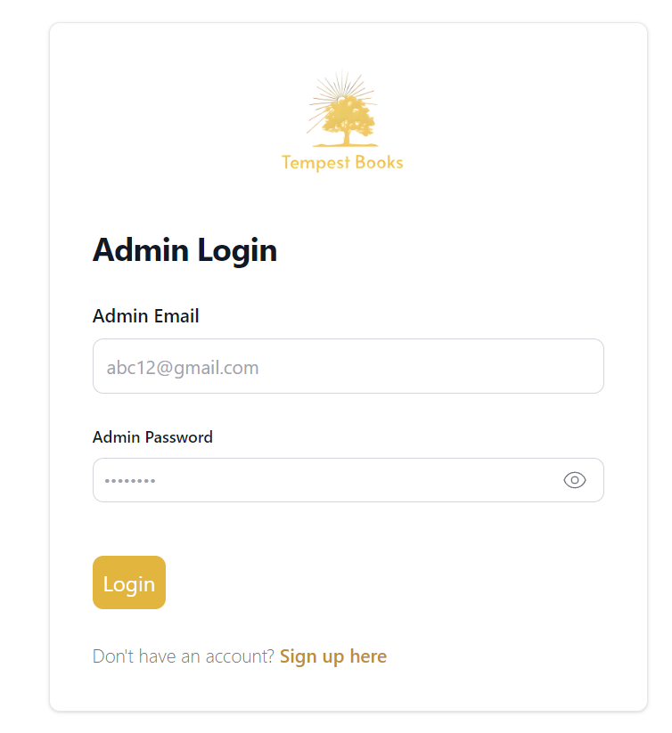

Enter admin password here, user can check it by clicking eye button

Enter admin email here

Enter login here after fill all information

If user doesn’t have an account, click this to make new account.

This is the first page that company sided user will see when entering into website. This is the login page.

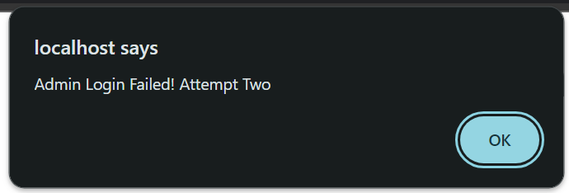

This is the alert box when user enter wrong password.

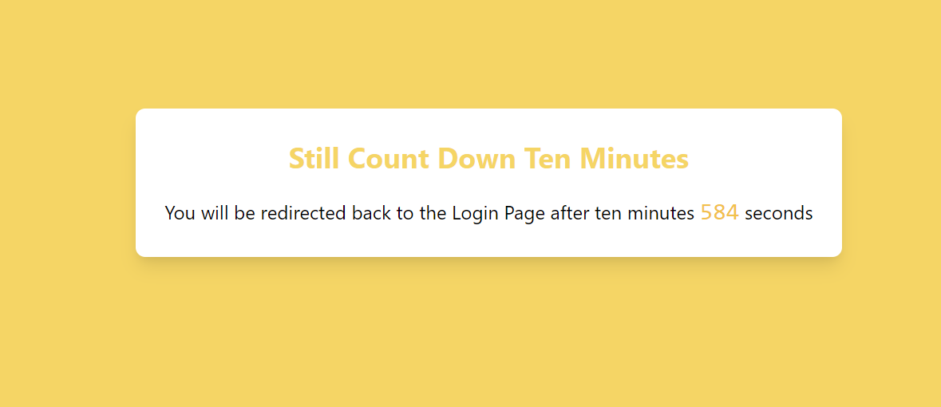

This is the timer when login failed three times.

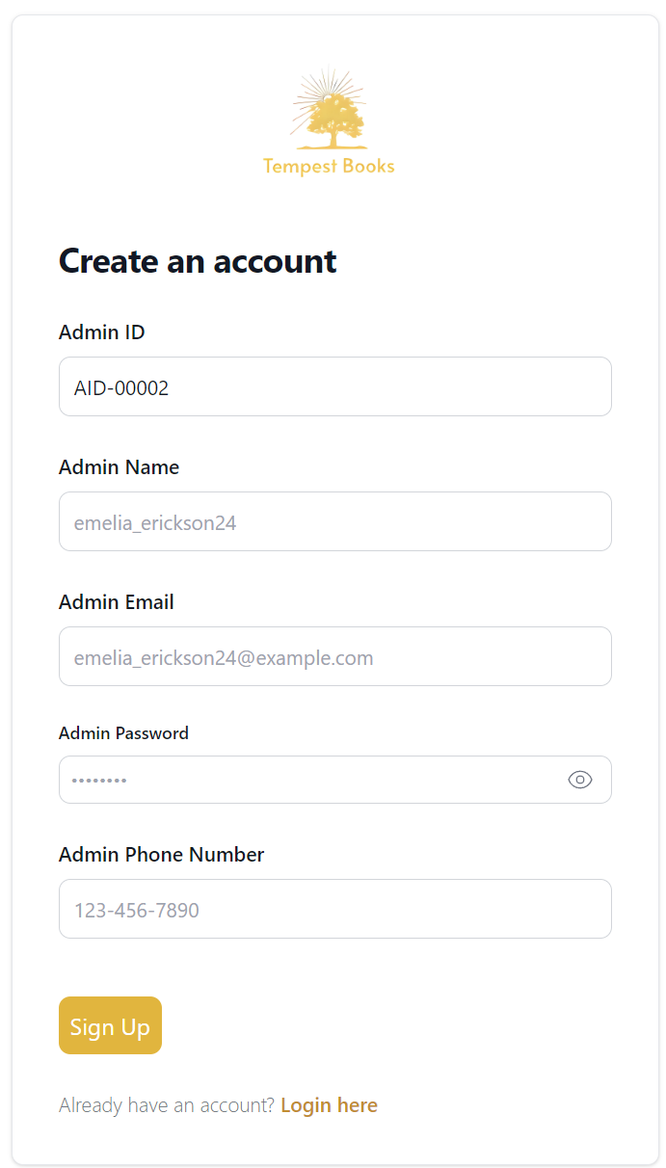

And enter sign up to submit all information.

If already have an account, click this to proceed to login page

Here admin will need to enter his phone number

Fill the password. The password has some policies for strong password.

Admin ID will be auto incremented.

Enter admin name here.

Enter admin email here

This is the registration page.

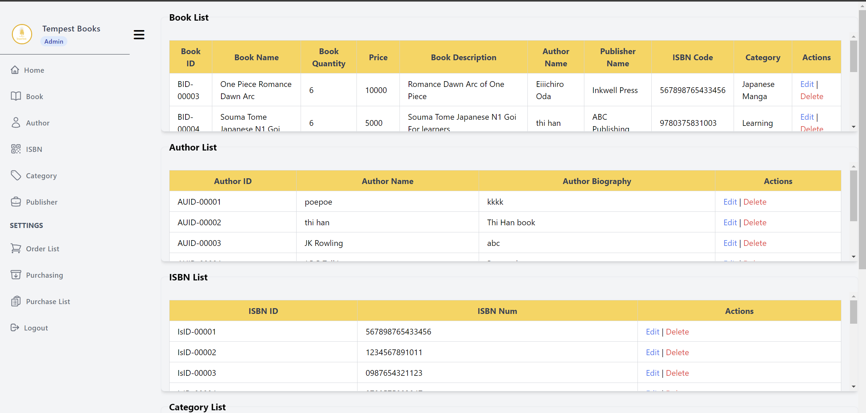

This is admin dashboard.

The usage of admin dashboard will be explained in two parts.

The first part is side bar navigation which will be explained in below.

The other part is explanation about listings.

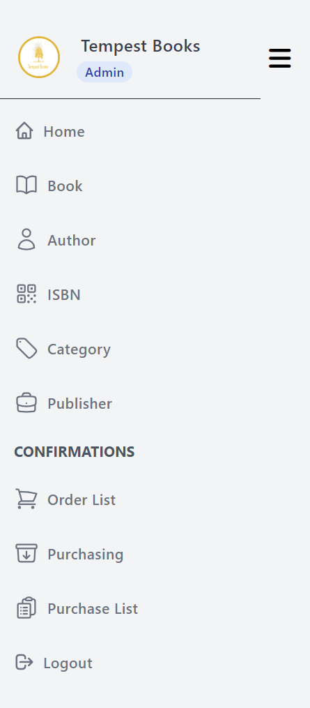

This is the navigation as a side bar for admin.

After clicking this admin will be logout. But confirmation will be shown.

This tag can link to purchase lists.

After clicking this tag, admin will able make purchases from suppliers.

Admins will able to check order lists from customers by clicking this tag.

This will link to publisher page.

This will lead to category page.

This links to ISBN page.

Linked with author page.

This links to the book adding page.

This will take to the home page which is also dashboard page.

Hemberger menu bar which will work in medium device.

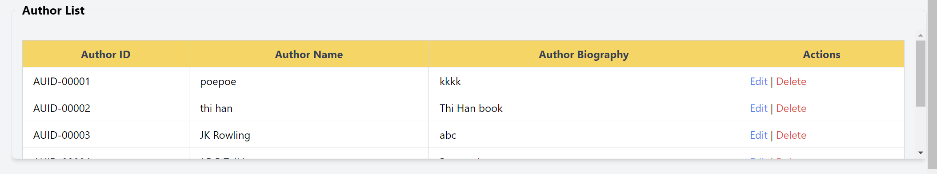

Edit and delete tags for changing information if needed.

**Author List will be exampled for every listing**

This is the listing from admin dashboard.   
Admins can check the respective information and their related data.

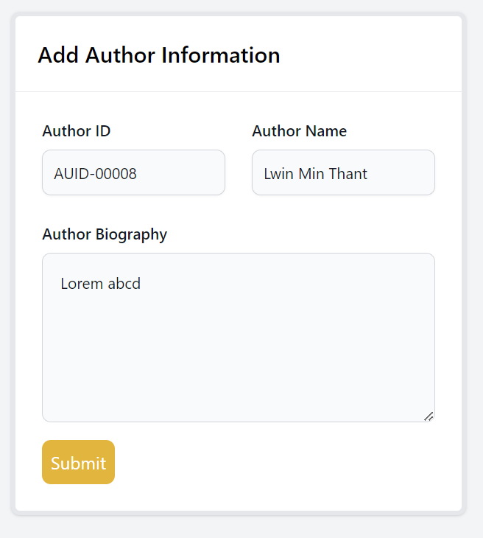

**Adding of author information page will be exampled** for category, ISBN, and publisher pages since their designs and data needed to be added are same.

Enter the author name.

Enter author biography.

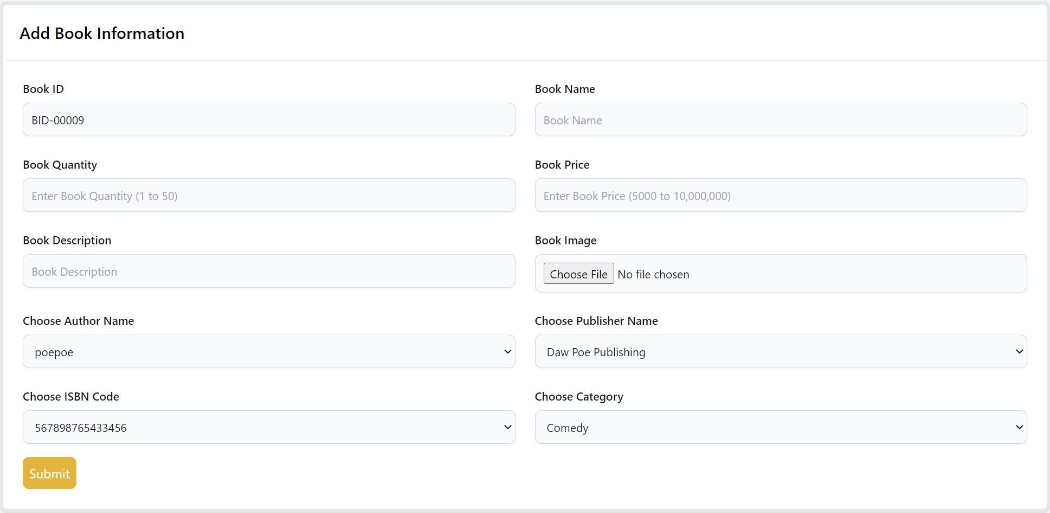

This is the page for adding information of books data. There are book id which will be auto incremented, book name which need to be filled, book quantity which can be clicked and filled, book price which will start from 5000 mmk and then increment or just fill manually, book description will need to be filled, book image will be chosen from device files, author name will be chosen from database, so do for publisher name, ISBN code and category.

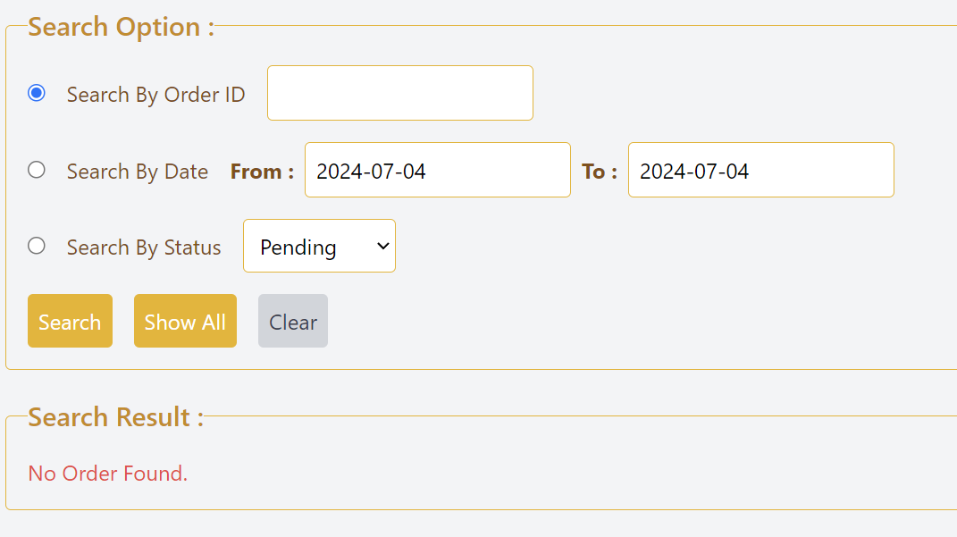

This is order list. Admins can search the order data with order ID, ordered date and status. These can be searched by clicking search button.

Or admins can see all the orders by clicking show all button.

Clear button works for clearing order ID.

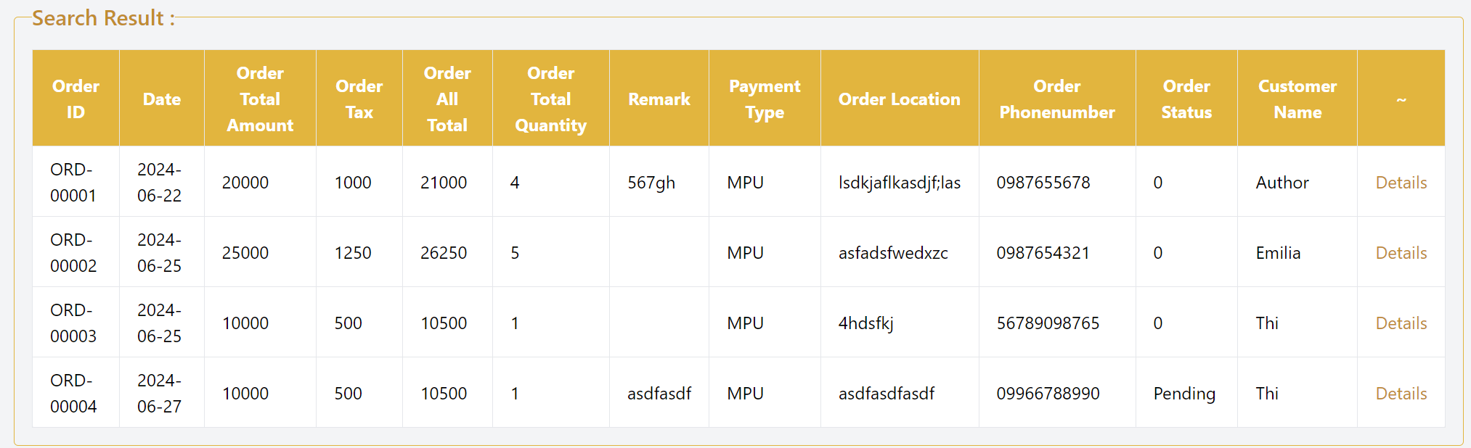

This will be shown when it is searched. Admins can click the details to check the order information.

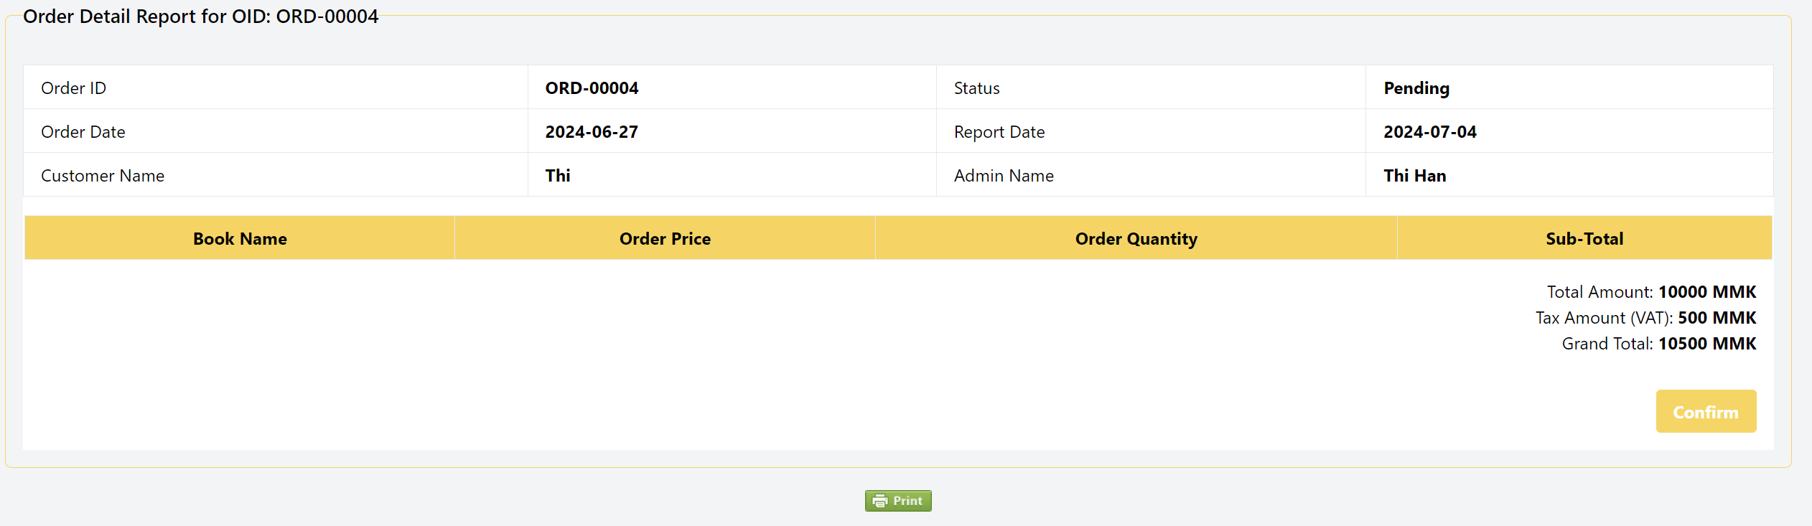

This will be shown and admins will need to click confirm button make the order confirm.

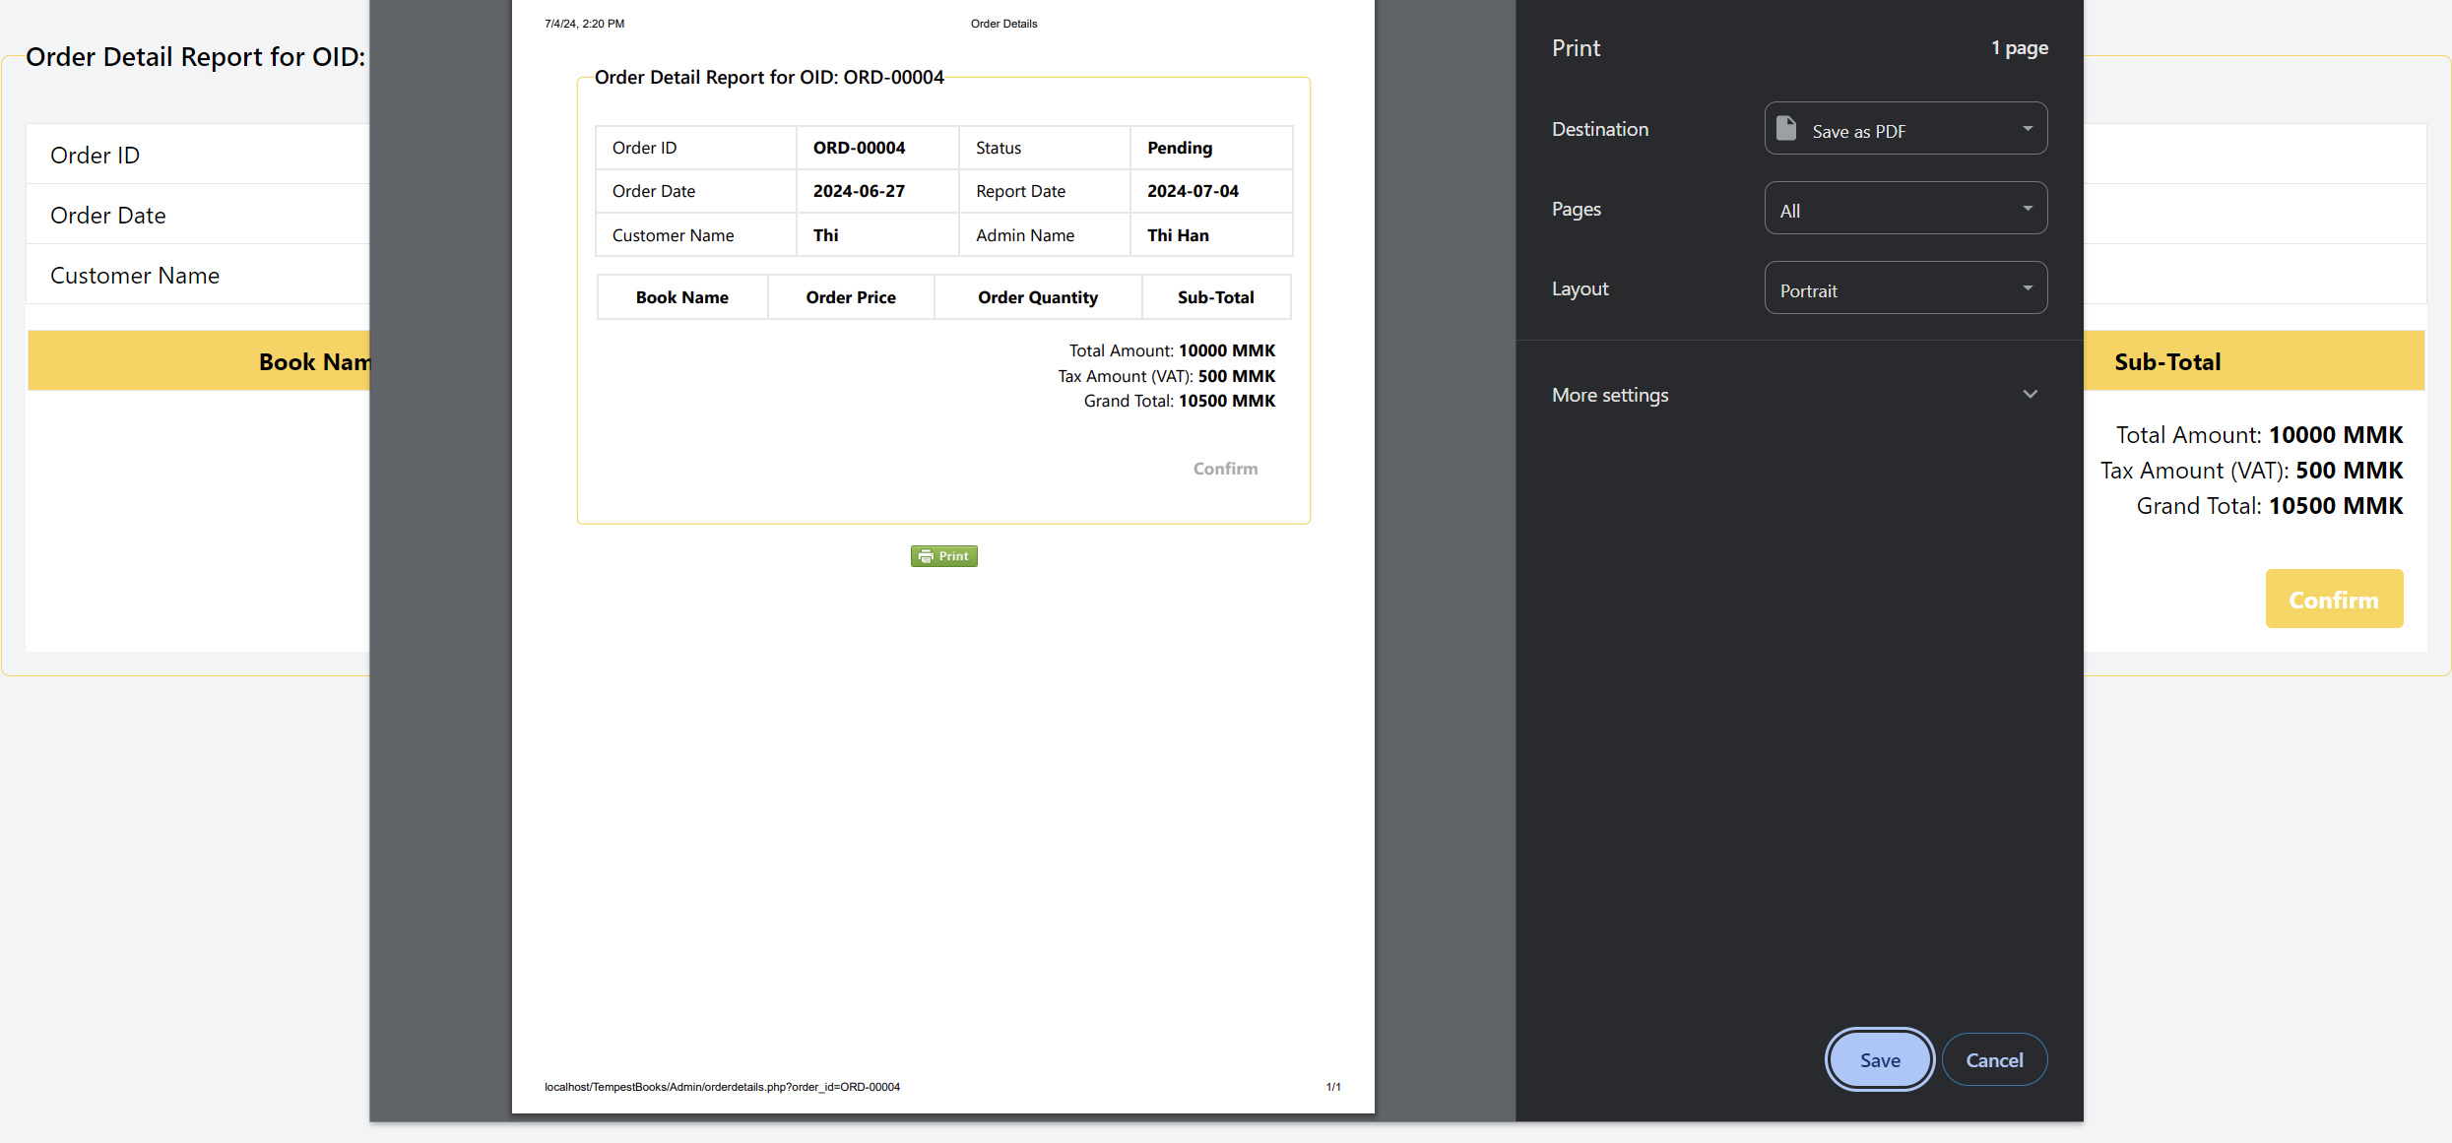

Admin can click print button make copy of order detail.

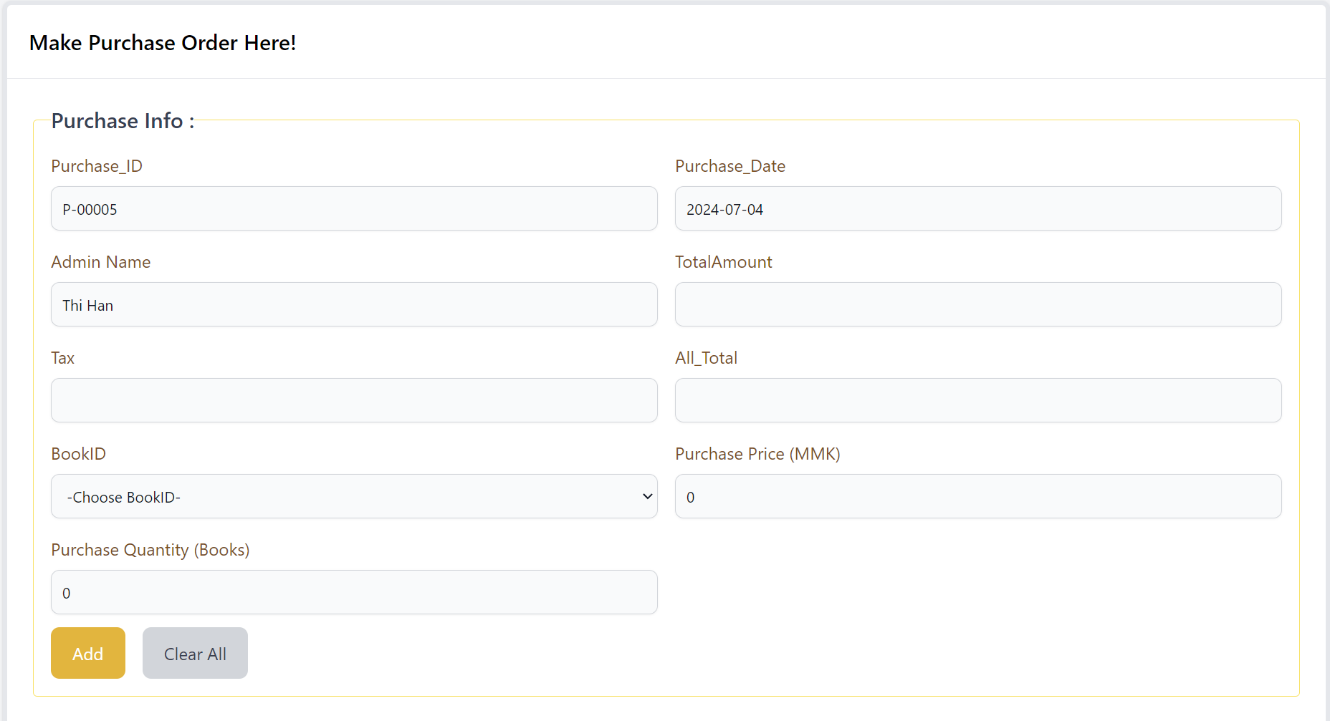

This is the page for making purchasing from suppliers. Admins will need to add the necessary information and then click the add too make.

Note Admins will just have to enter purchase price and quantity, all the tax, total amount and all total will be calculated automatically.

Admin can click clear all too.

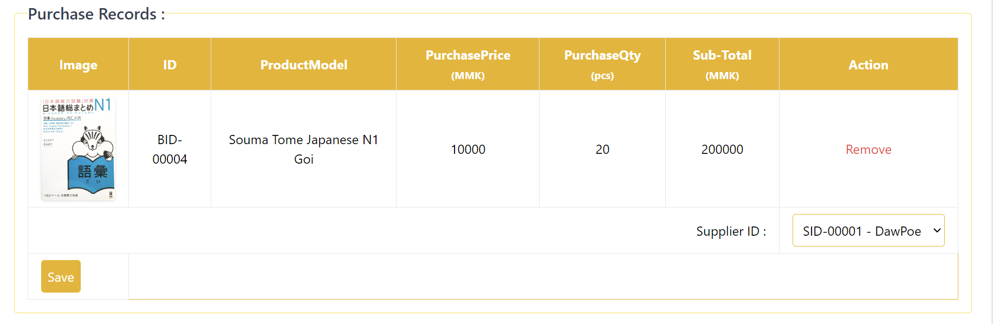

After clicking add button, the purchased record will be shown, when this is shown admin will need to choose supplier name from drop down box and click save to proceed the purchasing. Or the purchased record can be removed.

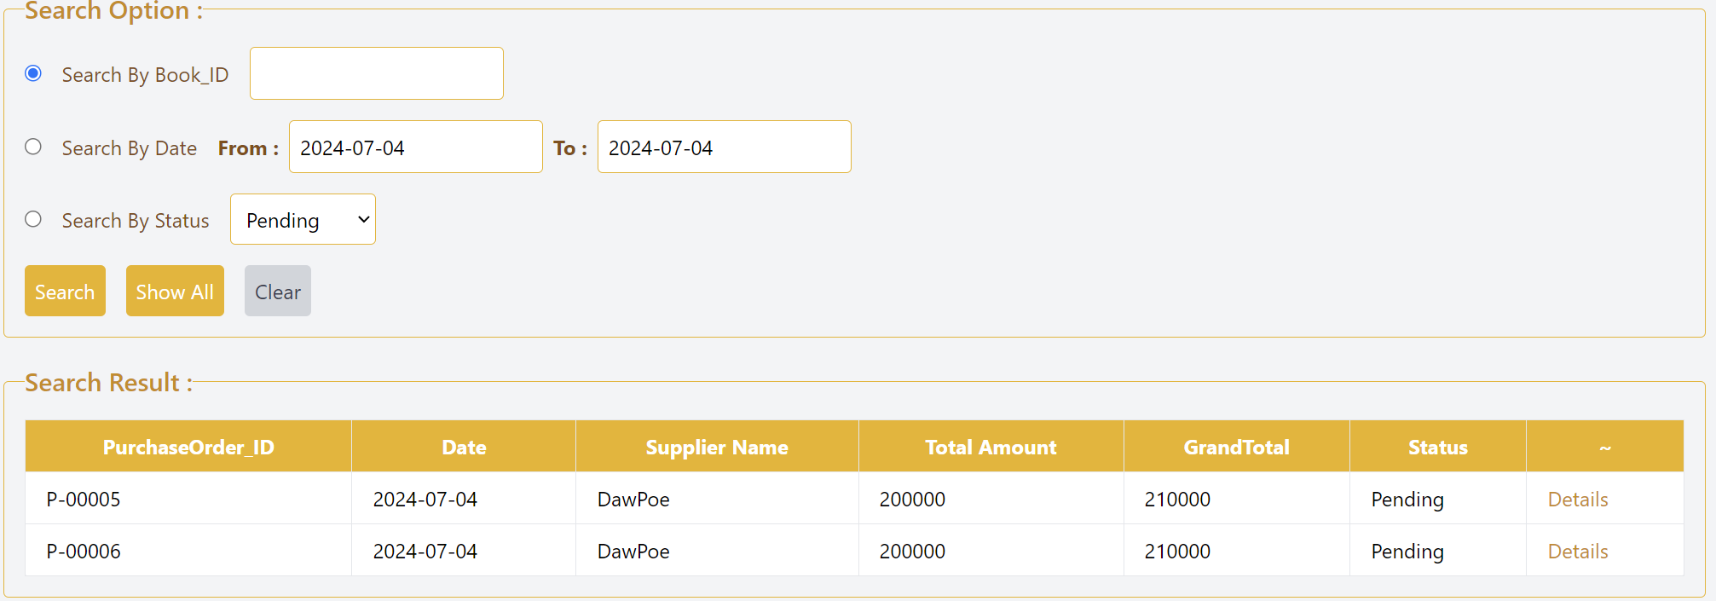

This is the purchasing list which admins can able to confirm their purchase orders by clicking details.

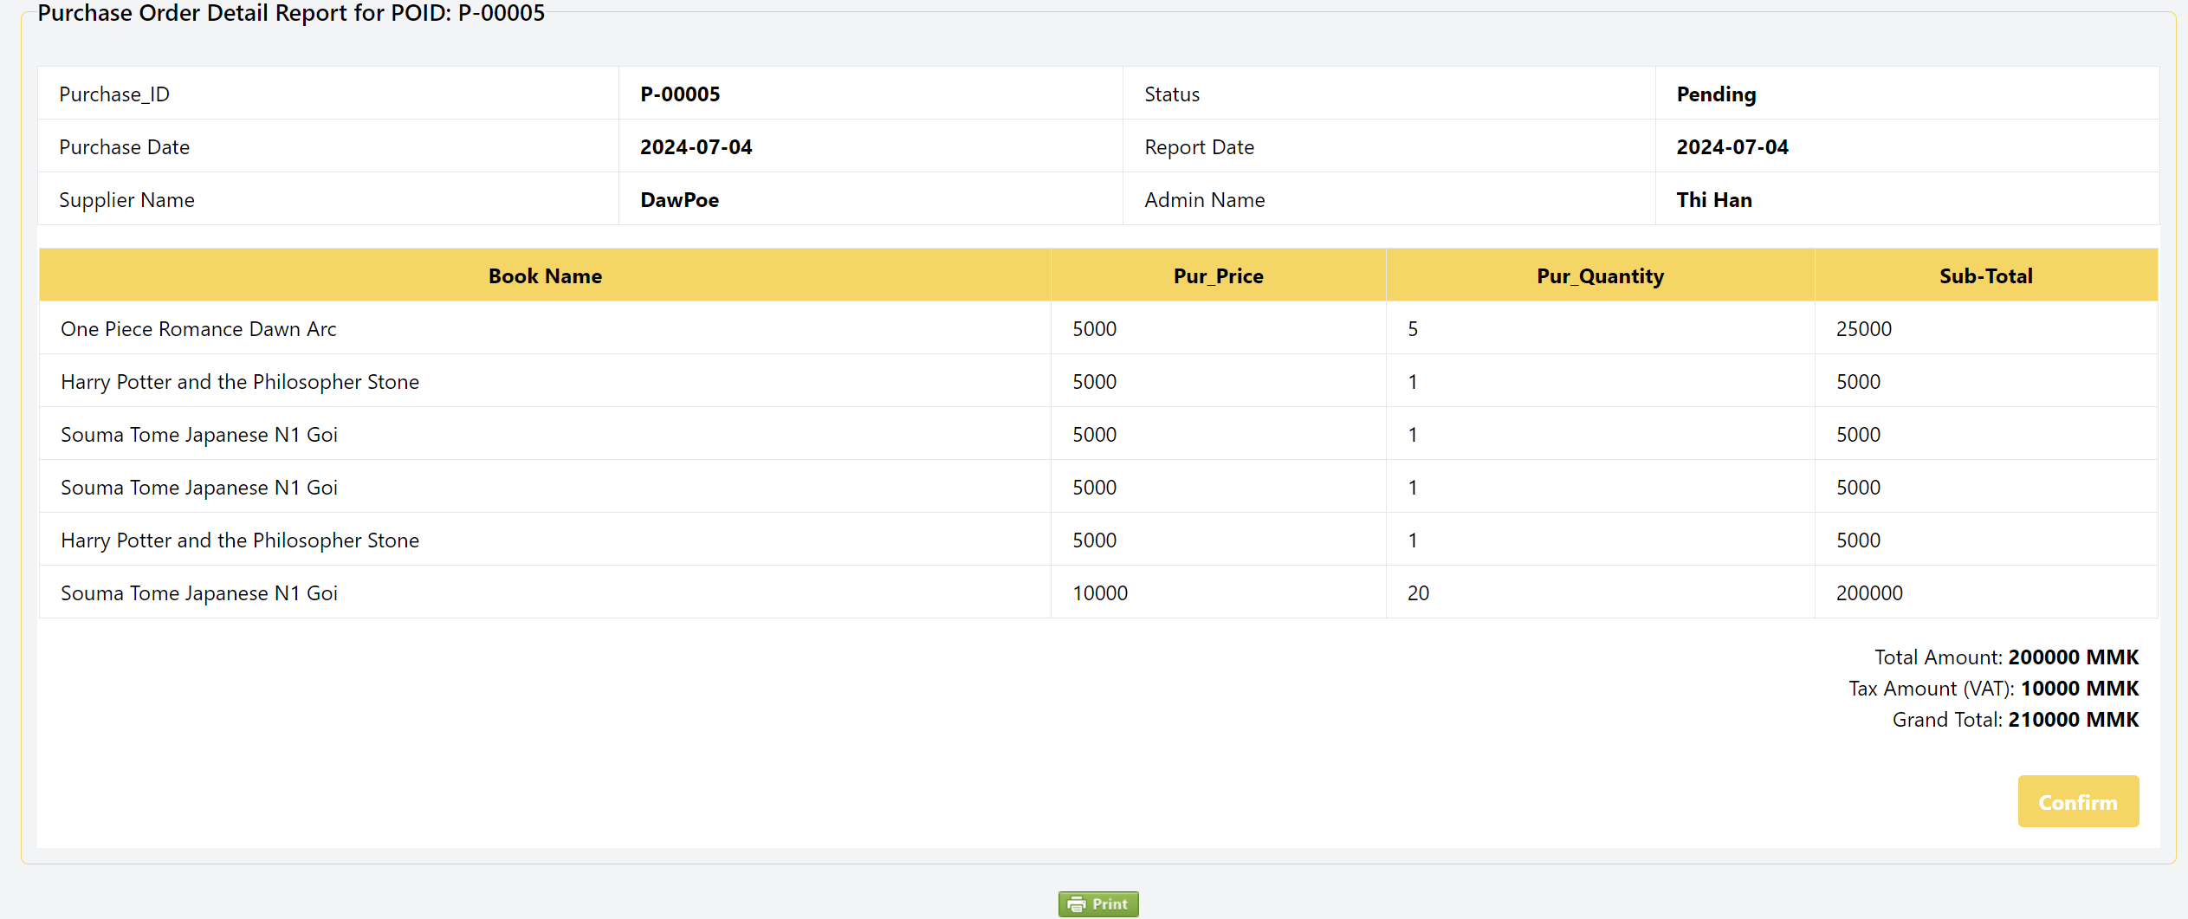

The purchased recorded is shown with the related ID and all the necessary information are shown below. After this, admins can click confirm to make the purchase order confirmed.

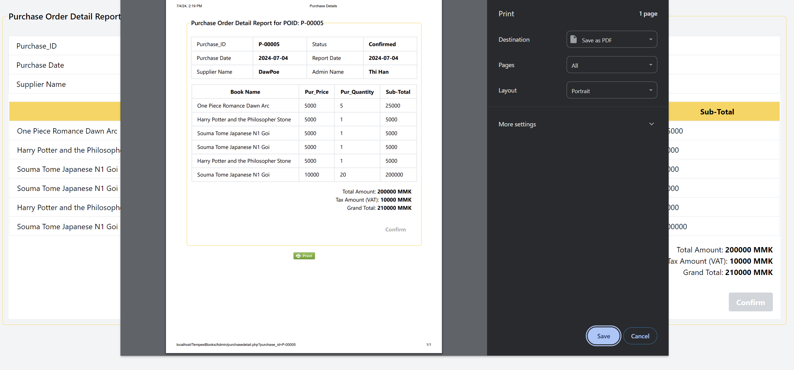

Admin can click print button to make slip or make copy.

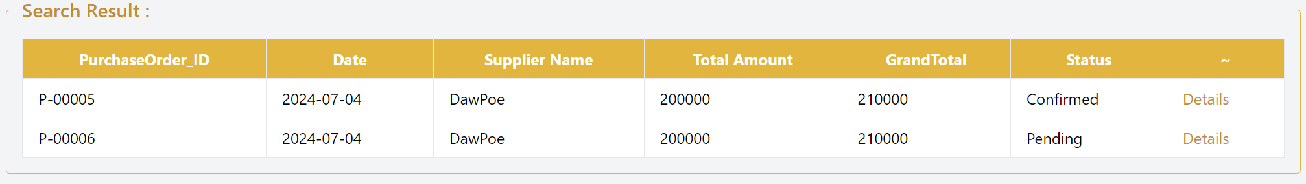

Then the status will be confirmed.

#### **Customer Process**

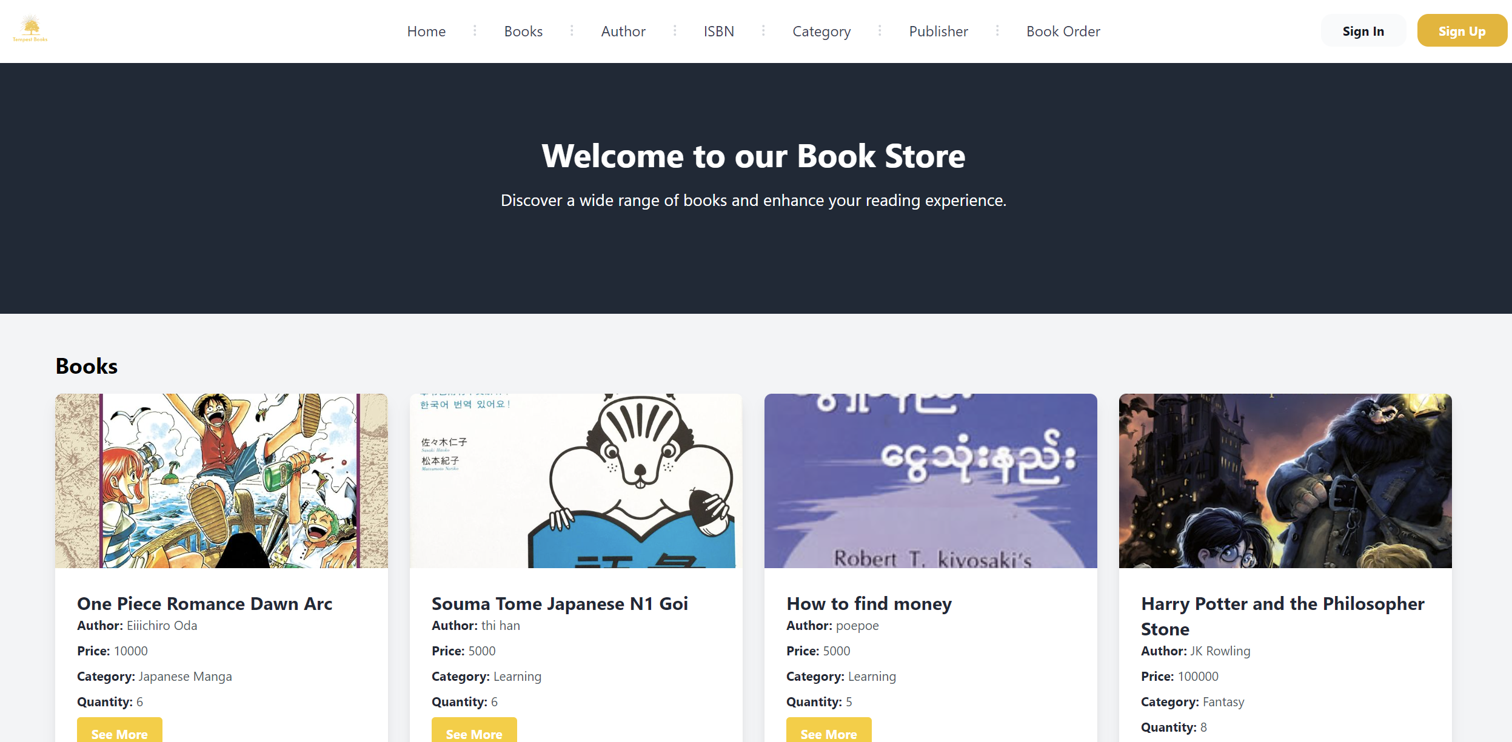

This is the home page for customers. In navigation bar there is sign and sign up buttons.

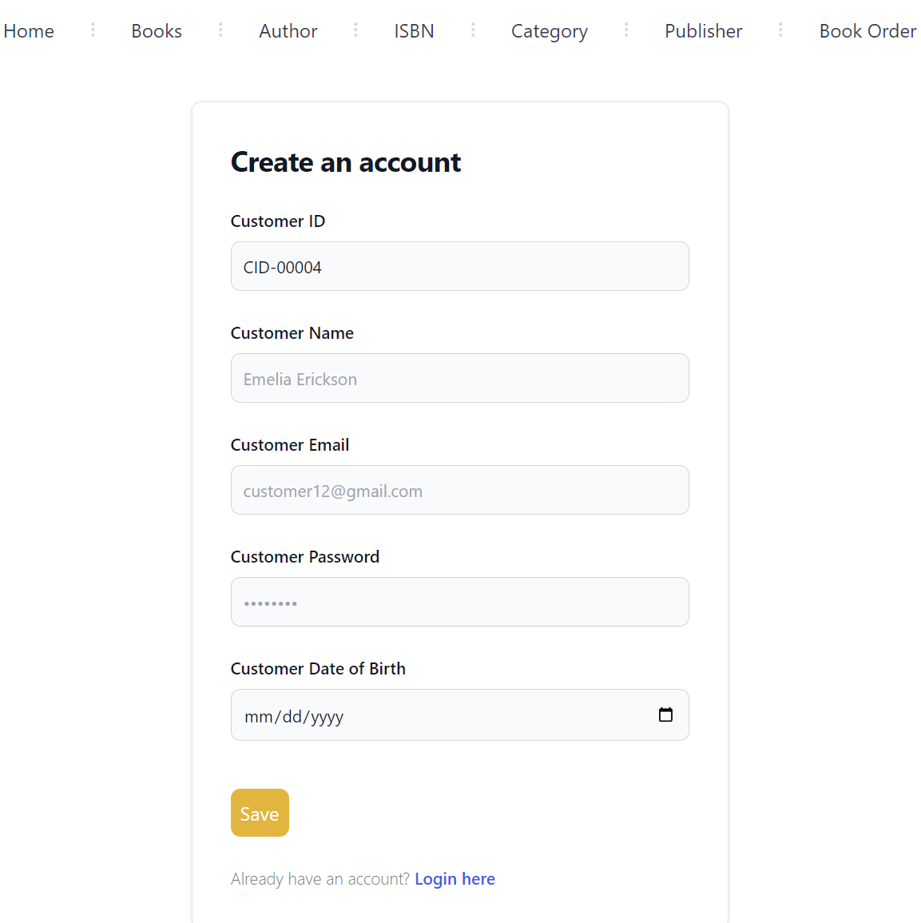

Customer will need to fill described information. Customer id will be auto incremented. Customer name, customer email and customer password will need to be filled. The password has some policies for strong password validations. Customer will need to click the icon for choosing date of birth. After filling all information click save button for registration. If the customer already have an account, login here can be clicked.

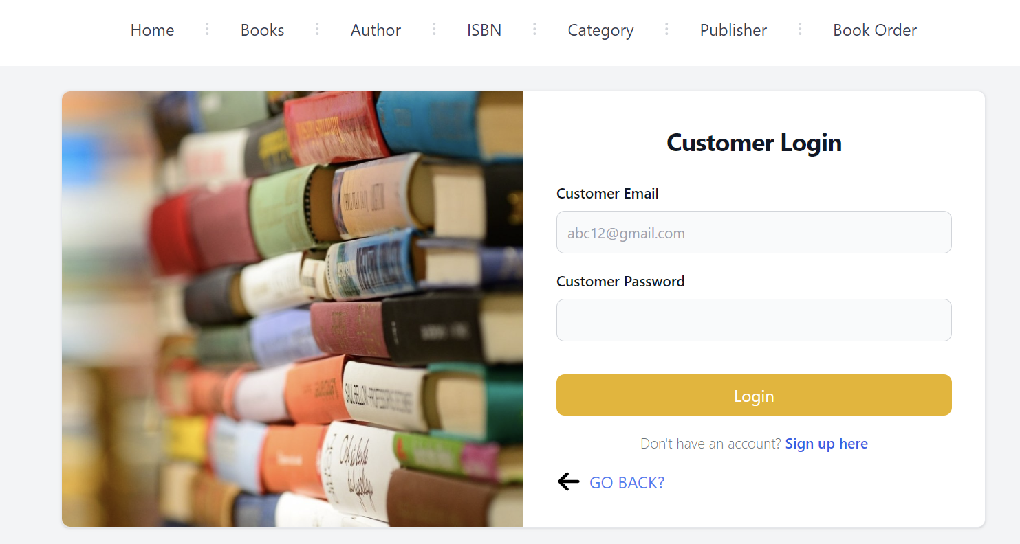

Customer will have to enter the email and password for login. If customer do not want to login he can click go back button to reach home page. Or clicking sign up here for new registration. Note, customer password must not be false three times.



This is the timer page when the customer enters wrong password three time same as admin.

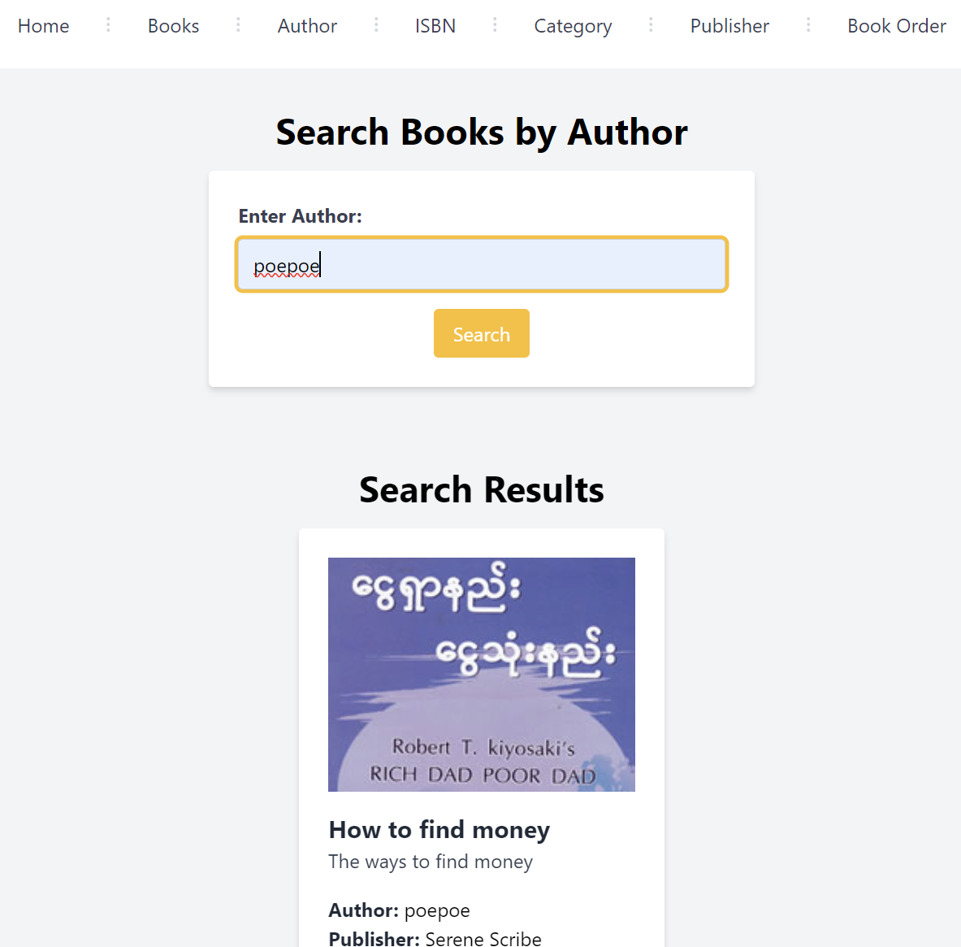

Enter the author name and click the search button, the related book will be shown below.

Customers can search books by author name.

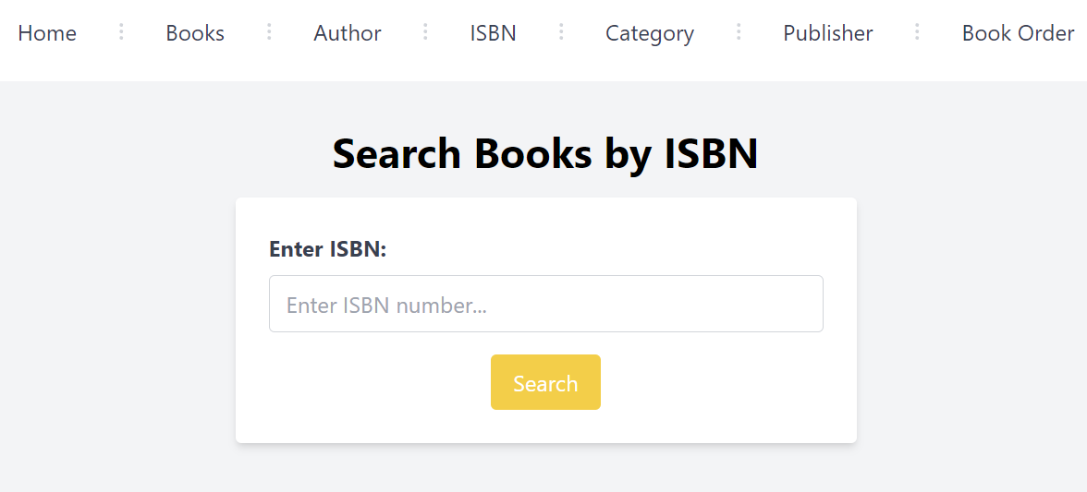

ISBN can also be search too. And this page has same function like author page.

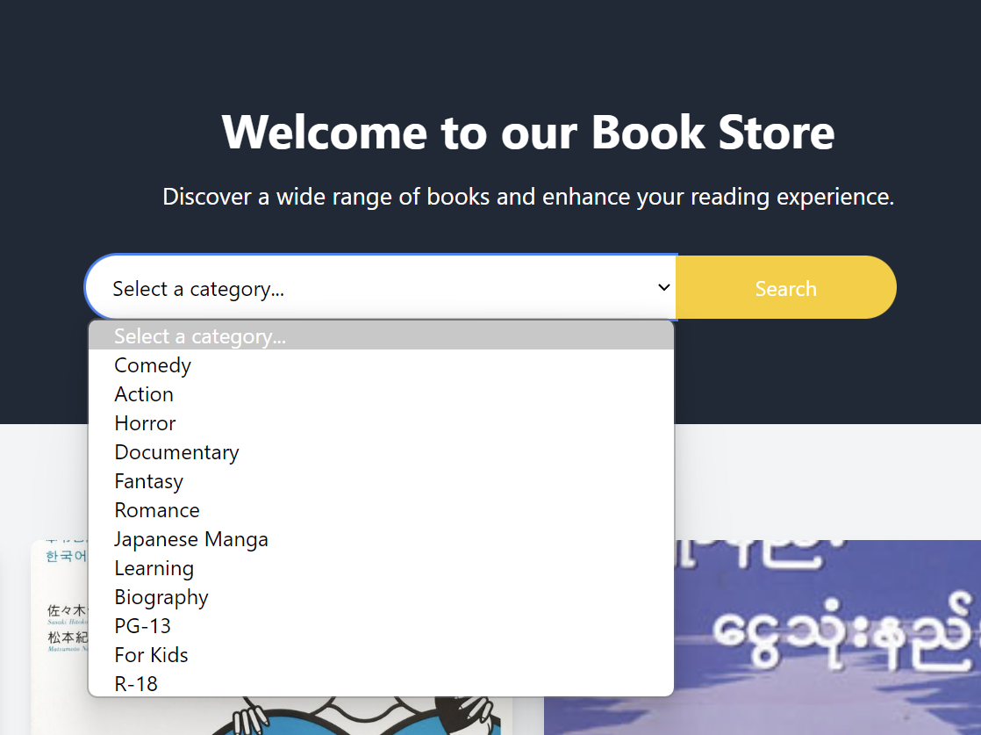

Click the down arrow button or the search box, the drop-down button will be shown.

These are category and publisher pages. The information are group and can be search with drop down boxes.

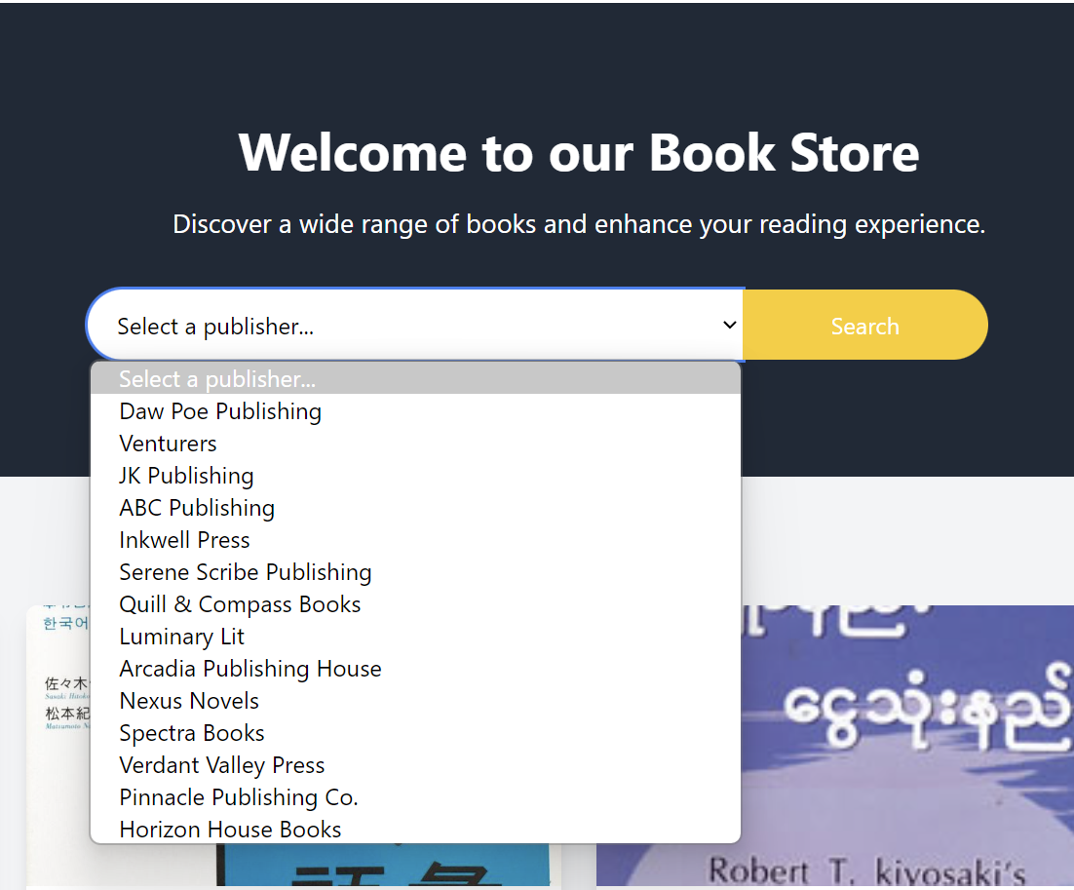

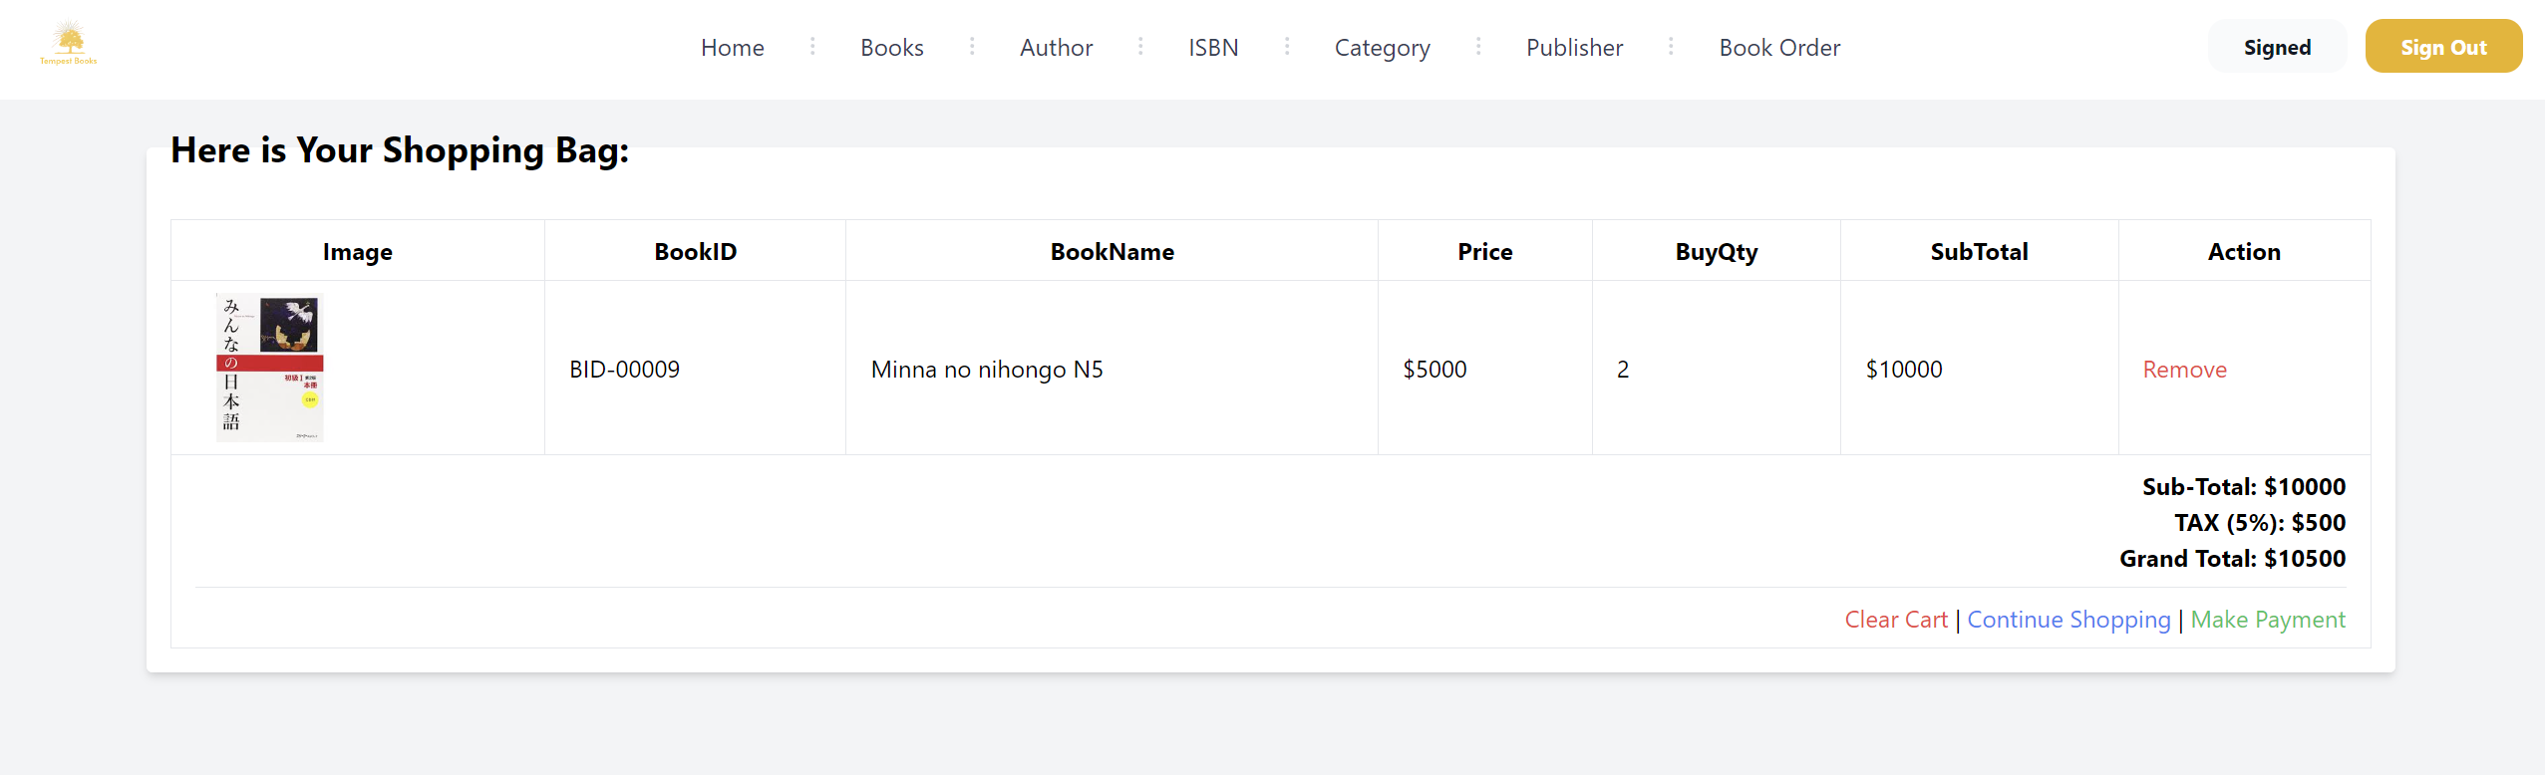

This page will be reached if book order tag is clicked. If the customer did not login, the system will ask customer to login first.

**Book ordering process**



Click see more button for ordering process

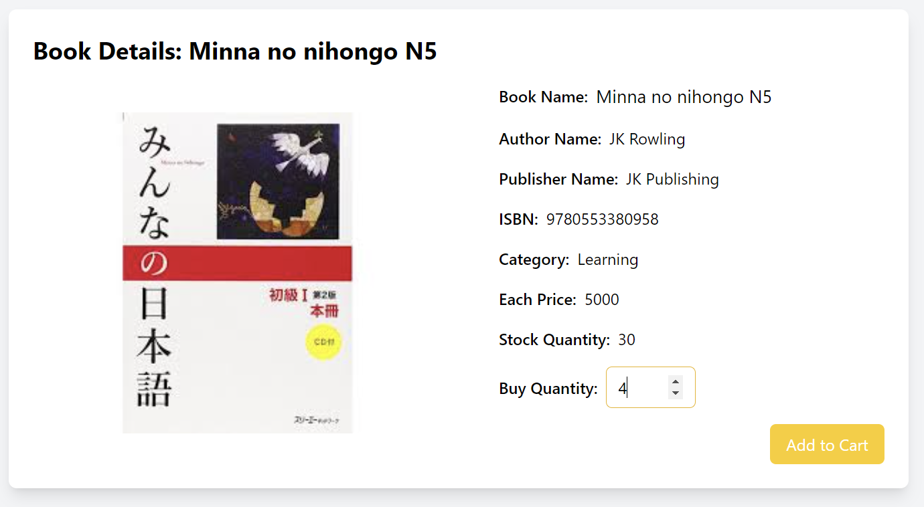

After choosing quantity, click add to cart button.

Choose quantity

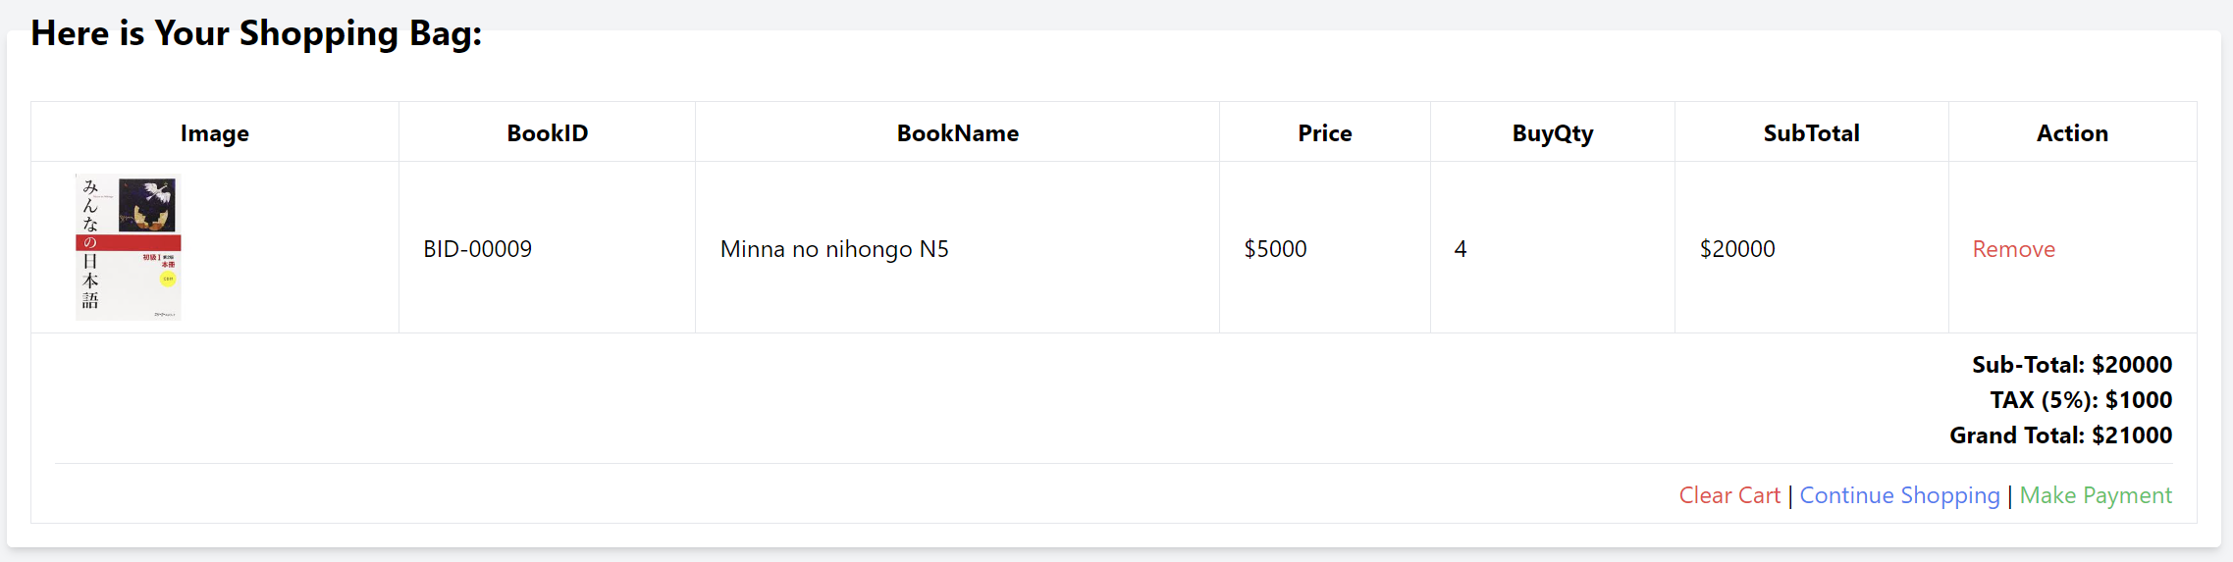

This is the shopping cart page. All the amount including taxes are shown. Customer can procced to make payment, continue shopping or clear cart. Customer can also remove by each book.

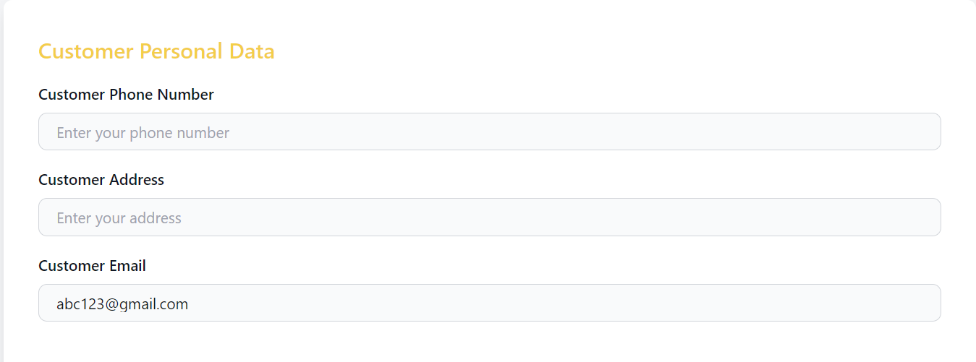

Here customer will need to add phone number and address, customer email will be used from the account and described.

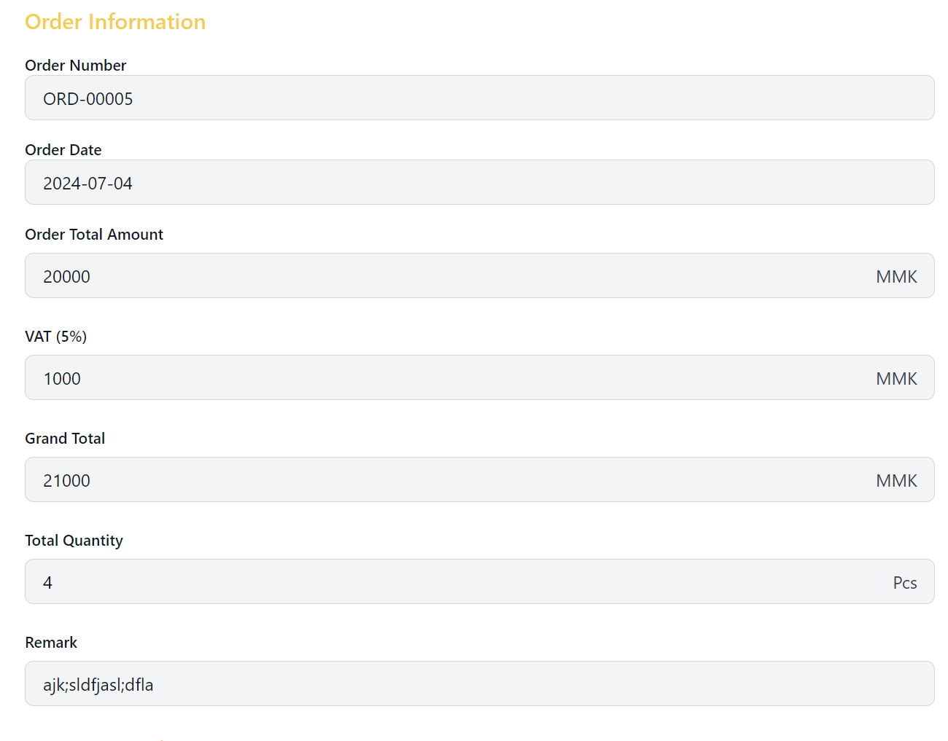

Here is the order information to check back, can add remark.

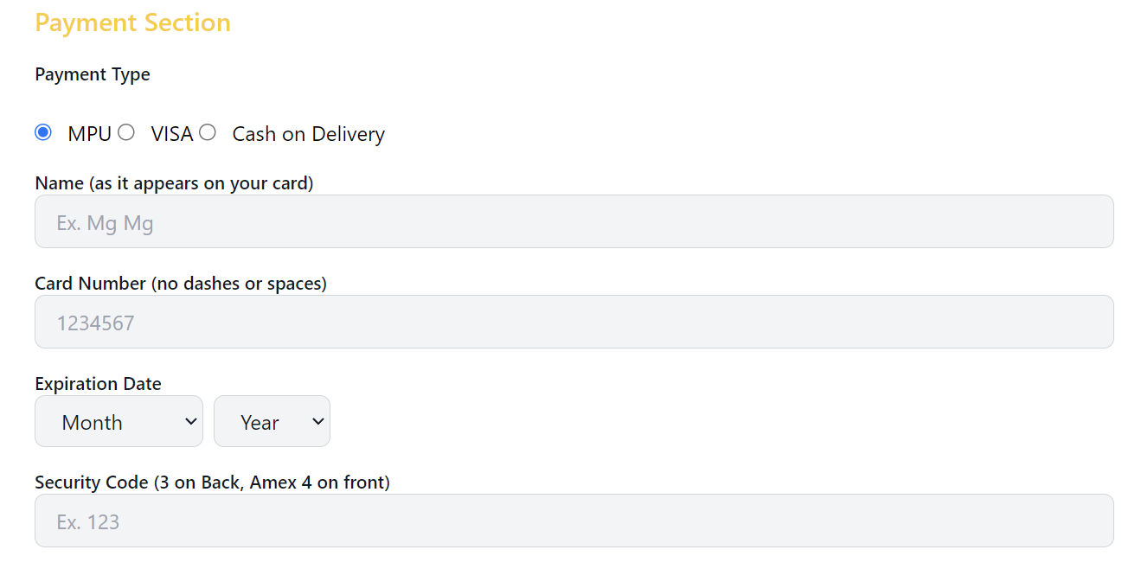

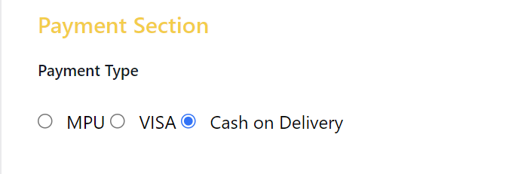

Can choose payment types MPU, Visa or cash on delivery. If cash on delivery is chosen no information will be needed to fill. If MPU or Visa is chosen, the detailed information will be need to filled.

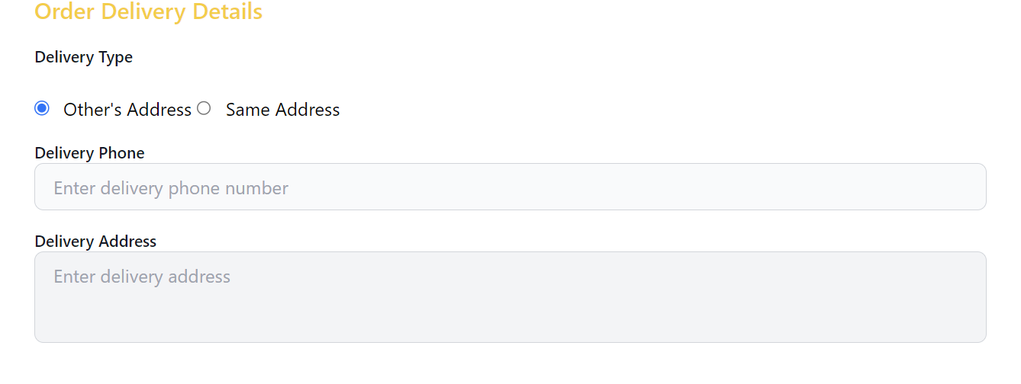

If order delivery is changed, the customer will need to fill information. If not, same address must be chosen.

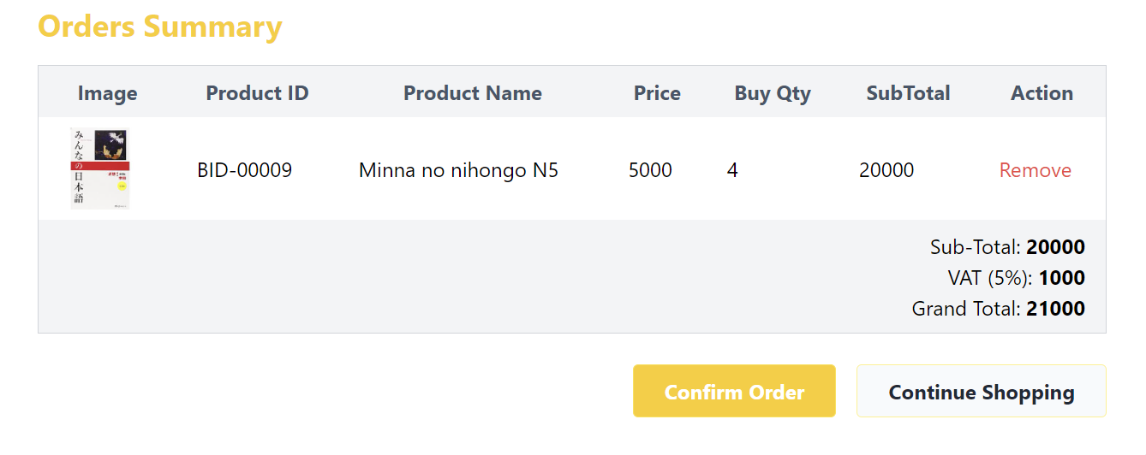

This will be order summary to check again before confirming order. If customer wants to confirm, confirm order will be clicked. If customer wants to continue shopping, continue shopping button will be clicked.

**Summary for User Manual**

This is all for user manual of the system. Store staffs including admins will need to read these manuals before using the system. Even thought they will have training sessions; these user manuals can help them even if they forget something in the future. There is also user manual for customers. They can share this user manual to customers too. For example, sharing the user manual books when they launch their program. Store staffs will also be able to read user manual and can guide customers about the usage of book too. For example, whenever a customer contact to the store for the service, they can read this user manual and able to guide to that customer.

**Chapter – 7**

**Conclusion**

# Chapter 7 Evaluation

## 7.1 Evaluation Against Aims & Objectives

### 7.1.1 Aims

The system included most features of e-commerce system website. It also provides automated features for admins. The system also provides smooth and convenient features for customers too. So, the system full fills the primary aims.

### 7.1.2 Objectives

#### Analysis

After gathering requirements, getting knowledge for making analysis in correct method is started. Before starting analysis, methodologies were studied and read documentation about analysis. Then current business scope and issues are analyzed which include SWOT analysis. When new system is decided, similar systems are research and compared. Their functionalities and non-functionalities are also compared and the systems (for both function and non-functional) that got best scores are referenced. These documentations can be read in Chapter 1 which contains about analysis and in Chapter 2 which contains about similar product comparisons.

#### Feasibility Study

For the feasibility study, strength and weakness of methodologies are listed and compared. Then used the suitable methodology for the current project. This process same goes for technical feasibility too which may include choosing programming language and database. After DSDM methodology is recommended and chosen for this current project, feasibilities for DSDM is also described in this documentation for why it is used. After this, possible legal social ethical professional issues are studied and used for this project. These documentations can be read in Chapter 3.

#### Foundation

For the foundation objective, target users are defined. Then functional requirements are also defined. These functional requirements are prioritized by MOSCOW prioritization which is referenced and applied for developing program. Non-functional requirements are described that may needed for the program. After defining these, time boxes are planed followed by risk management, risk monitoring and risk avoidance. Then possible risks are identified and after this risk matrix is described. These foundations are described in Chapter 4.

#### Design

Design for use cases and class diagram are developed within deadline. But there was not enough time for prototyping so time box 1 had only low-level prototyping and customer sided time box’s prototypes are iterated a lot until before the deployment.

#### Coding

Coding is a little difficult and had to take time from other plans such as testing. But some parts are performed in parallel. But the system was able to follow some parts of Nelson heuristic usability

#### Testing

Testing only done for the most necessary part of the system to catch up with the deadlines of the project plan. But all the essential functions and requirements have been tested and even iterated if necessary.

#### Implementation

All the implementation plans, required steps are described in chapter 6 which includes deployment diagram, explanations and data migration. User manual which will be needed before deployment is also explained in the same chapter.

#### Training

Before the deployment of the program, admin side users had to read user manual and training sessions for them are made. It had to make sure that they understand the flow of the program and have security and other technical knowledge. After the training camps are over, they had to use the program in beta version too.

## 7.2 Evaluation Against Similar System

|  |  |  |
| --- | --- | --- |
| No. | Current System | Similar System ( Shop.com.mm) |
| 1. | Shopping Cart Reference    Mathematic calculation function is included and continue shopping, deleting and make payment are not designed with icons but with letters to make customers easier to understand. | Shopping Cart Reference    Has mathematic calculations to provide user experience. Most of the linking and functions are provided with buttons. |
| 2. | Searching items    Search bar is referenced but this is not applied in the navigation bar. Search button is on the side. This is due to different system and business intentions. | Searching items    Has search bar in navigation bar to search all the products they provide. Search icon is in the search bar. |
| 3. | Display products in cards    Books are displayed with cards. Each card is huge to read specific information. Also, each card has links to detailed page. | Display products in cards    Products are display in small size card since they provide a lot. Each card links to their detailed information provided page. |
| 4. | Error prevention    Ask the user permission first before deleting something. | Error prevention    It pops up with message box in the middle. |
| 5. | Home page visual    Has clear and minimalist design in the home page. Navigation bar is on the top providing only necessary information for a book.  Use few main colors which are white, black and yellow. | Home page visual    Has many items provided in home page. Navigation is on the side since it has many different products.  Has main color orange and its related colors. |

## 7.3 Evaluation Against Justification Made

**Methodology**

In this project, Waterfall methodology and DSDM methodology are compared. From the comparison results, DSDM was chosen sine it is flexible and effect not only for developers but also for admins. Since admins will change the website depending on the customers’ taste and business requirements which also vary depending on business strategies. DSDM uses timeboxing method making the project having two time-boxes. There were also iterations in each time-boxes. Issues and problems were also occurred in the development phases of each time-boxes and had some delays. But after all the development and testing are done, the final product caught the client’s satisfactions. Sine the project is based on the DSDM method, whenever the client wishes to change design or system flow, the product can be able to change along with it. Documentations are also reported based on DSDM methodology, common issue that occurs in Agile development is already solved. In addition, using this methodology gain the knowledge of time boxing, and some other benefits.

**Language**

For the programming language, Java and PHP are compared and it is found that PHP is suitable for the current project. Although Java is strong and widely used web development, for the medium sized system like current project is better with PHP. Also, PHP is already familiar and easier when written with frontend languages like JavaScript, HTML and Tailwind CSS. It was also compactable when using with MySQL. Using pure PHP had some issues while processing data without reloading and better when the developer have more knowledge about scripting language and its syntax, symmetric and pragmatic. For the frontend languages, JavaScript is mainly used and for the designing only Tailwind CSS is used. JavaScript is strong and widely used in web development with many other languages. In this project, it was used to create functions for the purpose of frontend user experience. Its framework and libraries were strong too but they were not used in the project. To reduce CSS codes, tailwind is compactable and becoming people favorite framework. It was used in this project for making of beautiful and responsive UI design. In addition, using all these languages in PHP file format was easier to manage files and better while linking and reusing of the files.

**Database**

MySQL and mongoDB were compared which one is more suitable for this current project. Although mongoDB is becoming popular and stronger, MySQL is more suitable for this project. MySQL is an open-source database which is cost-effective for the store and it is familiar with most the developers. Although frontend of the system may change frequently, the backend which is database of the system may not change very much. MySQL is better suitable choice when the database architecture is stable. Even though other web-based systems may change their backend system, the requirement and business flow for this system will not change. The use of MySQL is also easy and can able to create databases, and their tables manually and by the use of executing SQL queries. Also, PHP is integrated with MySQL, it is easy to write SQL codes with PHP and easier to connect with the website. The usage of inserting, updating and deleting data are also simple. Not only that but also fetching and joining tables are also easy to understand. Since MySQL is familiar to many developers, even if the developer team is changed, other developers can easily understand how the database is architecture. But there are also issues and errors while using MySQL. The current project used Xampp application to use MySQL database, the shutting down is the huge problem. If the database is not exported, all the tables will be destroyed and will need to restart. Rebuilding process may be easy after the architecture is designed but it will take unnecessary time and slow down the progress of the development. In this project, there are select queries to view the data, and tables are joined to view and fetching of the data, creating table queries, deleting unwanted data and also other useful queries are also included for better consistency of the website.

**Design**

Designing in the project was a little difficult since it includes a lot of software development knowledge from real life projects. Design in the project includes designing of prototypes, designing of diagrams, and designing of system interfaces. Detail designing was really important and at the same time needs lot of research, analysis, planning and time. So, it was difficult but after the designs are finished the sequence process are easier a lot. By following the designs, the development can be done in short time seamlessly. Design in this current includes use case diagram, class diagram, prototypes, deployment diagrams and user manuals. Even though user manual may not be designing for the project development, designing user manual clearly can help when owners or clients read the book by good visuals, and explanations. Designs purposes were to reduce time and have better understanding for the user and all designs in the project are suited with that fact.

## 7.4 Evaluation Against Timebox Plan

**Timebox 1: Manage Purchases Time Box**

Time box 1 was developed on April 30, 2024 Tuesday and planned to end on May 20, 2024 Monday. Developing time box 1 was more trouble than the prediction which may due to coding skill and technical knowledge. But all the tasks were able to finish within deadlines. All the development steps were able to finish in time may due to the well planning of time box and following steps from it. As a conclusion, all the design, coding, documentation, testing was able to finish within planned date May 20, 2024 even though there are some errors and iterations.

**Timebox 2: Manage Order Time Box**

Time box 2 was developed on May 21, 2024 Tuesday and planned to end on June 10, 2024 Monday. After developing time box 1, developing time box 2 is easier than expected. Although there are new functions, and new things to learn in time box 2. Even though design iteration was repeated but it was not big in changes to be documented. As a result, time box 2 also able to finish within deadlines which is June 10, 2024. Like time box 1, time box 2 overall design, coding, documentation, and testing are also done without much problems than planned.

## 7.5 Personal Evaluation

**Personal Skills**

After doing this project, opinion on making a project in real life got wider. Learning new knowledge while continuing the project also taught many experiences. Moreover, skills like ability to work under deadlines, stresses, and pressures got improved. Documentation skills were also improved due to learning from many different sources.

**Analysis**

Doing this project helps me improve my analytic skills. Knew how to make analysis in diplomatic way and improve demonstrating skill to demonstrate the data that got from analysis. Also, realized comparisons and including clarifying of strength and weakness is important before confirming or deciding to choose something. Moreover, learnt more detailed factors about Agile and DSDM and hoping these methodology knowledges may help in the future. Furthermore, want to learn about more methodologies and want to make analysis in my future projects like SCRUM, XP, SSADM.

**Technology and Coding**

This project helped me improved my technical skills a lot. Improved my skills about using framework skill and realized using frameworks help projects faster and easier than using only pure technologies. During the project, learned about using tailwind CSS and applied and realized using tailwind is easier and faster than pure CSS which is hard to make responsive and need more codes for better design. Also, skills about PHP and JavaScript are improved a lot. Used more complex and difficult functions for better performance of a website than casual coding. File management also improve a little.

**Design**

Not only design the website but also design about project development got improved a lot. Designing prototypes, ERDs, Class diagram and sequence diagrams improved knowledge about design. Also designing in this project improved UI/UX knowledge since learnt a lot and made analysis.

**Report**

This project made me realized the importance of documentation in software development projects. Properly documenting project proposal and project report could recall the processes easily and increase the effectiveness of system even in many other fields like business and medicine.

## **7.6 Strength and Weakness of Tempest Books**

### **7.6.1 Strength of Tempest Books**

**For admins**

-They will able to use this website can manipulate purchasing, book information and their related information which are author, publisher, ISBN and category.

-They will able to know the ordering information from customer and can be able to give confirmation of order. But they will not be able to manipulate the data like purchasing.

-The system will let admin easily manipulate the admin side data and easily review past records.

-The system has auto calculated functions to save more time and reduce human errors.

**For customers**

-The system includes searching and listing functions which will save time for customers.

-Customers will able to manipulate the ordered data in the cart before making payment.

-The system has auto calculated functions to show the quantity and charges including tax fees.

-Customers will have only few inputs which can reduce errors and improve the experience.

### **7.6.2 Weakness of Tempest Books**

-The current lack of encryptions and weak security.

-The current UI may not be favored by the customers.

-The current UX is not smooth enough to penetrate into the enterprise level market.

-The system excludes weekly and month sales and reports.

## **7.7 Future Amendment**

### **7.7.1 Program**

In the future, the program will be more consistent and emphasize on security and functions for both customer and admin. There will be more functions and smoothness of website will be better. In addition, customer side website will be look better visually. Customers will be able explore the website and can be able to save or read brief introductions of books in the future. Customers will able to use the website without creating and by login using their Google and social media accounts. For the admin side, system will also improve by having more function like exporting data in excel, listing for selling status and role-based systems. The system will also have encryptions for both customer and admin, and some data will be encrypted.

### **7.7.2 Design**

The design changing of the website will frequently occur in future since the system depends on trends and user experiences. For example, the hover, active of website will slightly different by each iteration. Also, the visual of website can change according to owners and business requirements.

### **7.7.3 Report**

When adding new functions and features to the system, the documentation will have more new slides, iterations and test scripts. At that time, the documentation will be updated and since this report is based on DSDM method, the report will easily be documented. Unlike the other Agile based developments, this report will be easier and cleaner to read.

# **Appendix**

## **Section A: Use Case Descriptions**

**Timebox 1: Purchasing Timebox**

**Use Case Description**

|  |  |
| --- | --- |
| **Use Case Name** | View Orders |
| **Actor** | Admin |
| **Flow of Event** | Admin can able to view orders made by customers and making confirmation of orders. |

**Use Case Description**

|  |  |
| --- | --- |
| **Use Case Name** | Purchase Books |
| **Actor** | Admin |
| **Flow of Event** | Admin can able to buy books from suppliers and show these books on website. |

**Use Case Description**

|  |  |
| --- | --- |
| **Use Case Name** | Add Books |
| **Actor** | Admin |
| **Flow of Event** | Admin can able to add the books after purchasing from supplier. Admin can add book which include detail information like author name. |

**Use Case Description**

|  |  |
| --- | --- |
| **Use Case Name** | Update Books |
| **Actor** | Admin |
| **Flow of Event** | Admin can able to update the book information when it is needed. For example, updating price. |

**Use Case Description**

|  |  |
| --- | --- |
| **Use Case Name** | Delete Books |
| **Actor** | Admin |
| **Flow of Event** | Admin can able to delete the book when the book is not sold anymore. |

**Use Case Description**

|  |  |
| --- | --- |
| **Use Case Name** | Create Accounts |
| **Actor** | Supplier |
| **Flow of Event** | Supplier can able to create account for supplying books. |

Timebox 2: Ordering Timebox

**Use Case Description**

|  |  |
| --- | --- |
| **Use Case Name** | Create Accounts |
| **Actor** | Customer |
| **Flow of Event** | Customer can able to create account for ordering books. |

**Use Case Description**

|  |  |
| --- | --- |
| **Use Case Name** | Order Books |
| **Actor** | Customer |
| **Flow of Event** | Customer can able to order books on website. |

**Use Case Description**

|  |  |
| --- | --- |
| **Use Case Name** | View Orders |
| **Actor** | Customer |
| **Flow of Event** | Customer can able to view orders that are been made. |

## **Section B: Detailed Class Definitions**

**Timebox 1: Purchasing Timebox**

|  |  |
| --- | --- |
| **Class Name** | Admin |
| **Attributes** | AdminID, adminName, adminPassword, adminEmail, adminPhonenumber |
| **Operation** | Create () |
| **Description** | << The Admin class is used to manage purchase and order of books and add information of book and its detailed information on the website.>> |

|  |  |
| --- | --- |
| **Class Name** | Book |
| **Attributes** | BookID, bookName, bookQty, bookPrice, bookDesc, bookImg, authorID, categoryID, ISBN_id, publisherID |
| **Operation** | Create (), Update (), Search (), Delete () |
| **Description** | << The Book class is used to add books on the website by admin.>> |

|  |  |
| --- | --- |
| **Class Name** | Purchase |
| **Attributes** | PurchaseID, purchaseDate, purchaseAmount, purchaseTax, purchaseTotalAmount, supplierID, purchaseStatus, adminID |
| **Operation** | Create (), Update (), Search (), Delete () |
| **Description** | << The Purchase class is used to purchase books from the suppliers by admins.>> |

|  |  |
| --- | --- |
| **Class Name** | Purchasedetail |
| **Attributes** | PurchaseID, BookID, unitPrice, Qty |
| **Operation** | Create (), Update (), Search (), Delete () |
| **Description** | << The Purchasedetail class is used to check or edit detailed information of purchased data.>> |

|  |  |
| --- | --- |
| **Class Name** | Supplier |
| **Attributes** | SupplierID, supplierName, supplierEmail, supplierPassword |
| **Operation** | Create () |
| **Description** | << The Supplier class is used to contact with admins letting them purchase book.>> |

|  |  |
| --- | --- |
| **Class Name** | Category |
| **Attributes** | CategoryID, category |
| **Operation** | Create (), Update (), Search (), Delete () |
| **Description** | << The Category class is used to add specific category for books.>> |

|  |  |
| --- | --- |
| **Class Name** | Author |
| **Attributes** | AuthorID, AuthorName, AuthorBio |
| **Operation** | Create (), Update (), Search (), Delete () |
| **Description** | << The Author class is used to add author that wrote the books >> |

|  |  |
| --- | --- |
| **Class Name** | ISBN |
| **Attributes** | ISBN_ID, ISBN_code |
| **Operation** | Create (), Update (), Search (), Delete () |
| **Description** | << The ISBN class is used to add ISBN code of the books >> |

|  |  |
| --- | --- |
| **Class Name** | Publisher |
| **Attributes** | PublisherID, PublisherName, PublisherBio |
| **Operation** | Create (), Update (), Search (), Delete () |
| **Description** | << The Publisher class is used to add publisher that published the books.>> |

**Timebox 2: Ordering Timebox**

|  |  |
| --- | --- |
| **Class Name** | Customer |
| **Attributes** | CustomerID, customerName, customerEmail, customerPassword, customerDoB |
| **Operation** | Create (), |
| **Description** | << The Customer class is used to let customers make orders or search books on the website.>> |

|  |  |
| --- | --- |
| **Class Name** | Order |
| **Attributes** | OrderID, orderDate, orderTotalAmount, orderTax, orderAllTotal, orderTotalQuantity, remark, paymentType, orderLocation, orderPhone, orderStatus, customerID |
| **Operation** | Create (), Update (), Search (), Delete () |
| **Description** | << The Order class is used to let customers make orders on the website.>> |

|  |  |
| --- | --- |
| **Class Name** | Orderdetail |
| **Attributes** | OrderID, bookID, productPrice, BuyQty |
| **Operation** | Create (), Update (), Search (), Delete () |
| **Description** | << The Orderdetail class is used to let customers check or edit detailed orders on the website.>> |

|  |  |
| --- | --- |
| **Class Name** | Category |
| **Attributes** | CategoryID, category |
| **Operation** | Search () |
| **Description** | << The Category class is used to find with specific category of books.>> |

|  |  |
| --- | --- |
| **Class Name** | Author |
| **Attributes** | AuthorID, AuthorName, AuthorBio |
| **Operation** | Search () |
| **Description** | << The Author class is used to search with author name that wrote the books.>> |

|  |  |
| --- | --- |
| **Class Name** | ISBN |
| **Attributes** | ISBN_ID, ISBN_code |
| **Operation** | Search () |
| **Description** | << The ISBN class is used to find with specific ISBN code of the books.>> |

|  |  |
| --- | --- |
| **Class Name** | Publisher |
| **Attributes** | PublisherID, PublisherName, PublisherBio |
| **Operation** | Search (), |
| **Description** | << The Publisher class is used to search with publisher of the books.>> |

|  |  |
| --- | --- |
| **Class Name** | Book |
| **Attributes** | BookID, bookName, bookQty, bookPrice, bookDesc, bookImg, authorID, categoryID, ISBN_id, publisherID |
| **Operation** | Create (), Update (), Search (), Delete () |
| **Description** | << The Book class is used to let customers buy books on the website.>> |

## **Section C: Coding**

|  |  |  |
| --- | --- | --- |
| **Form** | **Function** | **Purpose** |
| Every page from admin except login and logout. Order, orderdetail from customer | Confirmlog() | To show confirm message of the transaction for the user. |
| Shopping Cart Functions | AddProduct() | To add the products repeatedly while saving data. |
| Shopping Cart Functions | RemoveProduct() | To remove the products from the cart. |
| Orderdetail list, purchasedetail list | PrintPage() | To print the report data. |
| Order form and purchase form | CalculateTotalQuantity() | To calculate the total quantity of products from cart. |
| Order form and purchase form | CalculateTotalAmount() | To calculate the total amount of products from cart. |

## **Section D: Test Scripts**

Timebox 1: Purchasing Timebox

|  |  |  |  |  |
| --- | --- | --- | --- | --- |
| **Unit Test 1** | | **Test Case: admin sign up form** | **Designed by: Thi Han Naing** | |
| **Data Source: Admin Table** | | **Objective**: To test the data entry in  Admins registration form | **Tester**: **Thi Han Naing** | |
| **Test Case** | **Description** | **Test Procedure** | **Expected Result** | **Actual Results** |
| 1.2 | Test admin password can be seen or not. | ‘Eye’ button is clicked, admin password can be seen or not | Passwords can be seen | See Fig.1.3 & 1.4 |

**Before**

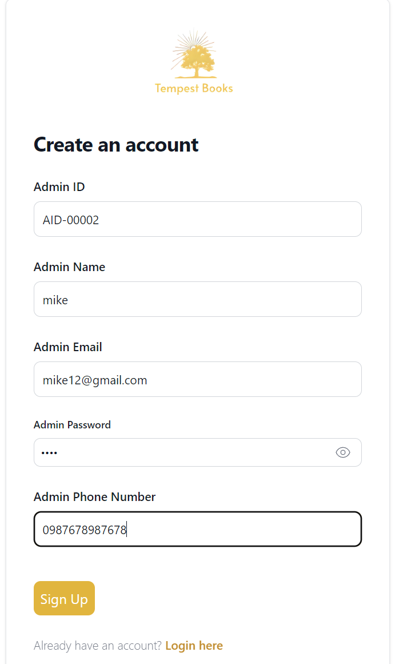

Whenever this is clicked, the password won’t show up.

Fig 1.3

**After**

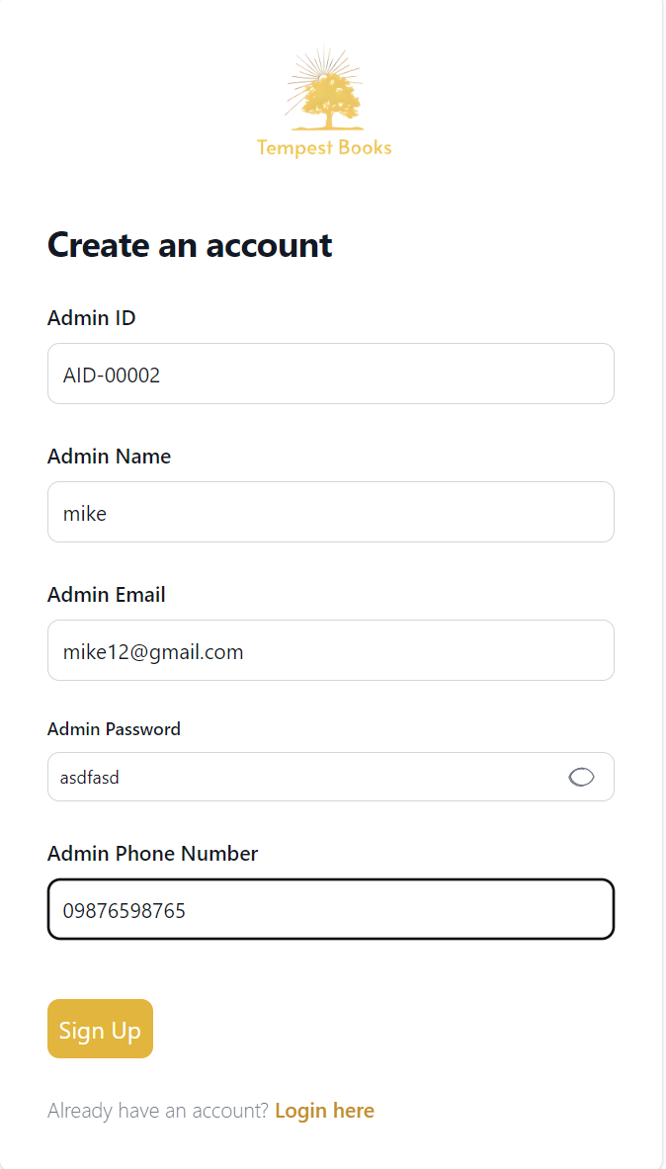

When this is clicked, the password is shown up. This helps user remember the password before sign up.

Fig 1.4

|  |  |  |  |  |
| --- | --- | --- | --- | --- |
| **Unit Test 1** | | **Test Case: admin sign up and registration form** | **Designed by: Thi Han Naing** | |
| **Data Source: Admin Table** | | **Objective**: To test the data entry in  Admins registration form | **Tester**: **Thi Han Naing** | |
| **Test Case** | **Description** | **Test Procedure** | **Expected Result** | **Actual Results** |
| 1.3 | Test admin password can be seen or not. | Weak password is entered, ask for stronger password | Password length must be including upper, lower, special characters and numbers | See Fig.1.5 & 1.6 |

**Before**

|  |
| --- |
|  |
| Fig 1. 5 |

**After**

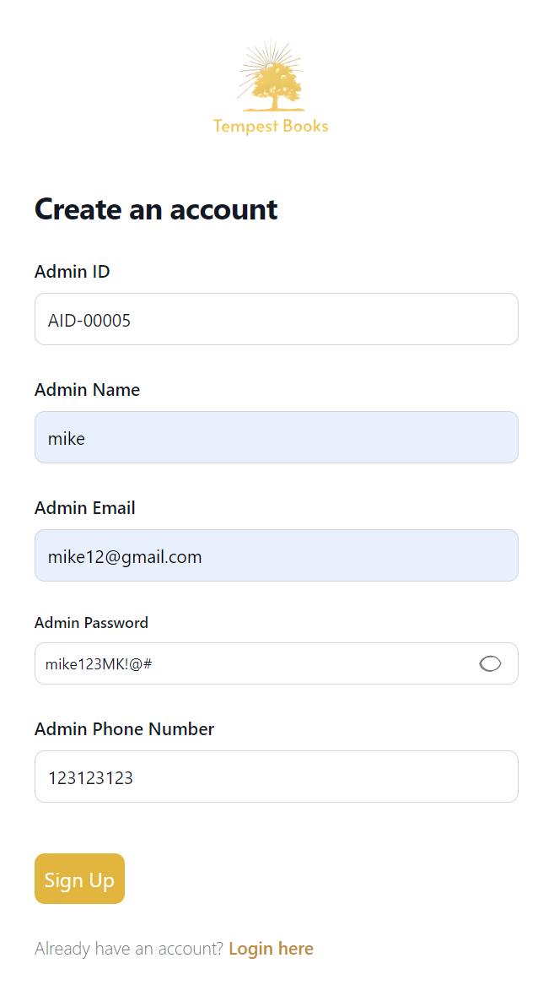

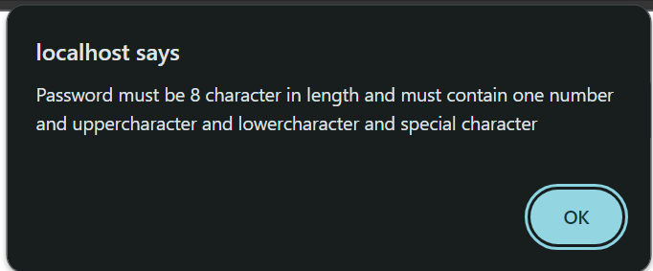

Fig 1.6

|  |  |  |  |  |
| --- | --- | --- | --- | --- |
| **Unit Test 1** | | **Test Case: admin sign up and registration form** | **Designed by: Thi Han Naing** | |
| **Data Source: Admin Table** | | **Objective**: To test the data entry in  Admins registration form | **Tester: Thi Han Naing** | |
| **Test Case** | **Description** | **Test Procedure** | **Expected Result** | **Actual Results** |
| 1.4 | Testing ‘@’ is needed or not in email. | 'Sign Up' button is clicked, ‘@, .com’ sign is missing in email input field. | Show message | See Fig.1.7 & 1.8 |

**Before**

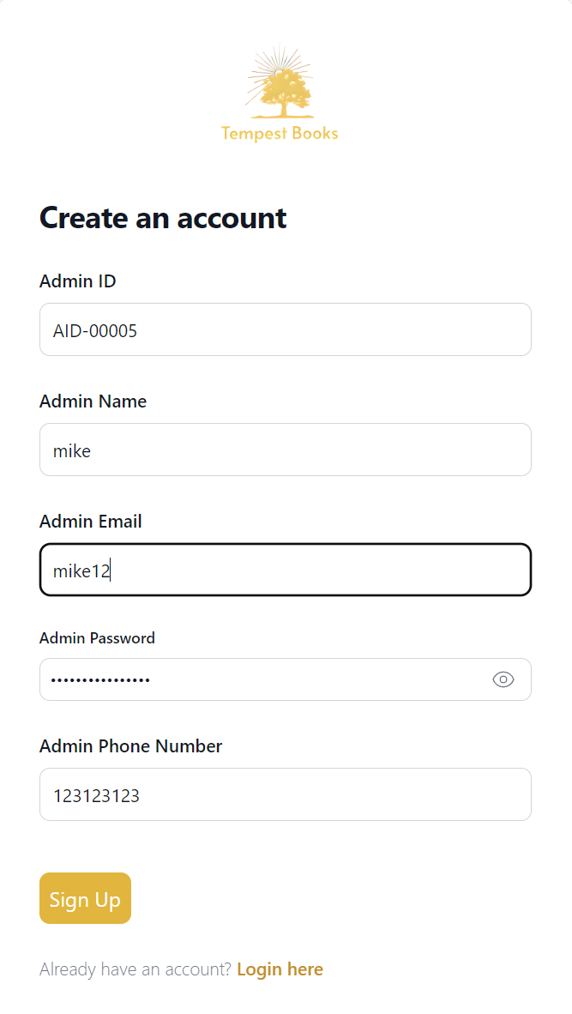

Fig 1.7

**After**

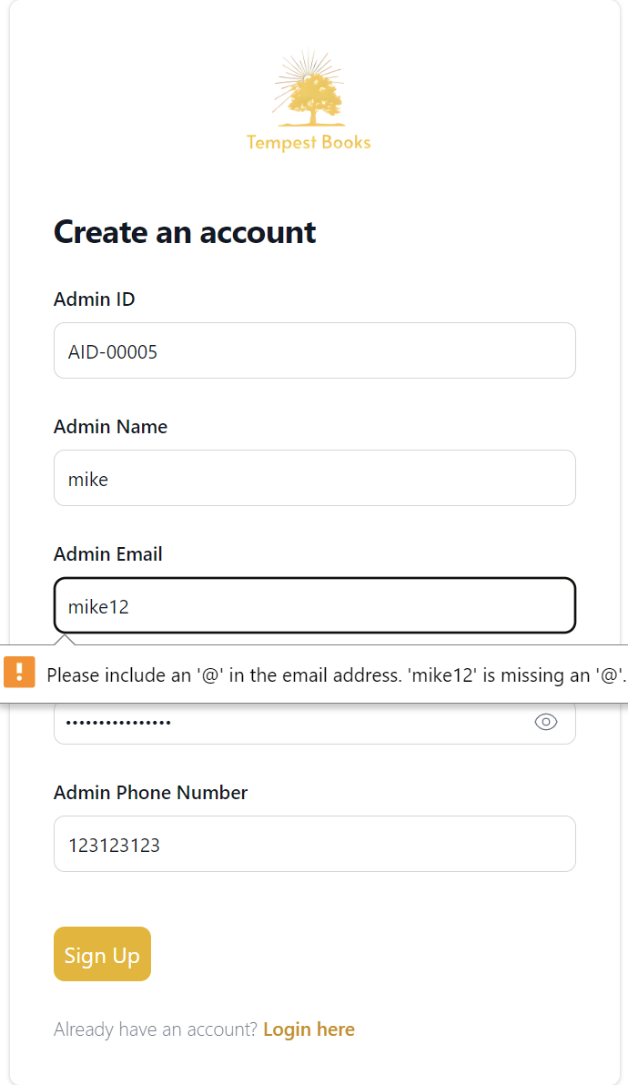

Fig 1.8

**Module 2: Adding information form**

|  |  |  |  |  |
| --- | --- | --- | --- | --- |
| **Unit Test 2** | | **Test Case: Add book information form** | **Designed by: Thi Han Naing** | |
| **Data Source: Book Table** | | **Objective**: To test the data entry in  Add Book information form | **Tester**: **Thi Han Naing** | |
| **Test Case** | **Description** | **Test Procedure** | **Expected Result** | **Actual Results** |
| 2.2 | Testing drop downs can work or not | When drop down button is clicked, related data will be shown up | Showing data from database | See Fig.2.3 & 2.4 |

**Before**

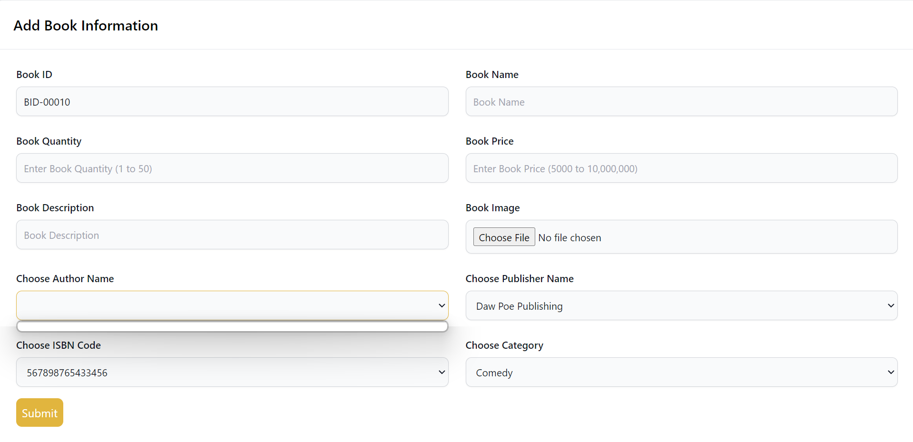

Fig 2.3

**After**

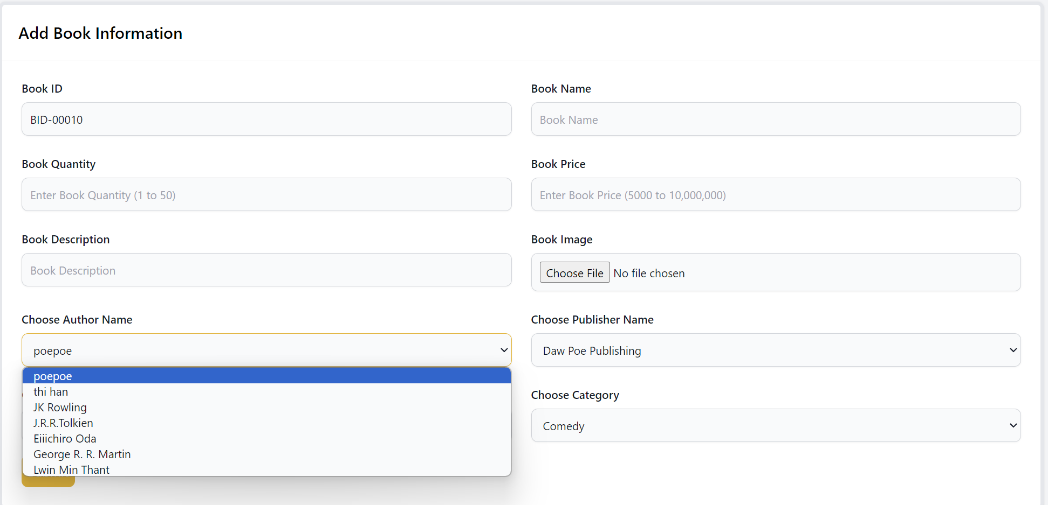

Fig 2.4

|  |  |  |  |  |
| --- | --- | --- | --- | --- |
| **Unit Test 2** | | **Test Case: Add book information form** | **Designed by: Thi Han Naing** | |
| **Data Source: Book Table** | | **Objective**: To test the data entry in  Add Book information form | **Tester**: **Thi Han Naing** | |
| **Test Case** | **Description** | **Test Procedure** | **Expected Result** | **Actual Results** |
| 2.3 | Testing image can be selected or not | When ‘choose file’ clicked, image can be able to choose | Showing images from file | See Fig.2.5 & 2.6 |

**Before**

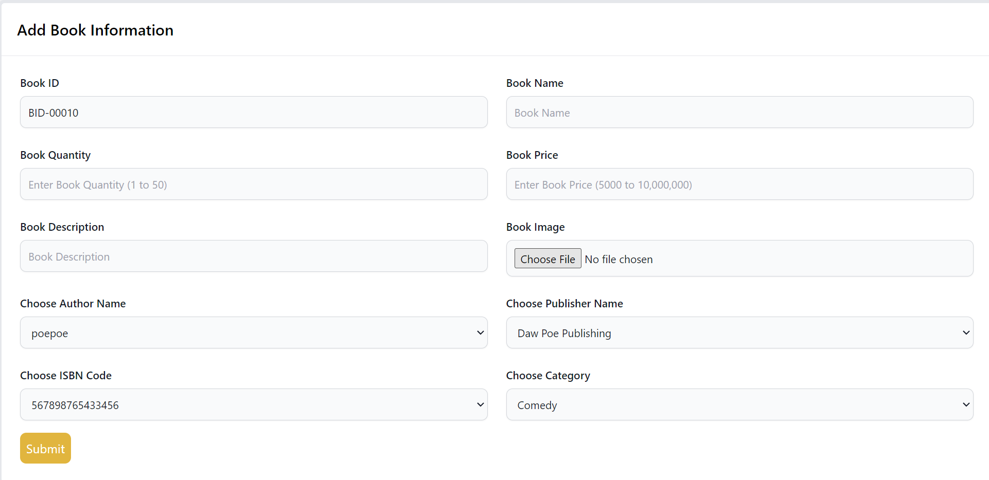

Fig 2.5

**After**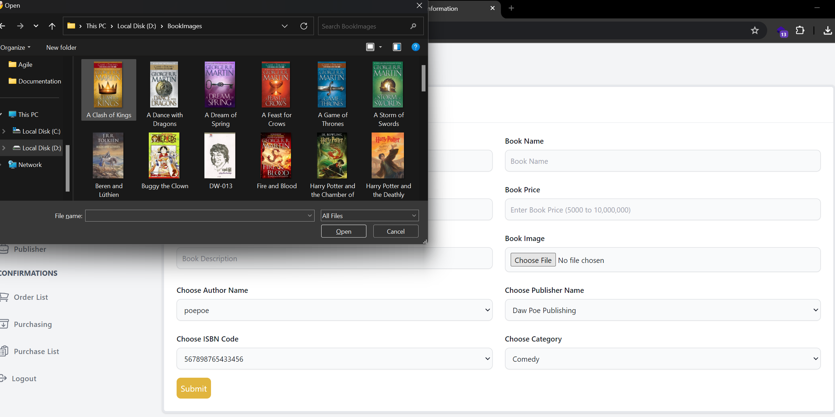

Fig 2.6

## **Section E: Interview Scripts**

|  |  |  |  |  |
| --- | --- | --- | --- | --- |
| No | Interviewee | Meeting Date | Scripts | Gathered Information |
| 1. | Founder |  | Meeting with founder of Tempest Books to understand operations of the shop | Admin process information |
| 2. | Co-founder |  | Meeting with co-founder to understand managing processes of the shop | Purchase process and delivery information |
| 3. | Staffs |  | Meeting with staffs to understand about books | Books and related information |
| 4. | Customers |  | Interviewing them to give review about store | Design and theme and customer support |

**References**

# References

*agilebusiness*. (n.d.). Retrieved from agilebusinessconsortium: https://www.agilebusiness.org/dsdm-project-framework/moscow-prioririsation.html

*agilebusinessconsortium*. (n.d.). Retrieved from agilebusiness: https://www.agilebusiness.org/dsdm-project-framework/principles.html

Aiden Gallagher, J. D. (2019, April 22). *IBM developer*. Retrieved from developeribm: https://developer.ibm.com/articles/waterfall-model-advantages-disadvantages/

*airfocus*. (n.d.). Retrieved from https://airfocus.com/glossary/what-is-dynamic-systems-development-method/

*atlassian*. (2023, August 30). Retrieved from atlassian.: https://community.atlassian.com/t5/App-Central/Understanding-the-MoSCoW-prioritization-How-to-implement-it-into/ba-p/2463999

*blue claw database developer resource*. (n.d.). Retrieved from blueclawdb: https://blueclawdb.com/mysql/advantages-disadvantages-mysql/

Buehring, S. (2023, May 18). *knowledgetrain*. Retrieved from https://www.knowledgetrain.co.uk/agile/agile-project-management/agile-project-management-course/dsdm-principles

Colos, L. (2023, March 20). *pitchgrade*. Retrieved from https://pitchgrade.com/companies/mongodb

*data flair*. (n.d.). Retrieved from https://data-flair.training/blogs/pros-and-cons-of-java/

*epamanywhere*. (2024, March 21). Retrieved from anywhereepam: https://anywhere.epam.com/en/blog/pros-and-cons-of-php

*geeksforgeeks*. (n.d.). Retrieved from geeksforgeeks: https://www.geeksforgeeks.org/advantages-and-disadvantages-of-java/

*geeksforgeeks*. (2022, Jun 20). Retrieved from geeksforgeeks: https://www.geeksforgeeks.org/advantages-and-disadvantages-of-php/

*IBM*. (n.d.). Retrieved from IBM: https://www.ibm.com/topics/risk-management#:~:text=Risk%20management%20is%20the%20process,an%20organization's%20capital%20and%20earnings.

KENTON, W. (2024, June 29). *Investopedia*. Retrieved from Investopedia: https://www.investopedia.com/terms/s/swot.asp

*knowledgenile*. (n.d.). Retrieved from https://www.knowledgenile.com/blogs/pros-and-cons-of-mongodb

*lucidchart*. (n.d.). Retrieved from https://www.lucidchart.com/blog/pros-and-cons-of-waterfall-methodology

*marquette uni*. (n.d.). Retrieved from marquette university: https://www.marquette.edu/riskunit/riskmanagement/whatis.shtml

Narayanan, U. (2015, February 18 ). *developer.com*. Retrieved from developer.com: https://www.developer.com/database/mongodb-advantages-disadvantages/

*patches*. (25, March 2018). Retrieved from oraclepatches: https://oracle-patches.com/en/databases/mysql/overview-of-mysql-database?start=2

Peterdy, K. (n.d.). *CFI*. Retrieved from CFI: https://corporatefinanceinstitute.com/resources/management/swot-analysis/

Petit, C. (2024, April 19). *appvizer*. Retrieved from https://www.appvizer.com/magazine/operations/project-management/dsdm

*Product Plan*. (n.d.). Retrieved from proudctplan: https://www.productplan.com/glossary/dynamic-systems-development-method/

*productplan*. (n.d.). Retrieved from productplan: https://www.productplan.com/glossary/moscow-prioritization/

Rafalski, K. (2023, Sep 12). *netguru*. Retrieved from netguru: https://www.netguru.com/blog/java-pros-and-cons

Schooley, S. (2024, January 03). *business new daily*. Retrieved from business new daily: https://www.businessnewsdaily.com/4245-swot-analysis.html

Shahrukh. (2022, February 2). *trendmut*. Retrieved from https://www.trendmut.com/advantages-and-disadvantages-of-dsdm/

*solo innovator*. (n.d.). Retrieved from solo innovator: https://soloinnovator.com/waterfall-methodology/

Stedman, L. T. (2023, September). *techtarget*. Retrieved from techtarget: https://www.techtarget.com/searchsecurity/definition/What-is-risk-management-and-why-is-it-important

Stephen J. Bigelow, M. K. (n.d.). *techtarget*. Retrieved from tech target: https://www.techtarget.com/searchcio/definition/SWOT-analysis-strengths-weaknesses-opportunities-and-threats-analysis#:~:text=SWOT%20analysis%20is%20a%20framework,or%20establishing%20a%20business%20strategy.

team, C. (n.d.). *CFI* . Retrieved from CFI: https://corporatefinanceinstitute.com/resources/career-map/sell-side/risk-management/risk-management/

*tryqa*. (n.d.). Retrieved from https://tryqa.com/what-is-waterfall-model-advantages-disadvantages-and-when-to-use-it/